CUSTOMER RELATIONSHIP
MANAGEMENT SYSTEM FOR MJJD TELECOM

A Capstone Project

Presented to
The Faculty of the College of Computer Studies
Philippine College of Science and Technology
Old Nalsian Road, Nalsian Calasiao Pangasinan

In partial Fulfillment
of the Requirement for the Degree
BACHELOR OF SCIENCE IN INFORMATION TECHNOLOGY

By:

EFRYEL JANE S. SORIANO
JYXZL IZZY P. MAMUGAY
RENS V. MAGALLON
ARJAY P. TUMANAN

November 2026

INDORSEMENT

This capstone project entitled “Customer Relationship Management System for MJJD Telecom”, prepared and submitted by Jyxzl Izzy P. Mamugay, Efryel Jane S. Soriano, Rens V. Magallon, Arjay P. Tumanan in partial fulfillment of the requirements for the degree Bachelor of Science in Information Technology, has been examined and is hereby recommended for acceptance and approval for Oral Examination.
This is to further certify that Rens V. Magallon, et al., are ready for Oral Examination
MR. IAN JEFFERSON B. VARGAS, MPA, MIT
Adviser

This is to certify that the capstone project entitled “Customer Relationship Management System for MJJD Telecom”, prepared and submitted by Rens V. Magallon, et al., is recommended for Oral Examination.

MR. IAN JEFFERSON B. VARGAS, MPA, MIT
Adviser

ENGR. CHARO G. ALMONTE, MIT
Chairman

MS. RACHELLE N. CAMACHO, MIT MR. RIZAL S. DE LEON, MIT
Member Member
APPROVAL SHEET
Approved by the Committee in Oral Examination with a rating _____ % on
October _____ .

MR. IAN JEFFERSON B. VARGAS, MPA, MIT
Adviser

ENGR. CHARO G. ALMONTE, MIT
Chairman

MS. RACHELLE N. CAMACHO, MIT MR. RIZAL S. DE LEON, MIT
Member Member

Accepted and approved in partial fulfillment of the requirements for the degree of Bachelor of Science in Information Technology.

MS. RACHELLE N. CAMACHO, MIT
Dean, College of Computer Studies

ENGR. RAUL B. GIRONELLA Sr., D.Min.
Vice President for Academic Affairs

ACKNOWLEDGEMENT
The researchers would like to express their sincere appreciation and profound gratitude to the individuals whose guidance, support, and contributions played an important role in the successful completion of this study.
Above all, the researchers offer their deepest gratitude to Almighty God for providing them with wisdom, strength, patience, and guidance throughout the entire research process. His blessings served as a constant source of inspiration and determination in overcoming the challenges encountered during the conduct of the study.
The researchers are especially grateful to Mr. Ian Jefferson B. Vargas, MPA, MIT, Research Adviser, for his invaluable guidance, constructive recommendations, and continuous support. His knowledge and expertise greatly assisted the researchers in improving the quality and direction of the study.
Sincere appreciation is extended to Ms. Kim Kyle Marquez, Research Coordinator, for her dedication, valuable assistance, and thoughtful recommendations throughout the development of the research. Her guidance contributed significantly to the completion and refinement of the study.
The researchers also wish to convey their sincere gratitude to Ma. Ditas A. Fernandez, OIC Research Director, for her leadership and dedication in promoting academic research and excellence. Her encouragement and direction motivated the researchers to conduct the study with responsibility, commitment, and professionalism.
The researchers are equally thankful to Ms. Rachelle N. Camacho, MIT, Dean of the College of Computer Studies and member of the panel, for her continued support, valuable advice, and assistance in ensuring that the study conforms to the academic standards and objectives of the college.
Special recognition and heartfelt appreciation are given to Engr. Charo G. Almonte, MIT, Chairman of the Panel, for sharing her expertise, constructive observations, and technical recommendations. Her valuable feedback contributed greatly to the refinement and overall improvement of the research.
The researchers also extend their sincere thanks to Mr. Rizal S. De Leon, panel member, for his insightful comments, practical suggestions, and technical recommendations. His contributions were instrumental in enhancing the proposed system and strengthening the overall quality of the study.
The researchers are deeply grateful to their Beloved Families for their unconditional support, understanding, encouragement, and financial assistance. Their constant motivation and sacrifices served as an important source of strength and inspiration throughout the completion of this research.
Appreciation is likewise extended to their fellow Block 1, 4th Year IT Students for their cooperation, encouragement, friendship, and willingness to support one another. Their camaraderie helped create a positive and collaborative environment throughout the research journey.
Finally, the researchers respectfully acknowledge the authors of published and unpublished theses, books, journals, articles, and other scholarly works that served as important references for this study. Their contributions to the field provided valuable knowledge and information that guided the researchers in developing and completing this Capstone Project.
To everyone who contributed, directly or indirectly, to the accomplishment of this study, the researchers extend their sincerest gratitude and appreciation.
The Researchers,
JYXZL IZZY P. MAMUGAY
EFRYEL JANE S. SORIANO
RENS V. MAGALLON
ARJAY P. TUMANAN

DEDICATION
This study is wholeheartedly dedicated to all the individuals who have served as sources of encouragement, strength, and inspiration throughout the researchers’ academic journey.
To our beloved parents, families, and loved ones, we express our deepest appreciation for their unwavering support, patience, understanding, and sacrifices. Their constant encouragement and guidance gave us the motivation to continue pursuing our goals despite the difficulties and challenges encountered along the way.
To our friends, classmates, and fellow Information Technology students, we are sincerely grateful for the knowledge, experiences, cooperation, and encouragement we shared throughout this journey. Their companionship and support made the entire research experience more meaningful and worthwhile.
Above all, this work is humbly dedicated to Almighty God, who blessed us with wisdom, strength, courage, and perseverance throughout the completion of this study. His guidance has been our foundation in overcoming every challenge and accomplishing this endeavor. To God be all the glory.
The Researchers,
JYXZL IZZY P. MAMUGAY
EFRYEL JANE S. SORIANO
RENS V. MAGALLON
ARJAY P. TUMANAN

CAPSTONE PROJECT ABSTRACT
Title: CUSTOMER RELATIONSHIP MANAGEMENT SYSTEM FOR MJJD TELECOM
Authors: JYXZL IZZY P. MAMUGAY, EFRYEL JANE S. SORIANO, RENS V. MAGALLON, ARJAY P. TUMANAN
Adviser: MR. IAN JEFFERSON B. VARGAS, MPA, MIT
Institution: Philippine College of Science and Technology
Location: Old Nalsian Road, Nalsian, Calasiao, Pangasinan
Abstract: This study developed a web-based Customer Relationship Management System for Mary Joy and Jepsy Dave Telecom to address difficulties in customer application processing, record management, installation coordination, and customer support communication. Using a quantitative descriptive-developmental approach and Agile Software Development Methodology, the study identified existing operational methods, problems, functional requirements, and preferred system features. Messaging applications or online platforms ranked first among the existing methods, while delays in responding to customer concerns ranked first among the problems encountered. Live chat or direct customer support ranked first among the functional requirements, while real-time status tracking ranked first among the preferred system features. The developed system centralized customer applications, records, technician assignments, installation monitoring, ticketing, live chat, notifications, and public tracking. The study supports Sustainable Development Goal 9 on Industry, Innovation and Infrastructure. The system obtained an overall average weighted mean of 4.3, interpreted as Strongly Agree.
Keywords: Customer Relationship Management System, MJJD TELECOM, Customer Relationship Management, Service Management, ISO/IEC 25010

TABLE OF CONTENTS
Page
TITLE PAGE i
INDORSEMENT ii
APPROVAL SHEET iii
ACKNOWLEDGEMENT iv
DEDICATION vii
CAPSTONE PROJECT ABSTRACT viii
TABLE OF CONTENTS x
LIST OF TABLES xii
LIST OF FIGURES xiv
CHAPTER I INTRODUCTION 1
Background of the Study 1
Conceptual Framework 5
Statement of Objectives 7
Assumptions 8
Scope and Delimitations 8
Paradigm of the Study 10
Importance of the Study 12
Definition of Terms 14
Review of Related Literature 16
Foreign Literature 17
Local Literature 20
CHAPTER II METHODS AND PROCEDURES 22
Research Design 23
Population and Locale of the Study 24
Instrumentation/Sources of Data 25
Data Analysis/Treatment of Data 26
Ethical Consideration 29
CHAPTER III RESULTS AND DISCUSSION 31
Present Methods Used 31
Problems Encountered 33
Functional Requirements 35
Features of the System 37
Functional Suitability 39
Performance Efficiency 40
Compatibility 42
Usability 43
Reliability 45
Security 46
Maintainability 47
Portability 49
System Evaluation According to ISO 25010 Software Quality Standards 51
Technical Design 52
System Design 53
System Development Methodology 55
Use Case Diagram 59
Physical Design 60
Software Requirements 60
Hardware Requirements 61
CHAPTER IV SUMMARY, CONCLUSION, AND RECOMMENDATIONS 62
Summary 63
Conclusions 64
Recommendations 65
REFERENCES 68
APPENDICES 72
Appendix A Letter to the Executive Vice-President 73
Appendix B Letter to the Vice-President for Academic Affairs 74
Appendix C Letter to the Vice-President for Administration 75
Appendix D Letter to the OIC Research Director 76
Appendix E Letter to the Dean 77
Appendix F Letter to the Client 78
Appendix G Invitation and Acceptance 79
Appendix H Certificate of Acceptance 80
Appendix I Survey Questionnaire for Respondents 81
Appendix J Survey Questionnaire for IT Experts 83
Appendix K Survey Questionnaire Validation Criteria 87
Appendix L Documentation 88
Appendix M User Manual 89
CURRICULUM VITAE 133
LIST OF TABLES
Tables Page
1 Five-Point Likert Scale 28
2 Present Methods Used 33
3 Problems Encountered 34
4 Functionality Requirements 36
5 Features of the System 38
6 Functional Suitability 39
7 Performance Efficiency 41
8 Compatibility 43
9 Usability 44
10 Reliability 46
11 Security 47
12 Maintainability 48
13 Portability 50
14 ISO 25010 Software Quality Standards 51
15 System Design 54
16 Minimum Software Requirements 61
17 Minimum Hardware Requirements 62
18 Homepage 89
19 Plans Section 90
20 Support and Contact Section 91
21 Login Page 92
22 Register Page 93
23 Application Lookup Page 94
24 Ticket Lookup Page 95
25 Admin Dashboard 96
26 Notifications Panel 98
27 Applications Page 99
28 Customers Page 100
29 Technicians Page 101
30 Add Technician Window 102
31 Support Tickets Page 104
32 Analytics and Reports Page 105
33 System Logs Page 106
34 Admin Live Chat Page 107
35 Technician Dashboard 108
36 My Installations Page 109
37 Customer Profile Page 110
38 My Assigned Tickets Page 111
39 Customer Dashboard 112
40 Applicant Information Step 114
41 Service Location Step 115
42 Location Pin Map 116
43 Choose Your Plan Step 117
44 Verify Your Identity Step 118
45 ID Upload Section 119
46 Review and Submit Step 120
47 Application Submitted Page 121
48 My Support Tickets Page 122
49 Customer Live Chat Page 123
50 Homepage for Mobile 124
51 Login Page for Mobile 125
52 Register Page for Mobile 126
53 Admin Dashboard for Mobile 127
54 Admin Navigation Menu for Mobile 128
55 Applications Page for Mobile 129
56 Technician Dashboard for Mobile 130
57 Customer Dashboard for Mobile 131
58 Customer Live Chat Page for Mobile 132
LIST OF FIGURES
Figures Page
1 Paradigm of the Study 12
2 Agile Methodology 58
3 Use Case Diagram 60
4 Homepage 89
5 Plans Section 90
6 Support and Contact Section 91
7 Login Page 92
8 Register Page 93
9 Application Lookup Page 94
10 Ticket Lookup Page 95
11 Admin Dashboard 96
12 Notifications Panel 98
13 Applications Page 99
14 Customers Page 100
15 Technicians Page 101
16 Add Technician Window 102
17 Support Tickets Page 104
18 Analytics and Reports Page 105
19 System Logs Page 106
20 Admin Live Chat Page 107
21 Technician Dashboard 108
22 My Installations Page 109
23 Customer Profile Page 110
24 My Assigned Tickets Page 111
25 Customer Dashboard 112
26 Applicant Information Step 114
27 Service Location Step 115
28 Location Pin Map 116
29 Choose Your Plan Step 117
30 Verify Your Identity Step 118
31 ID Upload Section 119
32 Review and Submit Step 120
33 Application Submitted Page 121
34 My Support Tickets Page 122
35 Customer Live Chat Page 123
36 Homepage for Mobile 124
37 Login Page for Mobile 125
38 Register Page for Mobile 126
39 Admin Dashboard for Mobile 127
40 Admin Navigation Menu for Mobile 128
41 Applications Page for Mobile 129
42 Technician Dashboard for Mobile 130
43 Customer Dashboard for Mobile 131
44 Customer Live Chat Page for Mobile 132
CHAPTER I
INTRODUCTION
Background of the Study
Internet connectivity had become an essential infrastructure that supported communication, education, commerce, and public services worldwide. As dependence on digital connectivity continued to grow, Internet Service Providers (ISPs) were expected to manage not only network performance but also customer interactions and service processes efficiently. The increasing number of internet users placed greater pressure on telecommunications companies to maintain organized customer records, respond promptly to service concerns, and coordinate operational activities effectively. When customer information, service requests, and technical coordination were handled through fragmented or manual processes, operational inefficiencies often arose. Studies showed that effective customer relationship management (CRM) systems could improve organizational efficiency by centralizing customer data, facilitating communication, and supporting better service delivery within telecommunications organizations (Ali & Ahmad, 2024; Fernando et al., 2023). These systems helped service providers organize customer interactions, monitor service activities, and improve overall customer satisfaction.
In the telecommunications industry, service quality and customer relationship management played a crucial role in maintaining long-term customer relationships. Research emphasized that telecommunications providers needed to adopt structured systems to manage customer data, service requests, and operational workflows in order to ensure service reliability and responsiveness. For example, in the study “The Impact of Electronic Customer Relationship Management Strategies on Customer Loyalty: A Mediated Model” by Magatef et al. (2023), the authors found that electronic customer relationship management strategies in telecommunications significantly improved customer relationship quality, which in turn positively influenced customer loyalty. Their findings supported the idea that digital CRM systems were effective because they improved communication and helped service providers manage customer interactions in a more organized and responsive manner. Likewise, the study “The Relationship between CRM, Knowledge Management, Organization Commitment, Customer Profitability and Customer Loyalty in Telecommunication Industry: The Mediating Role of Customer Satisfaction and the Moderating Role of Brand Image” by Gazi et al. (2024) showed that effective CRM in the telecommunications industry had a strong positive effect on customer satisfaction, profitability, and loyalty. The study further showed that better CRM performance contributed both directly and indirectly to stronger customer retention through improved customer satisfaction. These findings indicated that when customer data and service operations were poorly organized, telecommunications providers could experience delayed responses, inconsistent service, and difficulty monitoring performance. However, when structured digital CRM approaches were implemented, they could improve service coordination, responsiveness, and long-term customer relationships.
In the Philippines, the demand for reliable internet services had increased significantly because of the rapid expansion of digital communication, online learning, remote work, and electronic commerce. National digitalization initiatives further emphasized the importance of expanding internet access and improving service quality across the country. According to the Philippine Development Plan 2023–2028, digital transformation played a vital role in improving economic productivity and expanding access to services (National Economic and Development Authority [NEDA], 2023). Similarly, the Philippine Statistics Authority (2023) reported the continued growth of the digital economy as internet usage expanded across sectors. These developments highlighted the growing importance of internet service providers in supporting the country’s digital infrastructure. As internet connectivity became more integrated into everyday life, customers increasingly expected reliable service, prompt responses to concerns, and organized communication with service providers.
Despite these developments, many internet service providers in the Philippines still faced operational challenges related to service management and customer interaction. Studies in the Philippine telecommunications sector indicated that service reliability, responsiveness, and effective communication significantly influenced how customers evaluated their service providers. However, smaller and provincial ISPs often operated with limited administrative resources and continued to rely on semi-manual methods such as spreadsheets, messaging platforms, and paper-based documentation to manage daily operations. Although these methods could be manageable on a small scale, they often resulted in fragmented information management as the number of customers increased. When customer data, service requests, and operational coordination were handled across multiple platforms, it became more difficult to maintain consistent records, monitor service activities, and respond to customer concerns in a timely manner.
This situation was particularly relevant to small provincial internet service providers that served local communities without integrated information systems. Many of these providers managed customer applications, maintained subscriber records, coordinated installations, and addressed service concerns through separate communication channels and manually maintained files. As operations expanded, these practices could lead to incomplete documentation, difficulty retrieving customer records, delayed responses to service concerns, and challenges in coordinating operational tasks among staff. These issues underscored the need for improved service management practices that could support the increasing operational demands of local internet service providers.
One example of this situation was observed in MJJD TELECOM, a provincial internet service provider operating in Bayambang, Pangasinan. As the number of customers increased, the company experienced difficulties in organizing customer information, monitoring service activities, and coordinating operational tasks. Customer applications and inquiries were often received through messaging platforms or physical documents, while records were maintained using spreadsheet files and other manual methods. Although these approaches enabled the company to continue its operations, they also created challenges in maintaining consistent documentation, tracking service-related activities, and retrieving customer information efficiently. These operational limitations could lead to delays in processing requests, inconsistencies in handling service concerns, and difficulty maintaining organized records as the company expanded its services.
Although previous studies examined customer relationship management, service quality, and customer satisfaction in telecommunications, most of these studies focused on large telecommunications companies or general telecommunications settings. Limited literature specifically addressed the operational realities of small provincial internet service providers, particularly in terms of managing customer applications, installation coordination, customer records, and service concerns through an integrated digital system. Because of this, the specific operational challenges faced by smaller ISPs in provincial areas remained insufficiently explored. This gap justified the need for a study that developed a practical and localized web-based system for MJJD TELECOM.
To address these concerns, this study introduced a web-based Customer Relationship Management System for MJJD TELECOM. The system was designed to provide a centralized platform for organizing customer records, managing service-related activities, and improving coordination among operational processes. By centralizing information and improving workflow management, the system was expected to help the organization maintain organized records, monitor service activities more effectively, and improve communication between the service provider and its customers.
Conceptual Framework
This study was anchored on two complementary recent studies from the telecommunications field. The first was the study of Magatef et al. (2023) entitled The Impact of Electronic Customer Relationship Management Strategies on Customer Loyalty: A Mediated Model. Their study examined electronic customer relationship management (e-CRM) strategies in the telecommunications sector and explained that e-CRM consisted of functional and personal dimensions that influenced customer loyalty through customer relationship quality. The study emphasized that structured digital interaction and electronic service platforms strengthened the relationship between service providers and customers. This was relevant to the present study because the proposed system for MJJD TELECOM included customer-centered digital functions such as online application submission, customer record management, ticketing, live chat, and public status tracking. These features reflected the functional dimension of e-CRM because they enabled the company to manage customer information and interactions through a centralized web-based platform.
The second anchor was the study of Bandali et al. (2025) entitled ML-Based Fault Management Automation in Large-Scale Fixed and Mobile Telecommunication Networks. The study discussed how telecommunications service problems were handled through trouble tickets and showed that structured ticket-based processing was important for improving operational efficiency, resource allocation, and customer satisfaction. It also addressed the prediction of resolution time and dispatch relevance in fault-management operations. This study was relevant to the present research because the proposed system for MJJD TELECOM included service-related functions such as ticket submission, technician assignment, installation monitoring, and service status tracking. Although the present study was intended for a small provincial internet service provider rather than a large telecommunications operator, the operational principle remained similar: service requests and concerns needed to be properly documented, tracked, assigned, and resolved through an organized digital process.
Guided by these two studies, the present research combined customer relationship management and service management into one web-based system for MJJD TELECOM. The study of Magatef et al. (2023) supported the customer relationship dimension of the framework, particularly digital interaction, organized communication, and centralized customer records, while the study of Bandali et al. (2025) supported the service operations dimension, particularly structured ticket handling, technician-related workflows, and service monitoring. At the center of the framework was a centralized web-based database that stored customer profiles, application records, installation details, ticket histories, technician assignments, and communication logs in one integrated platform. Through this setup, customer information and service activities could be accessed, updated, and monitored more efficiently.
Statement of Objectives
General Objective
The study aimed to develop a Web-Based Customer Relationship Management System for organizing customer records and managing daily operations
Specific Objectives
1. To determine current methods used by MJJD in their daily operations
2. To determine the challenges associated with the current methods used by MJJD in their daily operations
3. To determine the necessary functional requirements for the development of the proposed Customer Relationship Management System.
4. To determine system features that can be incorporated in the development of the proposed system.
5. To evaluate extent of compliance of the developed system in terms of the ISO 25010 software quality standard, specifically addressing:
a. Functional Suitability
b. Performance Efficiency
c. Compatibility
d. Usability
e. Reliability
f. Security
g. Maintainability
h. Portability
Assumptions
For this study, the researchers made the following assumptions:
- There are current methods used by MJJD in their daily operations
- There are challenges associated with the current methods used by MJJD in their daily operations
- There are necessary functional requirements for the development of the proposed Customer Relationship Management System.
- There are system features that can be incorporated in the development of the proposed system.
- The developed system can be evaluated for compliance with the ISO 25010 software quality standard in terms of:
a. Functional Suitability
b. Performance Efficiency
c. Compatibility
d. Usability
e. Reliability
f. Security
g. Maintainability
h. Portability
Scope and Delimitations
This study focused on the design, development, and evaluation of a Customer Relationship Management System for MJJD TELECOM (Mary Joy & Jepsy Dave Telecom), a provincial internet service provider located in Bayambang, Pangasinan, that operated prepaid fiber internet services through Surf2Sawa. The proposed system centralized the key operational processes of MJJD TELECOM into a web-based platform, particularly customer application processing, installation management, scheduling, and customer communication.
The system allowed customers to create an account, select a service plan, submit an installation application, upload a valid identification document, provide their address, and pin their exact location on a map. The administrator reviewed each application, manually checked serviceability and slot availability based on the submitted location, and either approved or rejected the request. If approved, the administrator assigned a technician and scheduled the installation. If rejected, the customer could submit a new application. The system also allowed technicians to view assigned installations, update installation statuses, and maintain installation histories. In addition, the system included ticketing, live chat, public tracking through reference numbers, and in-system and email notifications that informed customers about application approval or rejection, installation schedules, and the progress of submitted tickets, including whether they had been resolved or closed.
The respondents of the study were limited to the administrator, technicians, and customers of MJJD TELECOM. The administrator evaluated system functions related to application review, technician assignment, scheduling, and records management. Technicians assessed installation-related functions, while customers evaluated customer-facing features such as application submission, ticketing, live chat, notifications, and tracking. Data were gathered through structured questionnaires and analyzed using descriptive statistics. The developed system was also evaluated based on the ISO/IEC 25010 software quality characteristics.
This study was limited to the development and evaluation of the developed system and did not include billing, online payment, load purchasing, reload requests, billing verification, or direct integration with Surf2Sawa’s internal activation and loading platform. The system did not monitor whether customers were active or inactive because MJJD TELECOM operated under a prepaid setup in which customers managed their own internet loading through authorized retailers after installation and activation. Furthermore, the study did not cover physical network infrastructure modification, fiber deployment, bandwidth provisioning, or network performance monitoring. The system was intended solely for the operational use of MJJD TELECOM and was evaluated based on software quality rather than internet speed, connectivity, or

Paradigm of the Study
The INPUT block consists of the current methods used by MJJD TELECOM in in their daily operations. It also includes the challenges associated with these existing methods, as well as the identified functional requirements and system features necessary for the development of the proposed Customer Relationship Management System.
The PROCESS block illustrates the stages undertaken in the development of the proposed system. The study utilizes the Agile Software Development Methodology to design, develop, test, and refine the system through iterative cycles. Agile methodology allows continuous improvement and adaptation based on system requirements. The research also applies the Descriptive Developmental Research design to systematically develop and evaluate the system. Additionally, the Quantitative Research Method is used to assess the developed system based on the ISO/IEC 25010 software quality characteristics, including functional suitability, performance efficiency, compatibility, usability, reliability, security, maintainability, and portability. Quantitative research involves collecting numerical data through survey questionnaires and analyzing the results using statistical methods.
After processing the inputs through the selected methodologies, the OUTPUT block presents the developed Customer Relationship Management System for MJJD TELECOM.

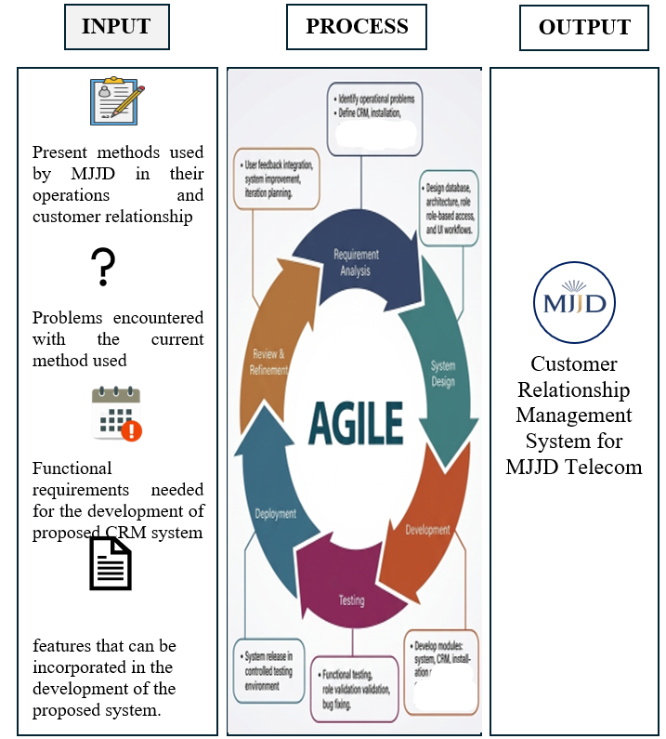

Figure 1. (Paradigm of the Study)
Importance of the Study
The researchers highlighted the benefits that the study brought to several stakeholders, particularly those directly related to the operations of MJJD TELECOM and to the development of localized service management systems for internet service providers.
MJJD TELECOM Management. The management of MJJD TELECOM benefits from the study through improved access to centralized records and more organized monitoring of customer applications, installation activities, and service-related concerns. The developed system supports better decision-making by providing structured information that is easier to retrieve, review, and manage.
Administrators. Administrators benefit from the system through more streamlined workflows in handling customer applications, maintaining customer records, coordinating installation schedules, and monitoring customer concerns. The system helps reduce manual encoding, improve record organization, and support more efficient service administration.
Technicians. Technicians benefit from the study through clearer task assignments, improved visibility of installation schedules, and better documentation of service updates. The system helps them monitor assigned work more effectively and coordinate installation-related activities with administrators in a more organized manner.
Customers. Customers benefit from the study through more convenient access to service-related processes such as online application submission, status tracking, and customer support communication. The system also provides a more transparent and organized way for customers to follow up on their requests and concerns.
Provincial Internet Service Providers. The study serves as a reference for other provincial ISPs that rely on manual and semi-digital processes in managing customer applications, installation coordination, and customer concerns. It provides insight into how a web-based system can help improve documentation, workflow organization, and service monitoring in a localized operational setting.
Information Technology Students. The study benefits Information Technology students by providing an example of how concepts in system analysis, database management, web development, and software quality evaluation can be applied in solving actual operational problems. It also serves as a model for developing practical and research-based capstone projects.
Researchers. The study enhances the knowledge and skills of the researchers in system analysis, database management, web development, and software evaluation. It also provides them with practical experience in developing a real-world customer relationship management system and applying research methodologies to address actual operational problems encountered by a local internet service provider.
Future Researchers. The study serves as a useful reference for future researchers who plan to conduct studies related to customer relationship management systems, service management systems, or web-based information systems for local service providers. It also provides guidance in terms of system design, development, and evaluation using recognized software quality standards.

Definition of Terms
The following terms are defined conceptually and operationally for clarity and better understanding of the study:
Compatibility. Refers to the degree to which a system can operate with other systems or within shared environments without conflict (ISO/IEC, 2023). In this study, compatibility refers to the system functioning properly across commonly used browsers/devices for administrators, technicians, and customers.
Customer Application Processing. Customer application processing refers to the structured handling of customer-provided information during service onboarding and request management (Benzaid & Taleb, 2022). In this study, it refers to the module where customers submit applications online, upload valid IDs, pin installation locations, and where administrators review and approve/reject requests.
Customer Communication. Customer communication refers to organized interaction practices that support customer relationship quality and responsiveness in service settings (Magatef et al., 2023). In this study, it refers to customer-facing communication features such as ticket submission and live chat, including logged interactions and status updates.
Customer Relationship Management (CRM). CRM refers to managing customer information and interactions in order to improve customer satisfaction and loyalty outcomes (Gazi et al., 2024). In this study, CRM refers to the system functions that manage customer profiles, application records, service history, and interaction logs to support organized customer handling.
Functional Requirements. Functional requirements define what a system must do its services, behaviors, and functions needed by users (ISO/IEC/IEEE 29148:2018). In this study, it refers to whether the system correctly performs the required tasks such as application processing, installation management functions, scheduling, and customer communication.
Installation Management. Installation management refers to organizing and monitoring deployment activities to ensure completion and documentation of service installation tasks (Benzaid & Taleb, 2022). In this study, it refers to technician assignment, scheduling, status updates, and proof-of-installation uploads handled through the system.
ISO/IEC 25010. ISO/IEC 25010 provides a product quality model defining characteristics for software quality evaluation (ISO/IEC, 2023). In this study, it is the standard used to evaluate the developed system.
Maintainability. Maintainability refers to how effectively a system can be modified to correct faults, improve, or adapt (ISO/IEC, 2023). In this study, it refers to how easily the system can be updated or improved without major redevelopment.
Performance Efficiency. Performance efficiency refers to system performance relative to resources used under stated conditions (ISO/IEC, 2023). In this study, it refers to response time and processing speed when users submit applications, upload files, or access tracking pages.
Portability. Portability refers to how effectively a system can be transferred from one environment to another (ISO/IEC, 2023). In this study, it refers to the system’s ability to be deployed across different machines/hosting environments.
Reliability. Reliability refers to the ability of a system to perform specified functions under specified conditions for a specified period (ISO/IEC, 2023). In this study, it refers to stable system operation during key processes such as approvals, updates, and record saving.
Security. Security refers to protecting information so access is appropriate to authorization (ISO/IEC, 2023). In this study, it refers to authenticated access and protection of uploaded IDs, application documents and customer records.
System Features. System features refer to functions and capabilities provided to users to meet requirements and support tasks (ISO/IEC/IEEE 29148:2018). In this study, system features refer to the modules implemented in the platform (application portal, admin dashboard, technician updates, scheduling, ticketing/chat, tracking).
Usability. Usability refers to the degree to which specified users can use a system to achieve goals effectively, efficiently, and with satisfaction (ISO/IEC, 2023).In this study, it refers to ease of use for admins, technicians, and customers when navigating and completing tasks.

Review of Related Literature
This section presents a review of related foreign and local literature relevant to the development of the Customer Relationship Management System for MJJD TELECOM. It examines existing studies on customer relationship management, service coordination, technician scheduling, and customer support systems in the telecommunications industry to establish a theoretical and conceptual foundation for the study. The reviewed literature highlights how structured digital systems improve service efficiency, customer satisfaction, and operational management, while also identifying gaps in the development of integrated and localized platforms for small-scale or provincial internet service providers. These insights serve as the basis for the design and development of the system, ensuring that it addresses the operational needs of MJJD TELECOM and aligns with established principles in service and customer management.

Foreign Literature
Electronic customer relationship management had been shown to play an important role in the telecommunications industry. In the study “The Impact of Electronic Customer Relationship Management Strategies on Customer Loyalty: A Mediated Model” by Magatef et al. (2023), the researchers found that e-CRM strategies significantly improved customer relationship quality, which in turn strengthened customer loyalty in the telecommunications sector. Their findings suggested that structured digital communication, organized customer interaction, and relationship-focused online service processes helped telecom providers retain customers more effectively. This study was relevant to the present research because MJJD TELECOM also needed a digital platform that could centralize customer communication, customer records, and service follow-up processes.
Customer relationship management had also been linked to customer satisfaction and profitability in telecommunications. In the study “The Relationship between CRM, Knowledge Management, Organization Commitment, Customer Profitability and Customer Loyalty in Telecommunication Industry: The Mediating Role of Customer Satisfaction and the Moderating Role of Brand Image” by Gazi et al. (2024), the researchers found that CRM had both direct and indirect effects on customer loyalty through customer satisfaction. The study emphasized that CRM became more effective when customer information, internal knowledge, and service processes were managed in a coordinated manner. This supported the need for a centralized system in MJJD TELECOM that could organize customer records, applications, and interactions in one platform.
Service operations in telecommunications also depended on organized technician assignment and scheduling. In the study “The Field Technician Scheduling Problem with Experience-Dependent Service Times” by Yu et al. (2023), the researchers examined how maintenance and service tasks could be assigned and sequenced efficiently despite limited technician resources. Their results showed that a structured scheduling model could improve task allocation and service execution. Although the study was developed as an optimization model, it was relevant to the present research because MJJD TELECOM also needed a system that could assign technicians, monitor installation schedules, and improve the coordination of field operations.
Customer support and issue resolution also required structured ticket-based systems. In the study “Ticket Automation: An Insight into Current Research with Applications to Multi-Level Classification Scenarios” by Zangari et al. (2023), support tickets were described as formal records of customer concerns, complaints, and incidents that helped organizations classify, monitor, and resolve issues systematically. The study highlighted the importance of traceable ticket workflows because poorly structured support handling could reduce consistency and efficiency in service delivery. This study supported the ticketing and tracking features of the MJJD TELECOM system.
Beyond customer-facing functions, telecommunication organizations increasingly relied on automated service management. In the study “A Survey on Zero Touch Network and Service Management (ZSM) for 5G and Beyond Networks” by Liyanage et al. (2022), the authors explained that service management in modern telecommunications increasingly depended on automation, monitoring, orchestration, and coordinated service workflows. The study emphasized that organized service management supported reliability, responsiveness, and efficient network-related operations. While MJJD TELECOM was a small provincial ISP and not a large 5G operator, the principle remained applicable because service operations still required coordinated documentation, monitoring, and process management.
Overall, the foreign studies showed that telecommunications organizations benefited from structured e-CRM, coordinated service workflows, technician scheduling, ticket-based support, and service management automation. These studies strongly supported the need for a web-based system that centralized customer records, communication, applications, installation monitoring, and customer concerns. However, most of these studies focused on large telecommunications firms, advanced digital environments, or general telecommunications settings rather than small provincial internet service providers. They also tended to examine CRM, ticketing, or service management as separate areas rather than as one integrated and localized system. This gap provided a basis for the development of the Customer Relationship Management System for MJJD TELECOM, specifically designed to address the operational realities of a provincial ISP.
I also changed the long author listings to Magatef et al. (2023), Gazi et al. (2024), Yu et al. (2023), Zangari et al. (2023), and Liyanage et al. (2022) because APA 7 uses “et al.” from the first in-text citation when a source has three or more authors.
Local Literature
In the Philippine setting, customer service remained a major factor in how customers evaluated internet providers. In the study “Work from Home Connection: A Cluster Analysis Based on the Internet Service Attributes towards Subscribers Profile” by Paulino and Esteban (2023), Filipino work-from-home internet subscribers were assessed based on attributes such as speed, network quality, customer service, after-sales support, price, contract, and value for money. The study found that customer service and after-sales support were among the important dimensions that shaped subscriber perceptions. This was relevant to the present study because MJJD TELECOM needed an organized system for handling customer inquiries, follow-ups, and service-related concerns.
ISP service quality was also examined in a Philippine provincial context. In “Towards Sustainable Internet Service Provision: Analyzing Consumer Preferences through a Hybrid TOPSIS–SEM–Neural Network Framework” by Saflor et al. (2024), conducted in Occidental Mindoro, Philippines, the researchers found that assurance, responsiveness, empathy, and data privacy directly affected service quality, while customer satisfaction further influenced customer loyalty. These findings were relevant because the MJJD TELECOM system was designed to improve responsiveness, transparency, and customer support through digital applications, tracking, and communication tools.
A more recent Philippine study also reinforced the importance of service quality and loyalty in telecommunications. In “Cognitive Perceptions and Behavioral Loyalty in Telecommunication Services: Integrating SERVQUAL and CSI in the Philippine Context” by Prasetyo et al. (2025), the researchers found that service quality dimensions, together with customer satisfaction, significantly influenced loyalty among Filipino telecommunications users. Their study showed that price, process, and human service aspects contributed to customer satisfaction and loyalty. This supported the present study because an organized service management system could help improve customer experience by making transactions, applications, and support services more systematic and transparent.
The performance and consistency of broadband services in the Philippines were also examined through real-world service measurements. In “Philippines, Fixed Broadband Experience, July 2023” by Fenwick and Lumb (2023), fixed broadband providers in the Philippines were assessed using indicators such as download speed, upload speed, video experience, success rate, and consistent quality. The report showed clear differences in user experience across providers and emphasized the value of measurable service monitoring. This was relevant to the present study because, although MJJD TELECOM was smaller in scale, it still required monitoring and documentation mechanisms that could support more organized service management and customer follow-up.
At the policy and infrastructure level, broadband service management also remained a national concern. In “Making Broadband Universal: A Review of Philippine Policies and Strategies” by Serafica, Francisco, and Oren (2023), the authors explained that while the Philippines had introduced broadband reforms and strategies, implementation remained uneven and widespread adoption still depended on improved service delivery, access, and monitoring. The study highlighted the continuing need for practical systems and interventions that could improve how internet services were managed and delivered, particularly outside major urban areas. This supported the relevance of developing localized digital systems for smaller providers such as MJJD TELECOM.
Overall, the local studies showed that internet and telecommunications users in the Philippines were influenced by customer service, responsiveness, assurance, data privacy, service quality, and measurable performance. These findings supported the need for improved customer handling and service coordination in internet service operations. However, the reviewed local studies mainly examined customer satisfaction, broadband performance, or policy conditions rather than the actual development of an integrated web-based CRM and service management system for a small provincial ISP. Limited local literature focused on combining customer application processing, technician assignment, installation monitoring, record management, and customer support into one localized platform. This gap provided a strong basis for the development of the study for MJJD TELECOM.

CHAPTER II
METHODS AND PROCEDURES
This chapter presents the strategies and tools used to collect data for the capstone project. It includes the research design, population and locale of the study, instrumentation or sources of data, data analysis and treatment of data, and the ethical considerations that guided the researchers. Through the application of these methods, the researchers collected reliable and objective information that supported the development and evaluation of the proposed system.
Research Design
This study employed a quantitative descriptive-developmental research design in the development and evaluation of the Customer Relationship Management System for MJJD TELECOM.
The quantitative approach was applied in this study to collect measurable and objective data from respondents through structured questionnaires. This approach allowed the researchers to quantify responses related to system usability, functionality, and performance. It was appropriate for the study because it enabled the researchers to determine the current operational methods of MJJD TELECOM, identify the problems encountered in handling applications, installation activities, scheduling, and customer inquiries, and evaluate the developed system based on the ISO/IEC 25010 software quality characteristics.
The study also adopted the descriptive-developmental method. The descriptive method was used to describe the existing operational processes, problems encountered, and system requirements of MJJD TELECOM, while the developmental method focused on the design and creation of the system based on the identified needs. This method was appropriate because it allowed the researchers to analyze the existing situation and develop a solution that addressed the identified problems, ensuring that the system was based on actual operational requirements.
For the system development process, the study utilized the Agile Software Development Methodology. Agile was an iterative and flexible approach that allowed continuous development and improvement of the system through repeated cycles. Each cycle included requirement gathering, planning, design, development, testing, evaluation, and refinement. In this study, development was conducted in three-week iterations to allow regular review and modification based on feedback and identified issues. This methodology was suitable because it provided a structured yet adaptable process that enabled the system to evolve according to the actual needs of MJJD TELECOM.
Population and Locale of the Study
The study was conducted at MJJD TELECOM (Mary Joy & Jepsy Dave Telecom), located at Dumlao St., Dusoc, Bayambang, Pangasinan. MJJD TELECOM was a provincial internet service provider that offered prepaid fiber internet services through its partnership with Surf2Sawa. The company managed customer applications, installation scheduling, customer records, and customer service concerns within its service coverage area. The locale of the study was selected because the organization experienced operational challenges in managing customer applications, installation coordination, and customer communication using semi-manual methods.
The respondents of the study consisted of individuals directly involved in the operational processes of MJJD TELECOM, particularly the administrator, technicians, and customers of the internet service. The administrator and technicians were included in the study because they were directly responsible for reviewing customer applications, coordinating installation activities, maintaining customer records, scheduling service tasks, and addressing customer concerns. Customers were included as respondents because they had direct experience with the company’s service processes, such as application submission, installation coordination, and customer support communication.
The study involved a total of 64 respondents, composed of 1 administrator, 3 technicians, and 60 customers. Purposive sampling was used to select the customer respondents based on their actual experience with MJJD TELECOM and its service processes. Meanwhile, total enumeration was applied to the administrator and technicians due to their limited number within the organization. Total enumeration involved including all members of a specific group or population in the study to ensure complete representation of the identified respondents (QuestionPro, 2023).
The system evaluation involved five (5) Information Technology (IT) experts who were selected through purposive sampling based on their knowledge and experience in system development, software evaluation, or related fields. Their expertise helped ensure a credible and reliable assessment of the developed system based on the ISO/IEC 25010 software quality characteristics. Purposive sampling is a non-probability sampling technique in which respondents are intentionally selected based on their expertise, knowledge, and relevance to the objectives of the study (Nikolopoulou, 2022).
Instrumentation/Sources of Data
To gather the necessary information, the researchers utilized various instruments and sources of data to support the development and evaluation of the system. These included survey questionnaires, related literature, unpublished theses, and internet research.
Survey Questionnaires. The primary source of data in the study was the survey questionnaire. Structured questionnaires were distributed to the administrator, technicians, customers or subscribers, and selected IT experts to gather information regarding the current operational methods of MJJD TELECOM, the problems encountered in handling applications, installation activities, scheduling, and customer concerns, as well as the functional requirements and system features needed for the proposed system. Another set of questionnaires was used to evaluate the developed system based on the ISO/IEC 25010 software quality characteristics. Prior to distribution, the questionnaires underwent content validation and pilot testing to ensure the clarity, relevance, and reliability of the instruments.
Related Literature, Unpublished Theses, and Internet Research. The researchers used related literature, unpublished theses, and internet research as secondary sources of data. Related literature provided the researchers with relevant concepts, studies, and findings concerning customer relationship management, service management systems, internet service providers, and software quality evaluation. Unpublished theses served as references for structuring the study and identifying useful ideas related to system development and research presentation. Internet research provided additional information from credible websites, government sources, and scholarly publications, which helped the researchers gather updated and relevant information in support of the study.
Data Analysis/Treatment of Data
In this study, the researchers used appropriate statistical methods to analyze and interpret the data gathered from the respondents of MJJD TELECOM. These statistical tools were used to organize, summarize, and present the data in a meaningful manner in order to address the objectives of the study and support the development and evaluation of the Customer Relationship Management System. The data gathered from the survey questionnaires were encoded, tabulated, and analyzed using Microsoft Excel.
For the data related to the methods used, problems encountered, functional requirements, and system features needed in the development of the system, the researchers used frequency distribution and percentage. Frequency distribution was used to determine how often a particular response appeared in the survey, while percentage was used to show the proportion of respondents who selected a specific answer. These statistical tools were appropriate because they provided a clear and simple description of the respondents’ answers and helped identify the most common operational practices, major problems encountered, priority functional requirements, and system features needed for the development of the proposed system.
The formula for percentage is presented as:


Where:
P = Percentage
f = Frequency of respondents
n = Total number of respondents
The percentage results were arranged from highest to lowest to identify the most frequently selected responses of the respondents. This helped the researchers determine the most common operational practices, major problems encountered, priority functional requirements, and system features needed for the development of the proposed system.
Table 1
Five-Point Likert Scale
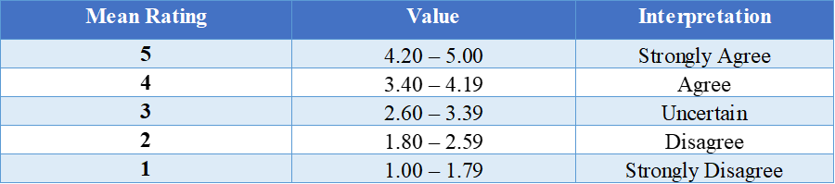
For the system evaluation, the study used a Five-Point Likert Scale to determine the extent to which the developed system complied with the ISO/IEC 25010 software quality standard. The quality characteristics evaluated included functional suitability, performance efficiency, compatibility, usability, reliability, security, maintainability, and portability. The Likert Scale was appropriate because it allowed the evaluators to express their level of agreement with each statement regarding the quality and performance of the developed system.
To analyze the responses from the system evaluation, the researchers used the Average Weighted Mean. This statistical method was appropriate because it provided the overall average rating for each evaluation criterion and helped determine the level of compliance of the developed system based on the selected ISO/IEC 25010 software quality characteristics.
The selected IT experts evaluated the system using the following response options: Strongly Agree, Agree, Uncertain, Disagree, and Strongly Disagree.
The formula for calculating the Average Weighted Mean is presented below:

Where:
W = Weighted average
n = Number of terms to be averaged
Wᵢ = Weights applied to the corresponding values
Xᵢ = Data values to be averaged
Ethical Consideration
The researchers observed ethical research principles to ensure the privacy, security, and proper treatment of all respondents involved in the study. The respondents of the study consisted of the administrator, technicians, customers, and selected IT experts who provided information and feedback relevant to the development and evaluation of the Customer Relationship Management System for MJJD TELECOM.
The researchers secured a formal permission letter from the management of MJJD TELECOM requesting approval to conduct the survey and gather the necessary data from the identified respondents. The researchers also prepared and distributed informed consent forms to the respondents before the administration of the survey questionnaires. These consent forms clearly explained the purpose of the study, the nature of participation, the procedures involved, and the intended use of the collected data.
Participation in the study was voluntary, and the respondents were informed that they had the right to refuse participation or withdraw from the study at any time without penalty or disadvantage. They were also given sufficient time and freedom to answer the questionnaires honestly and without coercion. The researchers ensured that the information gathered from the respondents was used strictly for academic and research purposes.
To protect the privacy of the respondents, the researchers minimized the collection of personal and sensitive information. Only the data necessary for the conduct of the study were gathered. Any information provided by the respondents was treated with confidentiality and stored securely. The collected data were protected from unauthorized access and were used solely for the analysis, development, and evaluation of the system.
The researchers also observed honesty, transparency, and academic integrity throughout the conduct of the study. All sources of information, including published articles, books, unpublished theses, institutional references, and online materials, were properly cited and credited to acknowledge the original authors of the materials used in the study.
In addition, the researchers observed the proper and responsible use of artificial intelligence (AI) in the preparation of the study. AI tools served only as supplementary aids for improving grammar, organizing ideas, refining sentence construction, and assisting in the presentation of research content. The researchers ensured that AI was not used to fabricate data, generate false references, or replace the researchers’ own analysis, interpretation, and decision-making. All gathered data, computations, interpretations, conclusions, and final research content remained the responsibility of the researchers.
Through these ethical considerations, the researchers upheld the integrity of the study and ensured that the rights, privacy, and welfare of the respondents were properly protected.

CHAPTER III
RESULTS AND DISCUSSION
This chapter presents the findings obtained from the collected data and provides their corresponding analysis and interpretation in relation to the objectives of the study. It discusses the key results and explains their significance in providing a better understanding of the research findings.
Present Methods Used
Based on the data gathered, the researchers identified the current methods used by MJJD TELECOM in conducting its daily operations, as presented in Table 2. The findings revealed that the use of messaging apps or online platforms was the most commonly selected method, with 43 out of 64 respondents (67.2%), ranking first. This was followed by the use of paper-based forms and physical documents, selected by 39 respondents (60.9%), ranking second. Meanwhile, face-to-face or verbal coordination with customers and staff and phone calls or text messages for follow-ups and updates were each selected by 32 respondents (50.0%), resulting in a tied rank of 3.5. These findings indicate that MJJD TELECOM relied on a combination of digital and manual methods in carrying out its daily operations.
The findings are related to studies concerning customer relationship management and digital interaction in the telecommunications sector. Magatef et al. (2023) found that electronic customer relationship management strategies influence customer relationship quality and customer loyalty, emphasizing the importance of structured digital interactions between service providers and customers. Similarly, Gazi et al. (2024) found that CRM performance is associated with customer satisfaction, profitability, and loyalty in the telecommunications industry. These findings support the importance of organized digital approaches in managing customer interactions and information.
The findings imply that although MJJD TELECOM already utilized digital communication methods, its operations still depended on several separate methods, including paper-based documents, verbal coordination, and phone or text communication. The use of multiple channels may have contributed to the operational problems identified in Table 3, particularly delays in customer responses, application processing, and service tracking.
Table 2
Present Methods Used

Problems Encountered
Building on the methods identified in Table 2, the researchers identified the problems encountered in the current methods used by MJJD TELECOM, as presented in Table 3. The findings showed that delays in responding to customer concerns were the most frequently selected problem, reported by 44 respondents (68.8%), ranking first. This was followed by delays in processing customer applications, identified by 35 respondents (54.7%), ranking second. Furthermore, difficulty monitoring installation schedules and status updates and lack of centralized communication and service tracking were each selected by 32 respondents (50.0%), resulting in a tied rank of 3.5.
The results are supported by related studies concerning responsiveness and organized service management. Saflor et al. (2024), in their study involving internet service provider users in Occidental Mindoro, found that responsiveness was among the factors that directly influenced service quality. Yu et al. (2023) examined field technician scheduling through technician-task matching and task sequencing, demonstrating the importance of structured scheduling in managing field service activities. In addition, Zangari et al. (2023) explained that support tickets can be categorized, routed to appropriate personnel, and resolved systematically, highlighting the value of organized processes for handling customer requests.
The findings suggest that the problems identified in Table 3 may be associated with the multiple communication and manual methods identified in Table 2. These results highlight the need for more organized customer communication, application processing, and service tracking, which served as the basis for identifying the functional requirements presented in Table 4.
Table 3
Problems Encountered

Functional Requirements
Based on the problems identified in Table 3, the researchers identified the functional requirements needed for the development of the Customer Relationship Management System for MJJD TELECOM, as presented in Table 4. The findings showed that live chat or direct customer support ranked first, with 39 respondents (60.9%). This was followed by online application submission, selected by 37 respondents (57.8%), ranking second. Public tracking of applications and concerns ranked third, with 30 respondents (46.9%). These findings indicate that respondents primarily prioritized functions that could address customer communication, application processing, and service tracking.
The identified functional requirements are related to existing research concerning digital customer interaction and customer-support management. Magatef et al. (2023) emphasized the role of electronic CRM in facilitating structured digital interactions between telecommunications service providers and customers. Meanwhile, Zangari et al. (2023) discussed how support-ticket systems allow customer requests to be categorized, routed, and processed systematically. These findings support the inclusion of functions that organize customer communication and service concerns.
The findings suggest that the proposed system should provide functions that directly respond to the problems identified in Table 3. Live chat can address delays in customer communication, online application submission can provide an alternative to paper-based processing, and public tracking can help address difficulties in monitoring applications and concerns. These functional requirements provided the basis for identifying the specific system features presented in Table 5.

Table 4
Functionality Requirements

Features of the System
Building on the functional requirements in Table 4, the researchers identified the system features that can be incorporated into the Customer Relationship Management System for MJJD TELECOM, as presented in Table 5. The findings revealed that real-time status tracking for applications and concerns received the highest number of responses, with 39 respondents (60.9%), ranking first. This was followed by live chat AI assistance for customer inquiries when no staff is active, selected by 37 respondents (57.8%), ranking second. Meanwhile, uploading of valid identification documents, application approval or rejection with stated reasons, and a dashboard for technician assignment and task scheduling each received 28 responses (43.8%), resulting in a tied rank of 4.
The findings are related to several studies concerning customer-support management and field service operations. Zangari et al. (2023) highlighted the importance of structured support-ticket processing for handling and routing customer requests effectively. Yu et al. (2023) examined structured approaches for matching technicians to tasks and sequencing field service activities, which is relevant to technician assignment and scheduling. Magatef et al. (2023) also demonstrated the importance of electronic customer relationship management in facilitating digital interactions between customers and telecommunications service providers.
The findings imply that the proposed system features were aligned with the functional requirements identified in Table 4 and the problems identified in Table 3. Real-time status tracking can support public tracking, while live chat AI assistance can support direct customer communication. Uploading valid identification documents and application approval or rejection can support online application processing, while the technician dashboard can assist in monitoring installation schedules. By integrating these features, the proposed system can provide MJJD TELECOM with a more centralized approach to managing customer and service-related operations.
Table 5
Features of the System

The extent of the Compliance of the Proposed System to ISO 25010 Software Quality Standard
The ISO/IEC 25010 software quality standard provides a framework for evaluating the quality of software systems based on established quality characteristics and sub-characteristics (International Organization for Standardization [ISO], 2023). It serves as a guide in determining whether a software system satisfies its intended requirements and performs effectively within its operational environment.
The proposed Customer Relationship Management System for MJJD Telecom was evaluated using ISO 25010-based criteria focusing on Functional Suitability, Performance Efficiency, Compatibility, Usability, Reliability, Security, Maintainability, and Portability. The evaluation was conducted to determine the extent to which the system meets its functional and quality requirements based on the assessment of the evaluators.
Functional Suitability
Functional Suitability refers to the extent to which a software system provides functions that meet stated and implied user requirements. It includes functional completeness, correctness, and appropriateness in accomplishing intended tasks and objectives (ISO/IEC 25010, 2023; Vacca et al., 2024). In the Customer Relationship Management System for MJJD Telecom, functional suitability refers to the system's ability to manage customer applications and records, support installation scheduling and technician assignment, track application and service status, and facilitate customer communication through chat or ticketing.
The evaluation revealed that the system obtained an average weighted mean of 4.4, interpreted as “Strongly Agree.” The highest-rated indicators were the provision of necessary features for managing customer applications and records and the provision of features for tracking application and service status, both with a weighted mean of 4.5 and a tied rank of 1.5. These were followed by installation scheduling and technician assignment and customer communication through chat or ticketing, both with a weighted mean of 4.3 and a tied rank of 3.5. The management of customer records and applications by administrators received a weighted mean of 4.2, ranking fifth. Overall, the findings indicate that the evaluators strongly agreed that the system provides the necessary and appropriate functions to support the customer relationship and service-management operations of MJJD Telecom.
Table 6
Functional Suitability of Customer Relationship Management for MJJD Telecom
Functional Suitability | 5 | 4 | 3 | 2 | 1 | WM | DE | Rank
The system provides the necessary features for managing customer applications and records. | 3  (15) | 3  (12) | 0 | 0 | 0 | 4.5 | SA | 1.5
The system allows administrators to manage customer records and applications properly. | 1  (5) | 5  (20) | 0 | 0 | 0 | 4.2 | SA | 5
The system supports installation scheduling and technician assignment effectively. | 2  (10) | 4  (16) | 0 | 0 | 0 | 4.3 | SA | 3.5
The system provides features for tracking application and service status | 3  (15) | 3  (12) | 0 | 0 | 0 | 4.5 | SA | 1.5
The system supports customer communication through chat or ticketing. | 2  (10) | 4  (16) | 0 | 0 | 0 | 4.3 | SA | 3.5
Average Weighted Mean |  |  |  |  |  | 4.4 | SA
Legend: SA-Strongly Agree; A- Agree; U- Uncertain; D- Disagree; SD- Strongly Disagree
Performance Efficiency
Performance Efficiency concerns how well a software system delivers its functions in relation to response time, processing behavior, and the resources used under specified conditions (ISO/IEC 25010, 2023). For the Customer Relationship Management System for MJJD Telecom, this characteristic covers page and data loading, transaction processing, handling of user requests, response speed, and the ability to maintain acceptable performance during regular use.
The evaluation revealed that the system obtained an average weighted mean of 4.3, interpreted as “Strongly Agree.” The highest-rated indicator was the system’s ability to handle user requests efficiently during normal usage, which obtained a weighted mean of 4.5 and ranked first. This was followed by the system’s ability to respond quickly when processing requests and maintain acceptable performance during regular use, both with a weighted mean of 4.3 and a tied rank of 2.5. Meanwhile, page and data loading and smooth transaction processing both obtained a weighted mean of 4.2, with a tied rank of 4.5. Overall, the findings indicate that the evaluators strongly agreed that the system demonstrates efficient performance and acceptable response times during regular operations.

Table 7
Performance Efficiency of Customer Relationship Management for MJJD Telecom

Performance Efficiency | 5 | 4 | 3 | 2 | 1 | WM | DE | Rank
The system loads pages and data within an acceptable amount of time. | 2  (10) | 3  (12) | 1  (3) | 0 | 0 | 4.2 | SA | 4.5
The system performs transactions smoothly without unnecessary delay. | 2  (10) | 3  (12) | 1  (3) | 0 | 0 | 4.2 | SA | 4.5
The system handles user requests efficiently during normal usage. | 4  (20) | 1  (4) | 1  (3) | 0 | 0 | 4.5 | SA | 1
The system responds quickly when processing requests. | 2  (10) | 4  (16) | 0 | 0 | 0 | 4.3 | SA | 2.5
The system maintains acceptable performance during regular use | 2  (10) | 4  (16) | 0 | 0 | 0 | 4.3 | SA | 2.5
Average Weighted Mean |  |  |  |  |  | 4.3 | SA
Legend: SA-Strongly Agree; A- Agree; U- Uncertain; D- Disagree; SD- Strongly Disagree
Compatibility
Compatibility evaluates whether a software system can function properly across different devices, platforms, and operating environments while maintaining consistent performance (ISO/IEC 25010, 2023). For the Customer Relationship Management System for MJJD Telecom, this includes operation on different devices and browsers, support for both web-based and mobile-based access, and adaptability to various screen sizes and device specifications.
The evaluation revealed that the system obtained an average weighted mean of 4.6, interpreted as “Strongly Agree.” The highest-rated indicators were the system’s ability to work properly across different devices and its support for both web-based and mobile-based access, both of which obtained a weighted mean of 4.7 and a tied rank of 1.5. Meanwhile, the system’s ability to function properly on different browsers or operating environments, operate well within the current working environment of the organization, and adapt well to different screen sizes and device specifications each obtained a weighted mean of 4.5 and a tied rank of 4. Overall, the findings indicate that the evaluators strongly agreed that the system is highly compatible across different supported devices, platforms, and operating environments.
Table 8
Compatibility of Customer Relationship Management for MJJD Telecom
Compatibility | 5 | 4 | 3 | 2 | 1 | WM | DE | Rank
The system works properly across different devices. | 4  (20) | 2  (8) | 0 | 0 | 0 | 4.7 | SA | 1.5
The system functions properly on different browsers or operating environments. | 3  (15) | 3  (12) | 0 | 0 | 0 | 4.5 | SA | 4
The system operates well within the current working environment of the organization | 3  (15) | 3  (12) | 0 | 0 | 0 | 4.5 | SA | 4
The system supports both web-based and mobile-based access appropriately. | 4  (20) | 2  (8) | 0 | 0 | 0 | 4.7 | SA | 1.5
The system adapts well to different screen sizes and device specifications. | 4  (20) | 1  (4) | 1  (3) | 0 | 0 | 4.5 | SA | 4
Average Weighted Mean |  |  |  |  |  | 4.6 | SA
Legend: SA-Strongly Agree; A- Agree; U- Uncertain; D- Disagree; SD- Strongly Disagree
Usability
Usability focuses on how easily users can understand, learn, and operate a software system while accomplishing their intended tasks. Recent ISO 25010-based usability research highlights factors such as learnability, operability, interface aesthetics, accessibility, and user satisfaction (Mamani-Pari et al., 2026). In the Customer Relationship Management System for MJJD Telecom, usability is reflected in the ease of learning and using the system, clarity of the interface, user-friendliness of navigation tools, understandability of system processes, and overall user experience.
The evaluation revealed that the system obtained an average weighted mean of 4.2, interpreted as “Strongly Agree.” The highest-rated indicators were the clarity and understandability of the system’s layout and design and the provision of a convenient and satisfying user experience, both obtaining a weighted mean of 4.3 and a tied rank of 1.5. These were followed by the system’s ease of learning and use and the ease of following its instructions and processes, both with a weighted mean of 4.2 and a tied rank of 3.5. Meanwhile, the user-friendliness of the buttons, menus, and navigation tools obtained the lowest weighted mean of 4.0, interpreted as “Agree,” and ranked fifth. Overall, the findings indicate that the evaluators strongly agreed that the system provides a generally usable and satisfactory experience, although its navigation tools may still be further improved.
Table 9
Usability of Customer Relationship Management for MJJD Telecom
Usability | 5 | 4 | 3 | 2 | 1 | WM | DE | Rank
The system is easy to learn and use for intended users. | 3  (15) | 1  (4) | 2  (6) | 0 | 0 | 4.2 | SA | 3.5
The layout and design of the system are clear and understandable. | 3  (15) | 2  (8) | 1  (3) | 0 | 0 | 4.3 | SA | 1.5
The buttons, menus, and navigation tools are user-friendly. | 3  (15) | 0 | 3  (9) | 0 | 0 | 4.0 | A | 5
The instructions and system processes are easy to follow. | 3  (15) | 1  (4) | 2  (6) | 0 | 0 | 4.2 | SA | 3.5
The system provides a convenient and satisfying user experience. | 3  (15) | 2  (8) | 1  (3) | 0 | 0 | 4.3 | SA | 1.5
Average Weighted Mean |  |  |  |  |  | 4.2 | SA
Legend: SA-Strongly Agree; A- Agree; U- Uncertain; D- Disagree; SD- Strongly Disagree
Reliability
Reliability describes the capability of a software system to perform its intended functions consistently and remain available under specified conditions. It covers qualities such as stability, fault tolerance, availability, accurate processing, and recovery from interruptions (ISO/IEC 25010, 2023). In the Customer Relationship Management System for MJJD Telecom, reliability is reflected in consistent system operation, accurate recording of transactions and user data, minimal errors, continued accessibility, and the ability to recover after minor interruptions.
The evaluation revealed that the system obtained an average weighted mean of 4.2, interpreted as “Strongly Agree.” The highest-rated indicator was the system’s ability to record transactions and user data accurately, which obtained a weighted mean of 4.5 and ranked first. This was followed by consistent operation without crashing, with a weighted mean of 4.3 and a rank of 2, and continued accessibility and stability during use, with a weighted mean of 4.2 and a rank of 3. Meanwhile, the system’s ability to minimize errors and recover or continue properly after minor interruptions both obtained a weighted mean of 4.0, interpreted as “Agree,” and a tied rank of 4.5. Overall, the findings indicate that the evaluators strongly agreed that the system demonstrates reliable operation, particularly in accurately recording transactions and maintaining stable performance.
Table 10
Reliability of Customer Relationship Management for MJJD Telecom

Reliability | 5 | 4 | 3 | 2 | 1 | WM | DE | Rank
The system operates consistently without crashing during use. | 2  (10) | 4  (16) | 0 | 0 | 0 | 4.3 | SA | 2
The system records transactions and user data accurately. | 3  (15) | 3  (12) | 0 | 0 | 0 | 4.5 | SA | 1
The system minimizes errors during operation. | 2  (10) | 2  (8) | 2  (6) | 0 | 0 | 4.0 | A | 4.5
The system remains accessible and stable during use. | 2  (10) | 3  (12) | 1  (3) | 0 | 0 | 4.2 | SA | 3
The system can recover or continue properly after minor interruptions. | 2  (10) | 2  (8) | 2  (6) | 0 | 0 | 4.0 | A | 4.5
Average Weighted Mean |  |  |  |  |  | 4.2 | SA
Legend: SA-Strongly Agree; A- Agree; U- Uncertain; D- Disagree; SD- Strongly Disagree
Security
Security focuses on protecting software systems and their information from unauthorized access, disclosure, modification, or misuse. It includes aspects such as confidentiality, integrity, authenticity, and access control (ISO/IEC 25010, 2023). In the Customer Relationship Management System for MJJD Telecom, security covers the protection of personal information, secure login access, safeguarding uploaded documents, restriction of unauthorized users, and maintenance of data confidentiality.
The evaluation revealed that the system obtained an average weighted mean of 4.3, interpreted as “Strongly Agree.” The highest-rated indicator was the system’s ability to restrict unauthorized users from accessing protected modules, which obtained a weighted mean of 4.7 and ranked first. This was followed by the protection of users’ personal information and maintenance of data confidentiality, both with a weighted mean of 4.3 and a tied rank of 2.5. Meanwhile, the security of the login system and protection of uploaded documents both obtained a weighted mean of 4.2 and a tied rank of 4.5. Overall, the findings indicate that the evaluators strongly agreed that the system provides appropriate security measures for protecting sensitive information, maintaining confidentiality, and preventing unauthorized access.
Table 11
Security for Customer Relationship Management for MJJD Telecom

Security | 5 | 4 | 3 | 2 | 1 | WM | DE | Rank
The system protects the personal information of users. | 3  (15) | 2  (8) | 1  (3) | 0 | 0 | 4.3 | SA | 2.5
The login system feature ensure secures access. | 4  (20) | 0 | 1  (3) | 1  (2) | 0 | 4.2 | SA | 4.5
The system keeps uploaded documents secure. | 2  (10) | 3  (12) | 1  (3) | 0 | 0 | 4.2 | SA | 4.5
The system restricts unauthorized users from accessing protected modules. | 4  (20) | 2  (8) | 0 | 0 | 0 | 4.7 | SA | 1
The system maintains data confidentiality. | 3  (15) | 2  (8) | 1  (3) | 0 | 0 | 4.3 | SA | 2.5
Average Weighted Mean |  |  |  |  |  | 4.3 | SA
Legend: SA-Strongly Agree; A- Agree; U- Uncertain; D- Disagree; SD- Strongly Disagree
Maintainability
Maintainability examines how easily a software system can be modified, corrected, tested, or enhanced without negatively affecting its existing functions. It covers aspects such as modularity, analyzability, modifiability, and testability (ISO/IEC 25010, 2023). In the Customer Relationship Management System for MJJD Telecom, maintainability is reflected in the organization of system modules, ease of identifying and correcting issues, support for system updates, testability, and the ability to accommodate future improvements and scaling.
The evaluation revealed that the system obtained an average weighted mean of 4.1, interpreted as “Agree.” The highest-rated indicator was the organization of the system structure and modules for easy maintenance, which obtained a weighted mean of 4.3 and ranked first. This was followed by the ease of identifying and correcting system errors or issues and the system design’s support for future enhancement and scaling, both with a weighted mean of 4.2 and a tied rank of 2.5. Meanwhile, the ability to improve or update the system without affecting major functions and the ease of testing the system when adding or modifying features both obtained a weighted mean of 4.0, interpreted as “Agree,” and a tied rank of 4.5. Overall, the findings indicate that the evaluators agreed that the system is generally maintainable and capable of supporting future improvements, although further refinement may help make updates and testing more efficient.
Table 12
Maintainability for Customer Relationship Management for MJJD Telecom

Maintainability | 5 | 4 | 3 | 2 | 1 | WM | DE | Rank
The system structure and modules are organized for easy maintenance. | 3  (15) | 2  (8) | 1  (3) | 0 | 0 | 4.3 | SA | 1
Errors or issues in the system can be easily identified and corrected. | 2  (10) | 3  (12) | 1  (3) | 0 | 0 | 4.2 | SA | 2.5
The system can be improved or updated without affecting major functions. | 0 | 6  (24) | 0 | 0 | 0 | 4.0 | A | 4.5
The system is easy to test when adding or modifying features. | 3  (15) | 0 | 3  (9) | 0 | 0 | 4.0 | A | 4.5
The design of the system supports future enhancement and scaling. | 2  (10) | 3  (12) | 1  (3) | 0 | 0 | 4.2 | SA | 2.5
Average Weighted Mean |  |  |  |  |  | 4.1 | A
Legend: SA-Strongly Agree; A- Agree; U- Uncertain; D- Disagree; SD- Strongly Disagree
Portability
Portability considers how well a software system can be transferred, deployed, or operated across different devices, hardware setups, platforms, and operating environments with minimal difficulty. In the Customer Relationship Management System for MJJD Telecom, portability is reflected in the system’s accessibility across different devices, ability to function on mobile and desktop platforms, transferability to different environments, compatibility with different hardware setups, and adaptability to future technological changes.
The evaluation revealed that the system obtained an average weighted mean of 4.3, interpreted as “Strongly Agree.” The highest-rated indicator was the system’s ability to be transferred or deployed into different environments when needed, which obtained a weighted mean of 4.5 and ranked first. Meanwhile, accessibility across different devices, proper operation across different hardware setups, functionality on mobile and desktop platforms, and adaptability to future platform or technology changes each obtained a weighted mean of 4.3 and a tied rank of 3.5. Overall, the findings indicate that the evaluators strongly agreed that the system demonstrates good portability and can operate effectively across different supported devices and environments while remaining adaptable to future technological changes.

Table 13
Portability for Customer Relationship Management for MJJD Telecom

Portability | 5 | 4 | 3 | 2 | 1 | WM | DE | Rank
The system can be accessed on different devices with minimal issues. | 2  (10) | 4  (16) | 0 | 0 | 0 | 4.3 | SA | 3.5
The system can be transferred or deployed into different environments if needed. | 3  (15) | 3  (12) | 0 | 0 | 0 | 4.5 | SA | 1
The system performs properly across different hardware setups. | 3  (15) | 2  (8) | 1  (3) | 0 | 0 | 4.3 | SA | 3.5
The system remains functional when accessed on mobile and desktop platforms. | 3  (15) | 2  (8) | 1  (3) | 0 | 0 | 4.3 | SA | 3.5
The system can adapt to future platform or technology changes. | 3  (15) | 2  (8) | 1  (3) | 0 | 0 | 4.3 | SA | 3.5
Average Weighted Mean |  |  |  |  |  | 4.3 | SA
Legend: SA-Strongly Agree; A- Agree; U- Uncertain; D- Disagree; SD- Strongly Disagree
System Evaluation According to ISO 25010 Software Quality Standards
Table 14 summarizes the results of the system evaluation using the ISO 25010 Software Quality Standards in assessing the Customer Relationship Management System for MJJD Telecom. Across all characteristics, the system recorded an overall average weighted mean of 4.3, interpreted as “Strongly Agree.” This shows that the evaluators agreed that the system meets the ISO 25010 standards in terms of Functional Suitability, Performance Efficiency, Compatibility, Usability, Reliability, Security, Maintainability, and Portability, indicating that the system operates efficiently, reliably, and meets the expected quality standards.
Table 14
ISO 25010 Software Quality Standards
ISO 25010 Software Quality Standards | Percentage  (%) | Description | Rank
- Functional Suitability | 4.4 | SA | 2
- Performance Efficiency | 4.3 | A | 4
- Compatibility | 4.6 | SA | 1
- Usability | 4.2 | A | 6.5
- Reliability | 4.2 | A | 6.5
- Security | 4.3 | SA | 4
- Maintainability | 4.1 | A | 8
- Portability | 4.3 | SA | 4
Average Weighted Percentage | 4.3 | SA
Legend:SA-strongly agree; A-agree; U-uncertain; DA-disagree; SD-strongly disagree.
Customer Relationship Management System for MJJD Telecom
The Customer Relationship Management System for MJJD Telecom is a centralized web-based platform developed to improve the management of customer information, service applications, installation requests, and communication processes. The system addresses the limitations of manual and fragmented customer handling by providing an organized digital solution for recording, monitoring and updating.
Through the system, customers are able to submit applications, monitor service status, communicate through chat or ticketing, and access relevant service information, while administrators can manage customer records, process applications, schedule installations, assign technicians, and monitor ongoing service requests. The system also helps ensure that customer data and uploaded documents are properly managed, accessible to authorized users only, and protected from unauthorized access.
The system improves the overall workflow of MJJD Telecom by reducing manual processing, improving communication between customers and staff, and providing better monitoring of applications and service activities. It also supports more efficient customer relationship management by maintaining organized and reliable records that can assist the company in delivering faster, more consistent, and more responsive services.
Technical Design
The Customer Relationship Management System for MJJD TELECOM was designed as a centralized web-based platform intended to organize and streamline the company’s customer and service-related operations. The system provides administrators, technicians, and customers with access to appropriate system functions through desktop and mobile web browsers. It supports customer application processing, customer record management, technician assignment, installation scheduling and monitoring, ticket management, live customer support, notifications, and application and ticket tracking. Through a centralized database and role-based access, the system provides a more organized approach to managing customer information, operational activities, and communication within MJJD TELECOM.
System Design
The Customer Relationship Management System for MJJD TELECOM was developed using modules that represent the primary functions performed by the different users of the system.
The Customer Interface Module allows customers to register and log in, submit service applications, provide applicant information, select an internet service plan, upload a valid identification document, specify the installation address, and pin the service location on a map. Customers can also monitor their application and installation progress, submit support tickets, communicate through live chat, view notifications, and monitor service concerns.
The Administrator Interface Module provides the administrator with centralized control over customer applications, customer records, installation activities, technician accounts, support tickets, and customer conversations. Administrators can review submitted applications, approve or reject requests, assign technicians, schedule installations, monitor installation progress, manage customer and technician records, assign support tickets, and oversee live chat conversations.
The Technician Interface Module enables technicians to view assigned installation jobs and support tickets. Technicians can access installation work orders, view customer and service-location information, update installation progress, complete assigned tasks, review assigned support concerns, and communicate with customers through routed live chat conversations.
The system also contains a Public Tracking and Notification Module, which allows users to track submitted applications and support tickets using reference information without requiring login. Notifications and email updates are also provided to inform users about important events such as application approval, rejection, installation updates, and ticket resolution. These functionalities are reflected in the developed system screens and documented workflows.
Table 15
System Design

System Development Methodology
Agile Software Development Methodology
The development of the Customer Relationship Management System for MJJD TELECOM followed the Agile Software Development Methodology. Agile emphasizes iterative development, allowing software functionalities to be planned, developed, reviewed, and improved through repeated development cycles. Pasuksmit, Thongtanunam, and Karunasekera (2022) explained that Agile teams plan, develop, and deliver software increments through time-boxed iterations, allowing changes and refinements to be addressed throughout development.
For the proposed system, Agile enabled the developers to progressively develop and refine customer application processing, technician assignment, installation monitoring, ticketing, live chat, notifications, and status-tracking functions. The development activities consisted of Requirement Analysis, Design, Implementation, Testing, Deployment, and Operation and Maintenance, which were performed iteratively as system requirements and feedback were addressed.
Requirement Analysis
Requirement Analysis involved identifying and documenting the needs of MJJD TELECOM and its intended system users. Franch et al. (2023) described requirements specification as a core activity of requirements engineering because it documents the requirements established during the early stages of software development and supports communication among project stakeholders.
During this phase, the developers gathered information regarding the current methods, problems encountered, functional requirements, and desired system features. The gathered requirements served as the basis for identifying functions such as online applications, customer record management, installation scheduling, ticketing, live chat, and status tracking.

Design
The Design phase transformed the identified requirements into the planned structure of the system. The SWEBOK Guide Version 4.0, published by the IEEE Computer Society in 2024, recognizes software design and software architecture as established areas of software engineering concerned with defining the structure and organization needed to implement software systems.
During this phase, the developers prepared the database structure, system workflows, interface layouts, user roles, and relationships among the different modules. The system was designed around three main users—Administrator, Technician, and Customer—with appropriate interfaces and functions provided for each role.
Implementation
The Implementation phase involved translating the approved system design into functional software components. The IEEE Computer Society's SWEBOK Guide Version 4.0 (2024) includes software construction as a major software engineering knowledge area covering the creation and integration of software through programming and related development activities.
During this phase, the developers implemented the front-end, back-end, and database components of the CRM system. Major modules included customer applications, administrator and technician dashboards, installation management, ticketing, live chat, notifications, and public tracking. Authentication and role-based access were also implemented to control access to system functions.

Testing
The Testing phase evaluated whether the developed system performed according to its intended requirements. ISO/IEC/IEEE 29119-2:2021 defines internationally recognized software-testing processes that can be applied to different software-development lifecycle models for managing and implementing software testing.
During this phase, the developers tested functions such as registration and login, application submission, application approval and rejection, technician assignment, installation updates, ticket management, live chat, notifications, and public tracking. Identified defects and workflow issues were corrected before the system proceeded to deployment.
Deployment
The Deployment phase involved preparing the completed system for operational use. The SWEBOK Guide Version 4.0 (2024) includes Software Engineering Operations as a recognized knowledge area concerned with activities required to operate and support software in its intended environment. NIST's Secure Software Development Framework also emphasizes secure software release practices as part of the software development lifecycle.
For the CRM system, this phase involved configuring the web application, database connection, hosting environment, and system accessibility. Final checks were conducted to ensure that administrators, technicians, and customers could access the system and perform their intended functions properly.

Operation and Maintenance
The Operation and Maintenance phase focuses on keeping the system functional and improving it after deployment. Ancán Bastías, Díaz, and López Fenner (2023) emphasized that software maintenance remains an important part of the software lifecycle and includes activities intended to sustain and improve software after its release.
For the proposed system, maintenance includes correcting reported errors, improving performance, updating system components, addressing security concerns, and refining functionality based on user feedback. These activities help ensure that the CRM system continues to support the operational requirements of MJJD TELECOM.
Figure 2
Agile Methodology
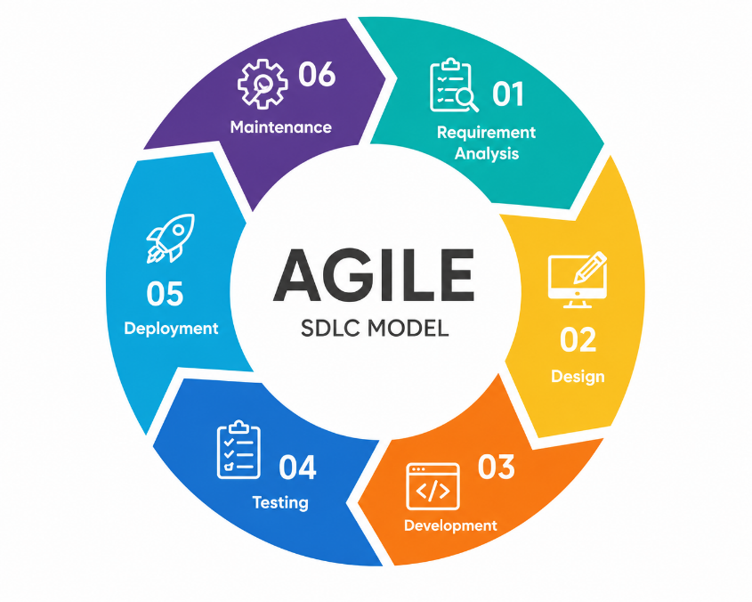

Use Case Diagram
The use case diagram for the Customer Relationship Management System for MJJD TELECOM illustrates the interactions between the system actors and the functions available to them. According to Malik et al. (2023), use case diagrams are useful in representing functional requirements by identifying actors, use cases, and their relationships.
The system identifies three primary actors: Customer, Administrator, and Technician. Customers can register, submit service applications, upload requirements, track application and ticket status, submit support concerns, and use live chat. Administrators can manage applications, customer records, technicians, installation schedules, support tickets, and customer conversations. Technicians can view assigned installations and tickets, update work progress, and respond to customer concerns.
Through these interactions, the use case diagram clearly presents the responsibilities of each user and how the system supports customer application management, installation coordination, ticket handling, and customer support.

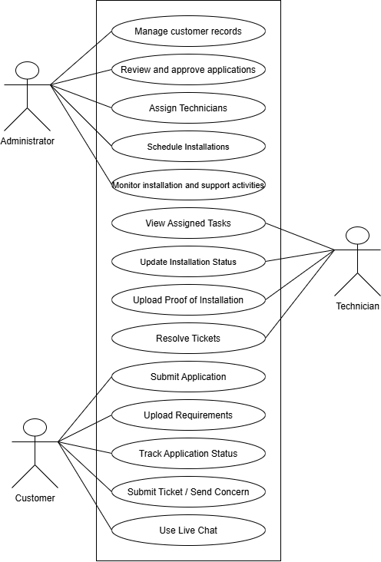
Figure 3
Use Case Diagram
Physical Design
Software Requirements
Software requirements identify the programs, platforms, and software environment needed for a system to perform its intended functions. Proper specification of software requirements helps developers and stakeholders clearly identify the technologies and system conditions necessary for implementation and operation. Franch et al. (2023) explained that requirements specification documents the requirements established during the early stages of software development and provides important information used by developers and other stakeholders throughout the project lifecycle.
For the Customer Relationship Management System for MJJD TELECOM, the proponents identified the software components needed to support system development, local testing, database management, and user access. The system was developed as a web-based application and can be accessed through commonly used browsers on desktop and mobile devices. Table 16 presents the minimum software requirements identified for the system.
Table 16
Minimum Software Requirements for Customer Relationship Management System for MJJD TELECOM

Minimum Software Requirements
Operating System | Windows 10 or later / Android / iOS
Database | XAMPP Control Panel
Browser | Chrome, Firefox, Edge, Safari, Brave

Hardware Requirements
Hardware requirements refer to the physical devices and computing resources necessary for the proper operation and access of a software system. These include the processor, memory, storage space, supported devices, and network connectivity required to provide acceptable system responsiveness and usability. In the proposed system, the hardware requirements were identified based on the minimum resources required for administrators, technicians, and customers to access and use the web-based platform.
The system may be accessed through laptops, desktop computers, and smartphones provided that the device has sufficient processing capability, memory, storage, and internet connectivity. The minimum hardware requirements established in the project documentation are presented in Table 17.
Table 17
Minimum Hardware Requirements for Customer Relationship Management System for MJJD TELECOM

Minimum Hardware Requirements
Processor | Dual-core 1.6 GHz or higher
Random Access Memory (RAM) | 4 GB RAM or higher
Storage | 500 MB free space
Connection | Internet / Ethernet / Data

CHAPTER IV
SUMMARY, CONCLUSION, AND RECOMMENDATIONS
This chapter presents the summary of findings, conclusions, and recommendations based on the development and evaluation of the Customer Relationship Management System for MJJD TELECOM. It discusses how the developed system addressed the limitations of the existing operational methods used in managing customer applications, installation activities, customer records, and service concerns. The system was designed to improve the organization, accessibility, monitoring, and communication of service-related processes through a centralized web-based platform. The evaluation results, conclusions, and recommendations are presented to determine the overall functionality, efficiency, usability, reliability, and effectiveness of the developed system in supporting the operations and customer relationship management processes of MJJD TELECOM.
Summary
This study focused on the development of a web-based Customer Relationship Management System for MJJD TELECOM. It aimed to determine the current methods used by the company in its daily operations, identify the challenges associated with these methods, determine the necessary functional requirements and system features, and evaluate the developed system based on the International Organization for Standardization and International Electrotechnical Commission 25010 software quality characteristics. The study addressed problems involving delays in responding to customer concerns, delays in processing customer applications, difficulty in monitoring installation schedules and status updates, and the lack of centralized communication and service tracking.
The study employed a quantitative descriptive-developmental research design and utilized the Agile Software Development Methodology in developing and refining the system. It was conducted at MJJD TELECOM, located at Dumlao Street, Dusoc, Bayambang, Pangasinan. The study involved 64 respondents consisting of 1 administrator, 3 technicians, and 60 customers, while 5 Information Technology experts participated in the system evaluation. Structured survey questionnaires were used to gather the necessary data. Frequency distribution and percentage were used to analyze the current methods, problems encountered, functional requirements, and system features, while the average weighted mean was used to evaluate the developed system.
The findings showed that messaging applications or online platforms ranked first among the current operational methods used by MJJD TELECOM, while delays in responding to customer concerns ranked first among the problems encountered. In terms of functional requirements, live chat or direct customer support ranked first, while real-time status tracking for applications and concerns ranked first among the preferred system features. Based on these findings, the developed system centralized customer applications, customer records, technician assignments, installation monitoring, ticketing, live chat, notifications, and public tracking. The system obtained an overall average weighted mean of 4.3, interpreted as Strongly Agree, indicating that the evaluators generally considered the developed system satisfactory based on the evaluated ISO 25010 software quality characteristics.
Conclusions
Based on the findings of the study, the researchers arrived at the following conclusions:
- MJJD TELECOM used both digital and manual methods in its daily operations. Messaging applications or online platforms ranked first, while paper-based documents, face-to-face coordination, phone calls, and text messages were also used.
- The existing operational methods created challenges in customer communication, application processing, and service monitoring. Delays in responding to customer concerns ranked first among the problems identified, showing the need for a more organized and centralized approach.
- The identified functional requirements emphasized communication, application processing, and tracking. Live chat or direct customer support ranked first, followed by online application submission and public tracking of applications and concerns.
- The identified system features addressed the operational needs of MJJD TELECOM. Real-time status tracking ranked first among the preferred features, while live chat AI assistance, document uploading, application processing, technician assignment, and scheduling supported a more centralized workflow.
- The developed Customer Relationship Management System satisfied the evaluated ISO 25010 software quality characteristics. It obtained an overall average weighted mean of 4.3, interpreted as Strongly Agree, indicating that the evaluators considered the system suitable for supporting the customer relationship and service management processes of MJJD TELECOM.

Recommendations
Based on the findings and conclusions of the study, the researchers recommend the following:
- MJJD TELECOM may utilize the developed Customer Relationship Management System as a centralized platform for managing customer applications, records, technician assignments, installation schedules, customer concerns, and service-related communication. This may help reduce dependence on separate messaging applications and paper-based records.
- The user interface and navigation may be further refined. Although Usability obtained an average weighted mean of 4.2, some navigation-related indicators received comparatively lower ratings. Improvements may focus on making buttons, menus, and navigation tools more intuitive and convenient.
- The reliability of the system should be continuously monitored and improved. Further attention may be given to error handling, system stability, and recovery after minor interruptions to support more dependable operation.
- The security features of the system should be regularly maintained and reviewed. Login security, access control, uploaded documents, customer information, and data confidentiality should continue to be protected against unauthorized access.
- Regular maintenance and testing should be prioritized. Maintainability obtained an average weighted mean of 4.1, interpreted as Agree, making it the lowest-rated ISO 25010 characteristic. Improvements may focus on system updates, testing, troubleshooting, and future enhancements.
- Administrators and technicians should be properly oriented on the use of the system. User guidance may help ensure that application processing, technician assignment, installation updates, ticket management, and customer communication are handled consistently.
- Future researchers and developers may expand the system based on future operational needs. Possible enhancements may include billing, online payment, load purchasing, external platform integration, or network-performance monitoring if these features become necessary and technically feasible.

References
Journals
Bandali, M., Riu, J. R., Lewitzki, A., Roy, D., & Gross, J. (2025).
ML-based fault management automation in large-scale fixed and mobile telecommunication networks. IEEE Transactions on Network and Service Management, 22(2), 1775–1787.

Gazi, M. A. I., Al Mamun, A., Al Masud, A., Senathirajah, A. R. bin S., & Rahman, T.
(2024). The relationship between CRM, knowledge management, organization c ommitment, customer profitability and customer loyalty in telecommunication industry: The mediating role of customer satisfaction and the moderating role of brand image. Journal of Open Innovation: Technology, Market, and Complexity, 10(1), Article 100227. https://doi.org/10.1016/j.joitmc.2024.100227

Liyanage, M., Pham, Q.-V., Dev, K., Bhattacharya, S., Maddikunta, P. K. R., Gadekallu,
T. R., & Yenduri, G. (2022). A survey on zero touch network and service management (ZSM) for 5G and beyond networks. Journal of Network and Computer Applications, 203, Article 103362. https://doi.org/10.1016/j.jnca.2022.103362

Magatef, S., Al-Okaily, M., Ashour, L., & Abuhussein, T. (2023).
The impact of electronic customer relationship management strategies on customer loyalty: A mediated model. Journal of Open Innovation: Technology, Market, and Complexity, 9(4), Article 100149. https://doi.org/10.1016/j.joitmc.2023.100149

Paulino, E. P., & Esteban, G. C. (2023).
Work from home connection: A cluster analysis based on the internet service attributes towards subscribers profile. Digital Transformation and Society, 2(1), 60–77. https://doi.org/10.1108/DTS-07-2022-0033

Prasetyo, Y. T., Belmonte, Z. J. A., Esberto, E. M., Cahigas, M. M. L., Nadlifatin, R., &
Gumasing, M. J. J. (2025). Cognitive perceptions and behavioral loyalty in telecommunication services: Integrating SERVQUAL and CSI in the Philippine context. Acta Psychologica, 259, Article 105298. https://doi.org/10.1016/j.actpsy.2025.105298

Saflor, C. S., Mariñas, K. A., Alvarado, P., Baleña, A., Tanglao, M. S., Prasetyo, Y. T.,
Tangsoc, J., & Bernardo, E. (2024). Towards sustainable internet service provision: Analyzing consumer preferences through a hybrid TOPSIS–SEM–Neural Network framework. Sustainability, 16(11), Article 4767. https://doi.org/10.3390/su16114767
Yu, V. F., Lin, Y.-S., Jodiawan, P., Lin, S.-W., & Lai, Y.-C. (2023).
The field technician scheduling problem with experience-dependent service times. Mathematics, 11(21), Article 4562. https://doi.org/10.3390/math11214562

Zangari, A., Marcuzzo, M., Schiavinato, M., Gasparetto, A., & Albarelli, A. (2023).
Ticket automation: An insight into current research with applications to multi-level classification scenarios. Expert Systems with Applications, 225, Article 119984. https://doi.org/10.1016/j.eswa.2023.119984

Internet Sources

Fenwick, S., & Lumb, S. (2023, July 20).
Philippines fixed broadband experience, July 2023. Opensignal. https://insights.opensignal.com/2023/07/20/philippines-fixed-broadband-experience-july-2023

Serafica, R. B., Francisco, K. A., & Oren, Q. C. A. (2023).
Making broadband universal: A review of Philippine policies and strategies (Discussion Paper Series No. 2023-31). Philippine Institute for Development Studies. https://doi.org/10.62986/dp2023.31

Nikolopoulou, K. (2022).
What is purposive sampling? Definition & examples. Scribbr. https://www.scribbr.com/methodology/purposive-sampling/

QuestionPro. (2023).
Total population sampling: Definition, examples, and advantages. QuestionPro. https://www.questionpro.com/blog/total-population-sampling/

Bastías, O. A., Díaz, J., & López Fenner, J. (2023). Exploring the intersection between software maintenance and machine learning—A systematic mapping study. Applied Sciences, 13(3), 1710. https://doi.org/10.3390/app13031710
Franch, X., Palomares, C., Quer, C., Chatzipetrou, P., & Gorschek, T. (2023). The state-of-practice in requirements specification: An extended interview study at 12 companies. Requirements Engineering, 28, 377–409. https://doi.org/10.1007/s00766-023-00399-7
International Organization for Standardization, International Electrotechnical Commission, & Institute of Electrical and Electronics Engineers. (2021). ISO/IEC/IEEE 29119-2:2021 software and systems engineering—Software testing—Part 2: Test processes. International Organization for Standardization.
Pasuksmit, J., Thongtanunam, P., & Karunasekera, S. (2022). Story points changes in agile iterative development: An empirical study and a prediction approach. Empirical Software Engineering, 27(6), Article 156. https://doi.org/10.1007/s10664-022-10192-9
Scarfone, K., Souppaya, M., & Dodson, D. (2022). Secure software development framework (SSDF) version 1.1: Recommendations for mitigating the risk of software vulnerabilities (NIST Special Publication 800-218). National Institute of Standards and Technology. https://doi.org/10.6028/NIST.SP.800-218
Washizaki, H. (Ed.). (2024). Guide to the software engineering body of knowledge (SWEBOK Guide), version 4.0. IEEE Computer Society.
International Organization for Standardization. (2023). Systems and software engineering—Systems and software Quality Requirements and Evaluation (SQuaRE)—Product quality model (ISO/IEC Standard No. 25010:2023). https://www.iso.org/standard/78176.html
Mamani-Pari, D., Peñaloza-Hualpa, A. F., Humpiri-Flores, M. E., Gutierrez-Quispe, E., & Otazu-Luque, J. E. (2026). Development and psychometric validation of a usability instrument based on ISO 25010 for electronic health record systems in Peruvian health care settings: Methodological study. JMIR Human Factors, 13, e81377. https://doi.org/10.2196/81377
Rahman, M. S., Shuhidan, S. M., Masrek, M. N., & Baharuddin, M. F. (2022). Validity and reliability testing of geographical information system (GIS) quality and user satisfaction towards individual work performance. Proceedings, 82(1), 68. https://doi.org/10.3390/proceedings2022082068
Suryadi, D. A., & Sulistiyani, E. (2022). Evaluation of information quality using ISO/IEC 25010:2011 (case research: Menu Harianku application). International Journal of Innovation in Enterprise System, 6(2), 143–156. https://doi.org/10.25124/ijies.v6i02.167
Vacca, A., Fredella, M., Di Sorbo, A., Visaggio, C. A., & Piattini, M. (2024). Functional suitability assessment of smart contracts: A survey and first proposal. Journal of Software: Evolution and Process, 36(7), e2636. https://doi.org/10.1002/smr.2636

APPENDICES
Appendix A:
Letter to the Executive Vice-President

ENGR. OSCAR B. GIRONELLA SR., D.Min.
Executive Vice-President
Philippine College of Science and Technology

Sir:
Greetings!

We are the 4th year students of the Philippine College of Science and Technology (PhilCST), and we are conducting a research study entitled “Customer Relationship Management System for MJJD Telecom”. The research study is a requirement in our course Capstone Project 2.

In this regard, may we humbly request permission to conduct this study. The objective of our research is to develop a Customer Relationship Management System for MJJD Telecom through a centralized web-based platform.

Your kind consideration on this matter will be much appreciated.

Thank you and God bless.

Yours truly,
Magallon, Rens V.
Mamugay, Jyxzl Izzy P.
Soriano, Efryel Jane S.
Tumanan, Arjay P.

Noted by:

MR. IAN JEFFERSON B. VARGAS, MPA, MIT
Research Adviser

MS. RACHELLE N. CAMACHO, MIT
Dean, College of Computer Studies

Approved by:

ENGR. OSCAR B. GIRONELLA SR., D.Min.
Executive Vice-President
Appendix B:
Letter to the Vice-President for Academic Affairs

ENGR. RAUL B. GIRONELLA SR., D.Min.
Vice-President for Academic Affairs
Philippine College of Science and Technology

Sir:
Greetings!

We are the 4th year students of the Philippine College of Science and Technology (PhilCST), and we are conducting a research study entitled “Customer Relationship Management System for MJJD Telecom”. The research study is a requirement in our course Capstone Project 2.

In this regard, may we humbly request permission from your good office for us to obtain the data and information necessary to complete our research study. The objective of our research is to develop a Customer Relationship Management System for MJJD Telecom through a centralized web-based platform.

Your kind consideration on this matter will be much appreciated.

Thank you and God bless.

Yours truly,
Magallon, Rens V.
Mamugay, Jyxzl Izzy P.
Soriano, Efryel Jane S.
Tumanan, Arjay P.

Noted by:

MR. IAN JEFFERSON B. VARGAS, MPA, MIT
Research Adviser

MS. RACHELLE N. CAMACHO, MIT
Dean, College of Computer Studies

Approved by:

ENGR. RAUL B. GIRONELLA SR., D.Min.
Vice-President for Academic Affairs
Appendix C:
Letter to the Vice-President for Administration

ENGR. OSCAR F. GIRONELLA JR., PEE
Vice-President for Administration
Philippine College of Science and Technology

Sir:
Greetings!

We are the 4th year students of the Philippine College of Science and Technology (PhilCST), and we are conducting a research study entitled “Customer Relationship Management System for MJJD Telecom”. The research study is a requirement in our course Capstone Project 2.

In this regard, may we humbly request permission to conduct this study. The objective of our research is to develop a Customer Relationship Management System for MJJD Telecom through a centralized web-based platform.

Your kind consideration on this matter will be much appreciated.

Thank you and God bless.

Yours truly,
Magallon, Rens V.
Mamugay, Jyxzl Izzy P.
Soriano, Efryel Jane S.
Tumanan, Arjay P.

Noted by:

MR. IAN JEFFERSON B. VARGAS, MPA, MIT
Research Adviser

MS. RACHELLE N. CAMACHO, MIT
Dean, College of Computer Studies

Approved by:

ENGR. OSCAR F. GIRONELLA JR., PEE
Vice-President for Administration
Appendix D:
Letter to the OIC Research Director

DR. MA. DITAS A. FERNANDEZ
OIC Research Director
Philippine College of Science and Technology

Ma’am:
Greetings!

We are the 4th year students of the Philippine College of Science and Technology (PhilCST), and we are conducting a research study entitled “Customer Relationship Management System for MJJD Telecom”. The research study is a requirement in our course Capstone Project 2.

In this regard, may we humbly request permission to conduct this study. The objective of our research is to develop a Customer Relationship Management System for MJJD Telecom through a centralized web-based platform.

Your kind consideration on this matter will be much appreciated.

Thank you and God bless.

Yours truly,
Magallon, Rens V.
Mamugay, Jyxzl Izzy P.
Soriano, Efryel Jane S.
Tumanan, Arjay P.

Noted by:

MR. IAN JEFFERSON B. VARGAS, MPA, MIT
Research Adviser

MS. RACHELLE N. CAMACHO, MIT
Dean, College of Computer Studies

Approved by:

DR. MA. DITAS A. FERNANDEZ
OIC Research Director
Appendix E:
Letter to the Dean

MS. RACHELLE N. CAMACHO, MIT
Dean, College of Computer Studies
Philippine College of Science and Technology

Ma’am:
Greetings!

We are the 4th year students of the Philippine College of Science and Technology (PhilCST), and we are conducting a research study entitled “Customer Relationship Management System for MJJD Telecom”. The research study is a requirement in our course Capstone Project 2.

In this regard, may we humbly request permission to conduct this study. The objective of our research is to develop a Customer Relationship Management System for MJJD Telecom through a centralized web-based platform.

Your kind consideration on this matter will be much appreciated.

Thank you and God bless.

Yours truly,
Magallon, Rens V.
Mamugay, Jyxzl Izzy P.
Soriano, Efryel Jane S.
Tumanan, Arjay P.

Noted by:

MR. IAN JEFFERSON B. VARGAS, MPA, MIT
Research Adviser

Approved by:

MS. RACHELLE N. CAMACHO, MIT
Dean, College of Computer Studies
Appendix F:
Letter to the Client

Appendix G:
Invitation and Acceptance

Dear Ma’am/Sir:
The group members of the thesis/project feasibility study/capstone project study entitled “Customer Relationship Management System for MJJD Telecom” have requested through the undersigned that you serve as their adviser. Relative to this request, the undersigned takes the pleasure of inviting you to do so. With your qualifications, expertise, and experience, there is no doubt that the researchers will benefit from your guidance for the completion of their research study for AY 2025–2026.
Your acceptance is duly anticipated and very much appreciated.
Thank you and more power.
Sincerely,

MS. RACHELLE N. CAMACHO, MIT
Research Instructor

ACCEPTANCE SLIP
To the Research Instructor/Research Coordinator,
Thank you for the invitation.
I am willing to accept the duties and responsibilities of an adviser for the thesis/project feasibility study/capstone project study entitled “Customer Relationship Management System for MJJD Telecom.”

MR. IAN JEFFERSON B. VARGAS, MPA, MIT _______________
Research Adviser Date
Appendix H:
Certificate of Acceptance

CERTIFICATE OF ACCEPTANCE

This is to certify that the system entitled “Customer Relationship Management System for MJJD Telecom” by the group of Magallon et al. has been reviewed and accepted by the undersigned.
This certificate further attests that the said system is accepted and will be considered for future implementation or reference purposes in the business.

Given this ____ day of ______________ 2026.

MR. JEPSY DAVE P. MAMUGAY
Owner, MJJD TELECOM
Appendix I:
Survey Questionnaire for Respondents

Name (Optional): _______________________________ Date: __________________
Gender: ( ) Male ( ) Female Age: __________
Instructions: Listed below are the items. Please put a check mark (✓) beside the item(s) that correspond to your answer.
1. What are the usual methods used by MJJD TELECOM in handling customer applications, installation scheduling, and customer concerns?
(Select up to three (3) options.)
☐ Use of paper-based forms and physical documents
☐ Use of spreadsheet files for storing records
☐ Use of messaging apps or online platforms
☐ Face-to-face or verbal coordination with customers and staff
☐ Phone calls or text messages for follow-ups and updates
☐ Other (please specify): _______________________________
2. What challenges are commonly experienced in the current process of handling customer applications, installation scheduling, and customer concerns?
(Select up to three (3) options.)
☐ Delays in processing customer applications
☐ Difficulty retrieving customer records and information
☐ Incomplete or inconsistent documentation
☐ Delays in responding to customer concerns
☐ Poor coordination between administrators and technicians
☐ Difficulty monitoring installation schedules and status updates
☐ Lack of centralized communication and service tracking
☐ Other (please specify): _______________________________
3. What functionalities are essential for an effective Customer Relationship Management System for MJJD TELECOM?
(Select all that apply.)
☐ Online application submission
☐ User registration and secure login
☐ Customer record management
☐ Technician assignment and installation scheduling
☐ Installation status updates and monitoring
☐ Ticket submission and tracking for customer concerns
☐ Live chat or direct customer support
☐ Public tracking of applications and concerns
☐ Other (please specify): _______________________________
4. What additional features would improve MJJD TELECOM’s system?
(Select up to three (3) options.)
☐ Uploading of valid identification documents
☐ Map-based location pinning for installation sites
☐ Application approval or rejection with stated reasons
☐ Dashboard for technician assignment and task scheduling
☐ Real-time status tracking for applications and concerns
☐ Notification or alert system for updates and follow-ups
☐ Live chat support for customer inquiries
☐ Other (please specify): _______________________________
Appendix J:
Survey Questionnaire for IT Experts

Name (Optional): _____________________ | Age: __________
Date: _______________________________ | Gender: ( ) Male ( ) Female

Directions: Below are the guide questionnaires for the assessment of the development system. Please assess the system by checking the number that corresponds to your rating as specified below:
5 – Strongly Agree
4 – Agree
3 – Uncertain
2 – Disagree
1 – Strongly Disagree

How does Customer Relationship Management System for MJJD Telecom comply with the ISO 25010 Software Quality Standards in terms of the following factors?

Functional Suitability

Statement | 5 | 4 | 3 | 2 | 1
The system provides the necessary features for managing customer applications and records.
The system allows administrators to manage customer records and applications properly.
The system supports installation scheduling and technician assignment effectively.
The system provides features for tracking application and service status
The system supports customer communication through chat or ticketing.

Performance Efficiency

Statement | 5 | 4 | 3 | 2 | 1
The system loads pages and data within an acceptable amount of time.
The system performs transactions smoothly without unnecessary delay.
The system handles user requests efficiently during normal usage.
The system responds quickly when processing requests.
The system maintains acceptable performance during regular use

Compatibility

Statement | 5 | 4 | 3 | 2 | 1
The system works properly across different devices.
The system functions properly on different browsers or operating environments.
The system operates well within the current working environment of the organization
The system supports both web-based and mobile-based access appropriately.
The system adapts well to different screen sizes and device specifications.

Usability

Statement | 5 | 4 | 3 | 2 | 1
The system is easy to learn and use for intended users.
The layout and design of the system are clear and understandable.
The buttons, menus, and navigation tools are user-friendly.
The instructions and system processes are easy to follow.
The system provides a convenient and satisfying user experience.

Reliability

Statement | 5 | 4 | 3 | 2 | 1
The system operates consistently without crashing during use.
The system records transactions and user data accurately.
The system minimizes errors during operation.
The system remains accessible and stable during use.
The system can recover or continue properly after minor interruptions.

Security

Statement | 5 | 4 | 3 | 2 | 1
The system protects the personal information of users.
The login system feature ensure secures access.
The system keeps uploaded documents secure.
The system restricts unauthorized users from accessing protected modules.
The system maintains data confidentiality.

Maintainability

Statement | 5 | 4 | 3 | 2 | 1
The system structure and modules are organized for easy maintenance.
Errors or issues in the system can be easily identified and corrected.
The system can be improved or updated without affecting major functions.
The system is easy to test when adding or modifying features.
The design of the system supports future enhancement and scaling.

Portability

Statement | 5 | 4 | 3 | 2 | 1
The system can be accessed on different devices with minimal issues.
The system can be transferred or deployed into different environments if needed.
The system performs properly across different hardware setups.
The system remains functional when accessed on mobile and desktop platforms.
The system can adapt to future platform or technology changes.
Appendix K:
Survey Questionnaire Validation Criteria

Title of Study: Customer Relationship Management System for MJJD TELECOM
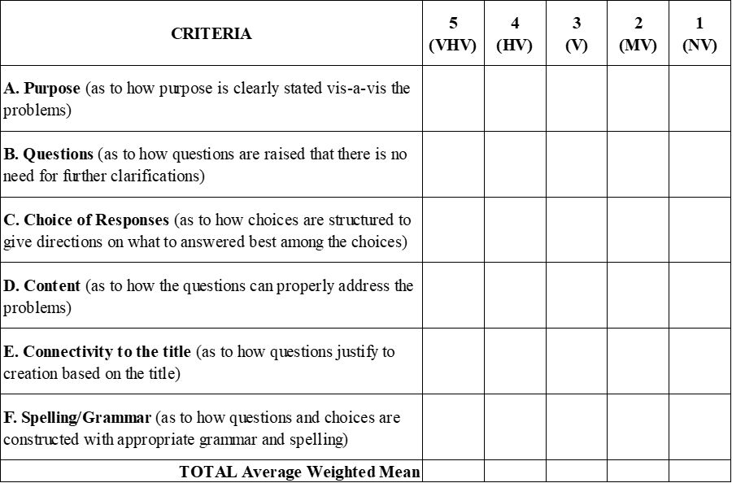Reference: http www.uky ed kdbrad2 EPE619 Rubrics Survey/Rubric
(with modifications)

Legend: 4-VHV-Very Highly Valid, 3-HV-Highly Valid, 2-V-Valid, 1-NV-Not Valid

Comments/Suggestions:___________________________________________________________________________________________________________________________ ________________________________________________________________________

Evaluated by: ___________________________________________________________
(Signature over Printed Name) (Position) (Date)

________________________________________
(Institution)
Appendix L:
Documentation
Survey for the Respondents
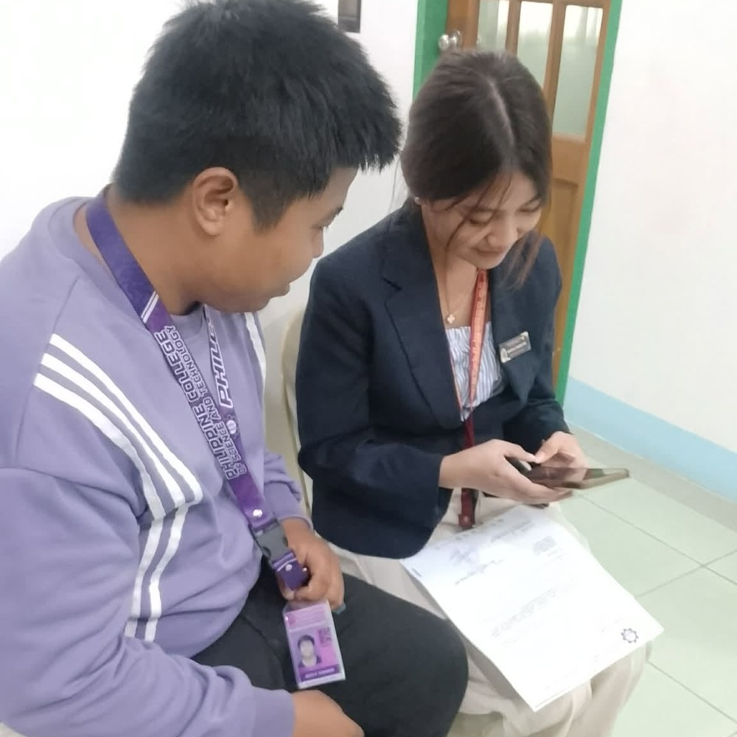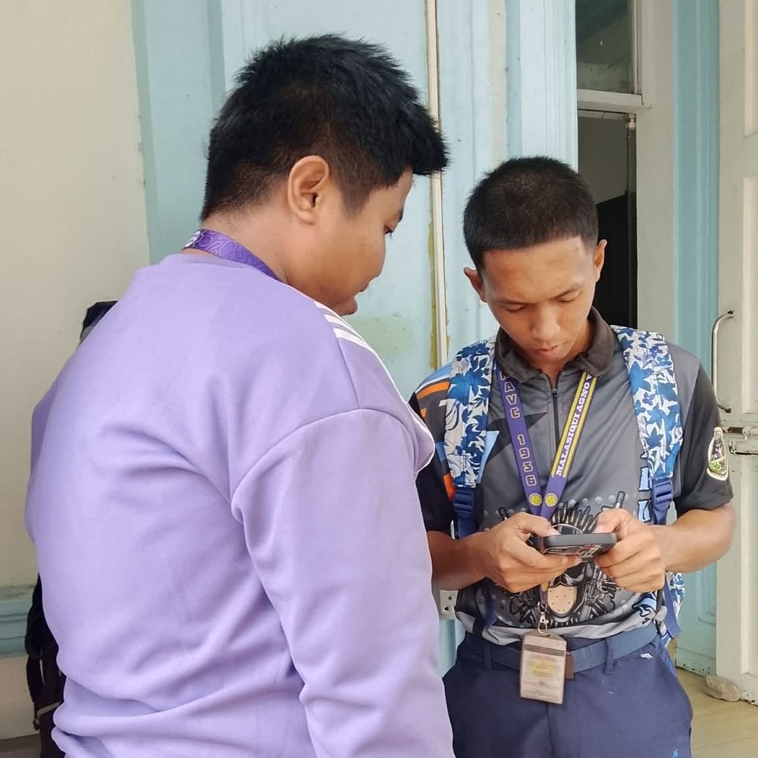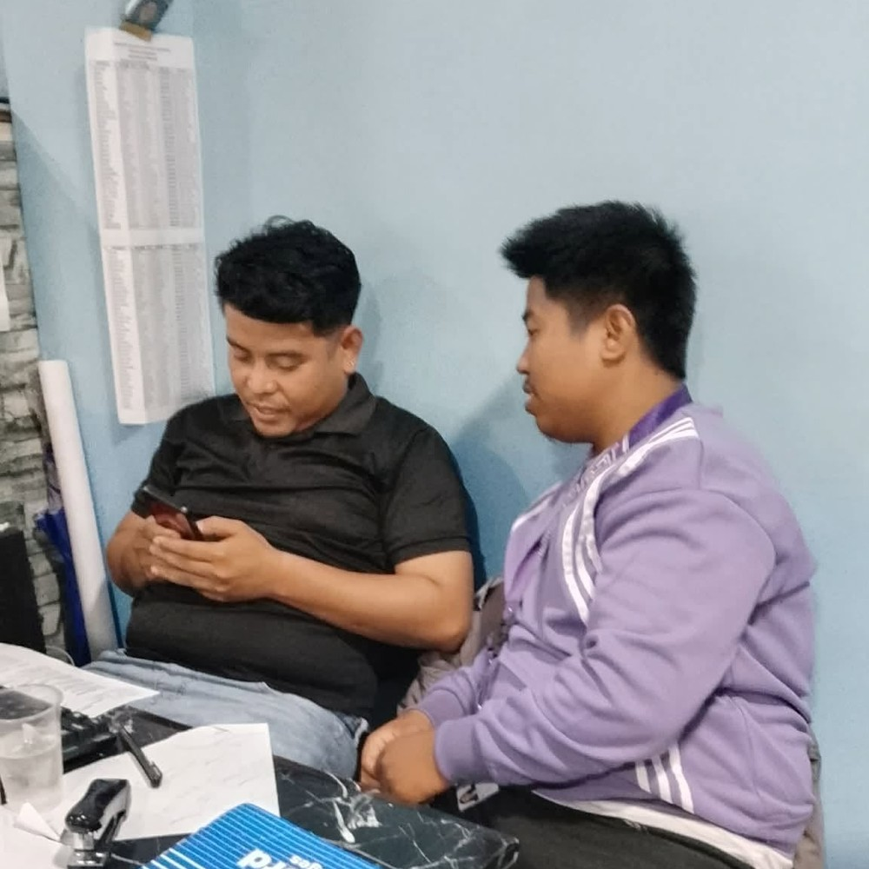
Appendix L focuses on gathering information through a survey that aims to identify the present methods used, the problems encountered, the functional requirements needed, and the features that can be included in the proposed system. The survey serves as a guide in understanding the respondents’ experiences and expectations, ensuring that the proposed Customer Relationship Management System for MJJD Telecom will effectively address existing issues and provide an efficient and organized way of handling customer applications, installation scheduling, and customer concerns.
Survey for the IT Experts
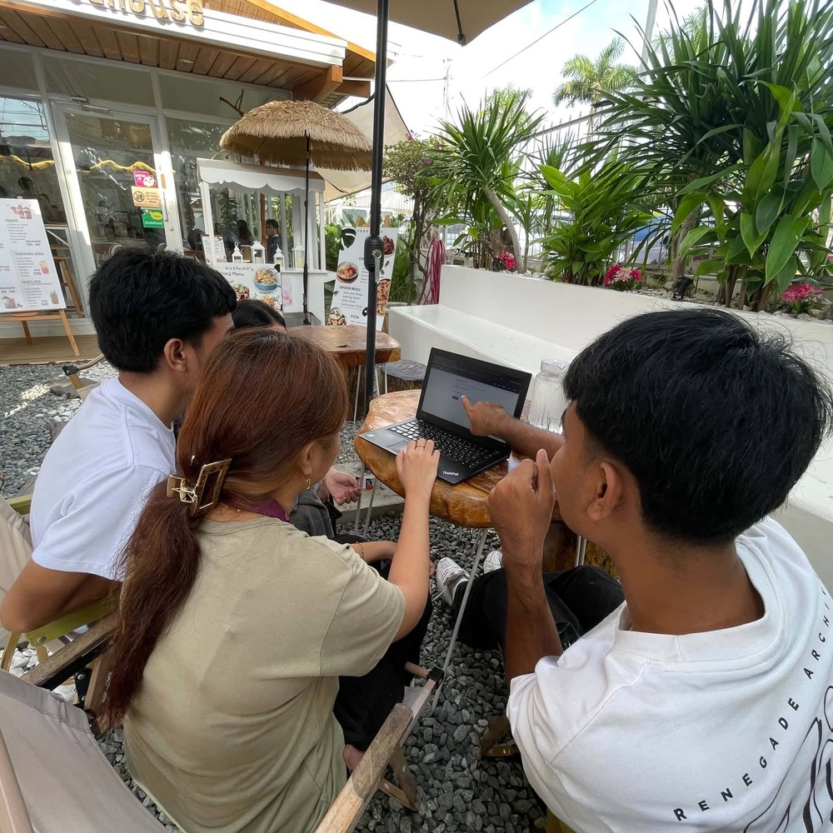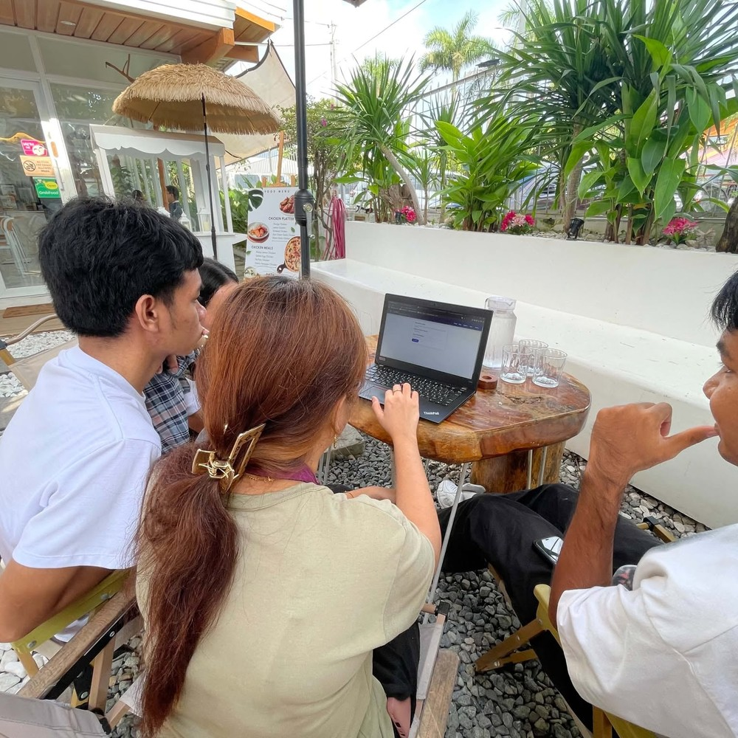
The survey for IT experts focused on evaluating the system based on the ISO 25010 software quality standards, assessing its functional suitability, performance efficiency, compatibility, usability, reliability, security, maintainability, and portability. Their feedback helped identify technical issues and improvements to enhance system performance.
Appendix M:
User Manual
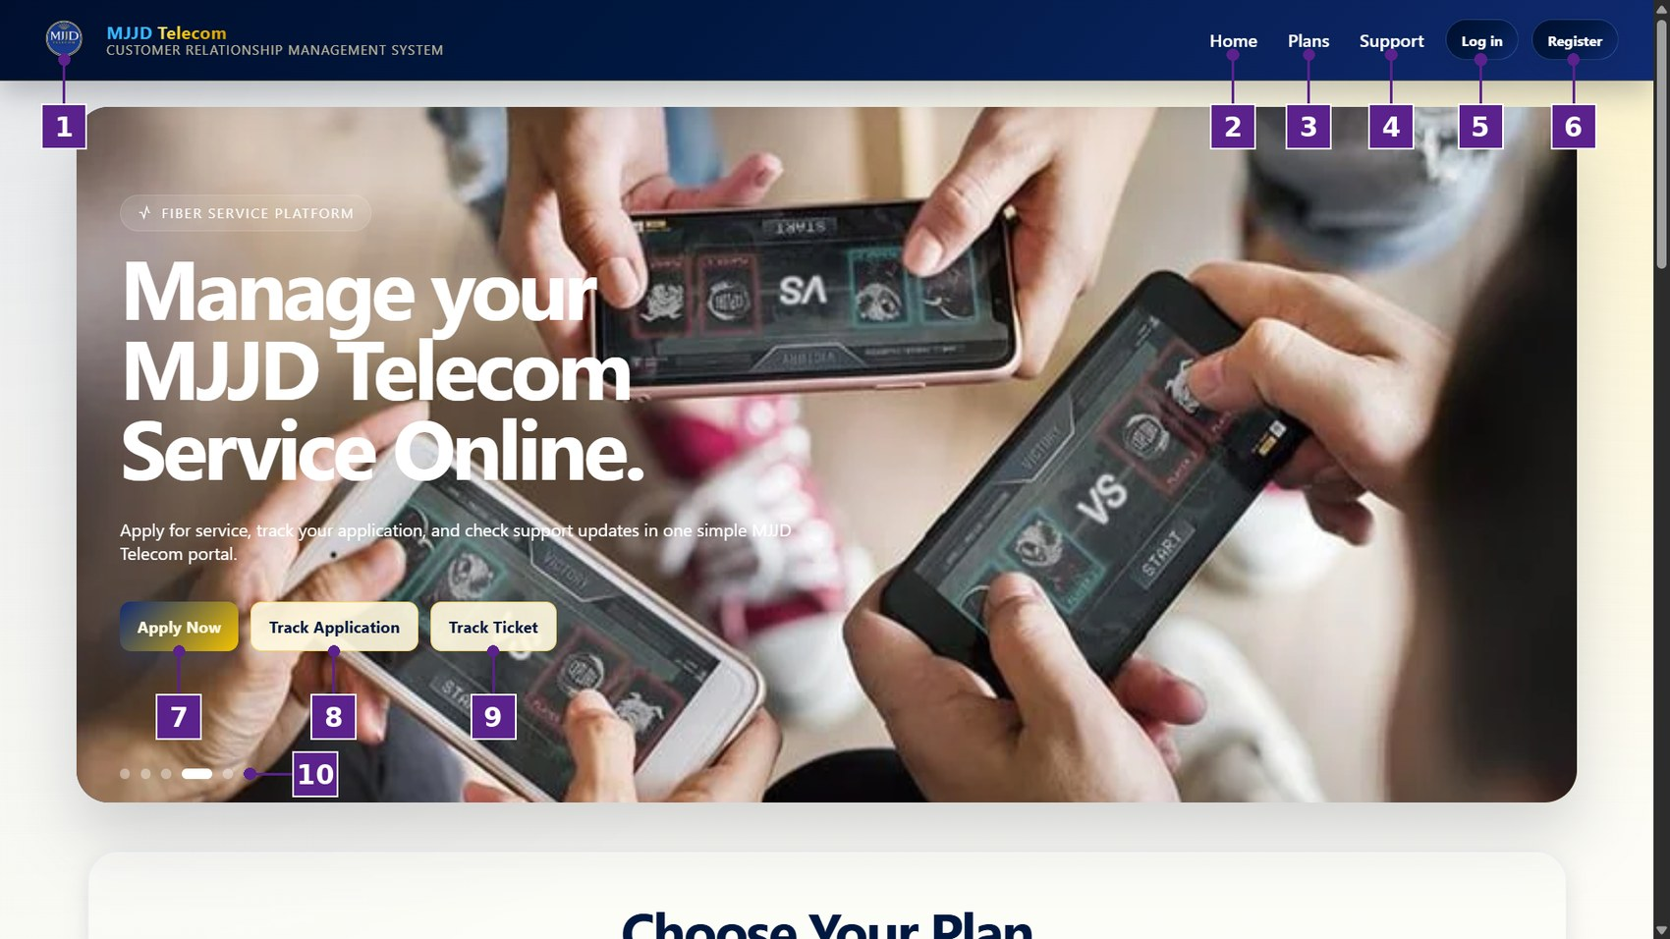
Figure 4
Homepage
Table 18
Homepage
No. | Icon/Button Name | Functions and Description
1 | MJJD Telecom Logo | Displays the MJJD Telecom logo and the name of the Customer Relationship Management System.
2 | Home | The user can select this option to go to the homepage of the system.
3 | Plans | The user can select this option to view the available internet service plans.
4 | Support | The user can select this option to view the frequently asked questions and contact information of MJJD Telecom.
5 | Log in Button | The user can select this button to open the login window and sign in to their account.
6 | Register Button | The user can select this button to open the registration window and create a new account.
7 | Apply Now Button | The user can select this button to start an application for internet service installation.
8 | Track Application Button | The user can select this button to check the status of a submitted service application.
9 | Track Ticket Button | The user can select this button to check the status of a submitted support ticket.
10 | Slider Indicators | The user can select these indicators to view the different featured banners on the homepage.
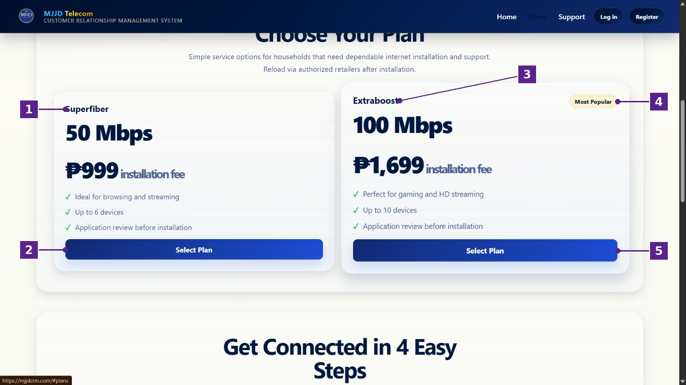
Figure 5
Plans Section
Table 19
Plans Section
No. | Icon/Button Name | Functions and Description
1 | Superfiber Plan | Shows the Superfiber plan, which offers 50 Mbps with a ₱999 installation fee, is ideal for browsing and streaming, and supports up to 6 devices.
2 | Select Plan Button (Superfiber) | The user can select this button to choose the Superfiber plan and proceed with a service application.
3 | Extraboost Plan | Shows the Extraboost plan, which offers 100 Mbps with a ₱1,699 installation fee, is suited for gaming and HD streaming, and supports up to 10 devices.
4 | Most Popular Label | Indicates that the Extraboost plan is the most popular among the available plans.
5 | Select Plan Button (Extraboost) | The user can select this button to choose the Extraboost plan and proceed with a service application.
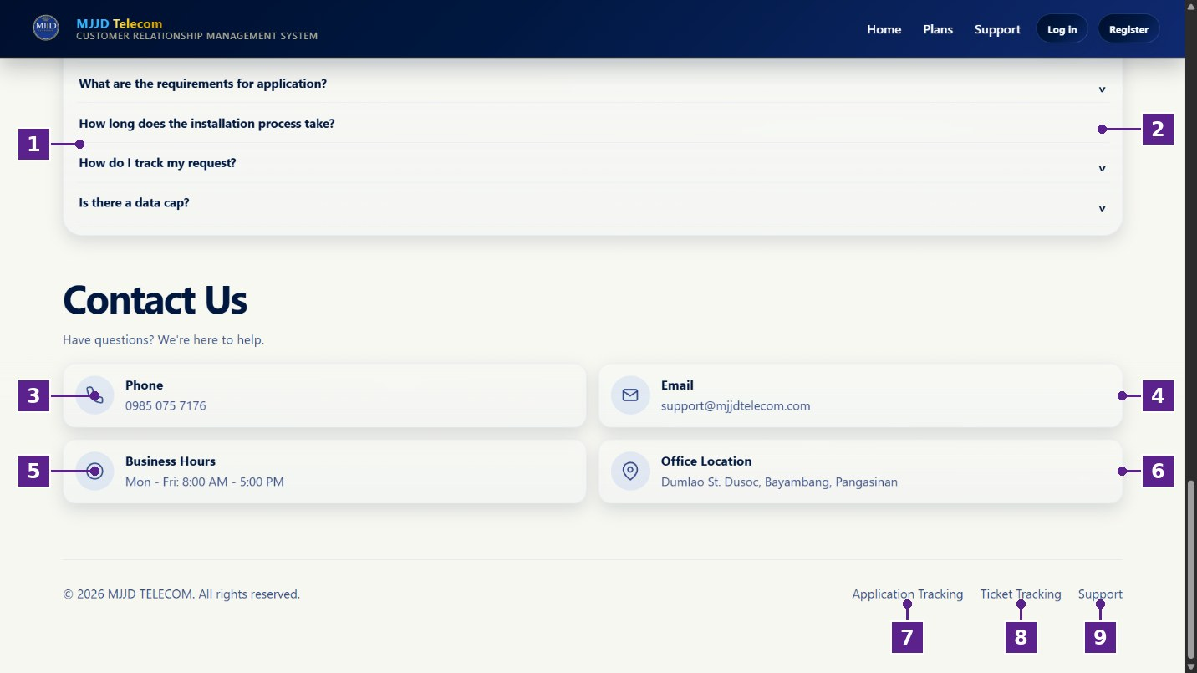
Figure 6
Support and Contact Section
Table 20
Support and Contact Section
No. | Icon/Button Name | Functions and Description
1 | Frequently Asked Questions | Lists common questions about application requirements, installation time, request tracking, and data caps.
2 | Expand Arrow | The user can select this arrow to show or hide the answer to a question.
3 | Phone | Displays the contact number of MJJD Telecom.
4 | Email | Displays the support email address of MJJD Telecom.
5 | Business Hours | Displays the days and hours when MJJD Telecom is open.
6 | Office Location | Displays the office address of MJJD Telecom.
7 | Application Tracking Link | The user can select this link to go to the application tracking page.
8 | Ticket Tracking Link | The user can select this link to go to the ticket tracking page.
9 | Support Link | The user can select this link to go to the support section.
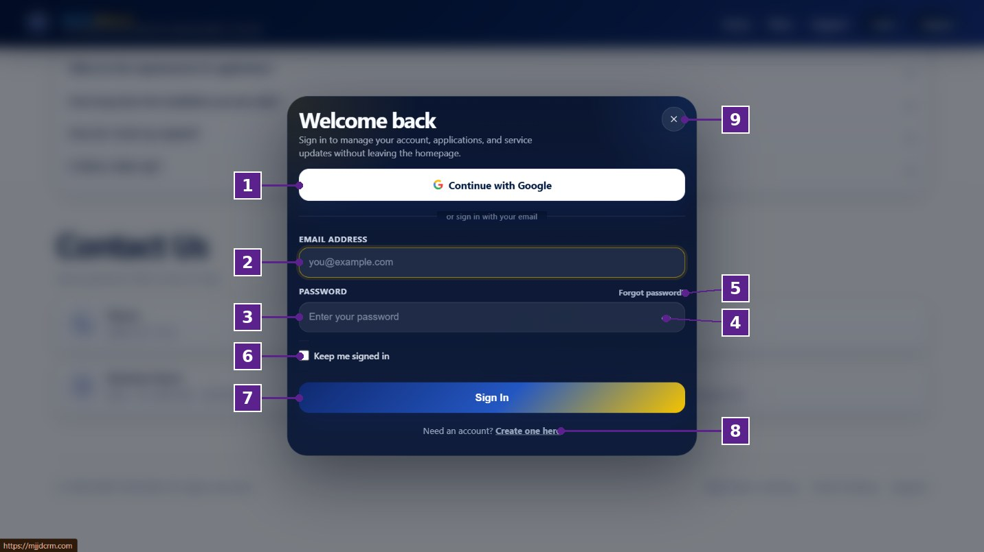
Figure 7
Login Page
Table 21
Login Page
No. | Icon/Button Name | Functions and Description
1 | Continue with Google | The user can select this button to sign in using their Google account.
2 | Email Address | The user can enter their registered email address.
3 | Password | The user can enter their account password.
4 | Show Password Icon | The user can select this icon to show or hide the entered password.
5 | Forgot Password? | The user can select this option to recover or reset their password.
6 | Keep Me Signed In Checkbox | The user can check this box to stay signed in on the device.
7 | Sign In Button | The user can select this button to submit their email address and password and access their account.
8 | Create One Here | The user can select this option to open the registration window if they do not have an account.
9 | Close (×) Button | The user can select this button to close the login window.
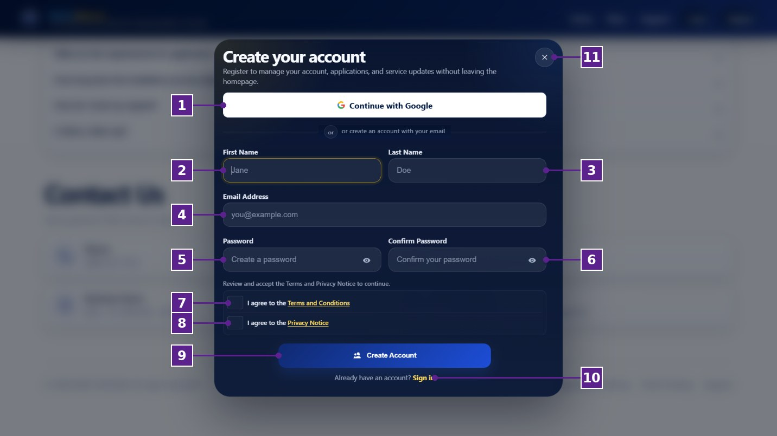
Figure 8
Register Page
Table 22
Register Page
No. | Icon/Button Name | Functions and Description
1 | Continue with Google | The user can select this button to create an account using their Google account.
2 | First Name | The user can enter their first name.
3 | Last Name | The user can enter their last name.
4 | Email Address | The user can enter the email address to be used for their account.
5 | Password | The user can create a password. The eye icon shows or hides the password.
6 | Confirm Password | The user can re-enter the password to confirm that both entries match.
7 | Terms and Conditions Checkbox | The user can check this box to agree to the Terms and Conditions.
8 | Privacy Notice Checkbox | The user can check this box to agree to the Privacy Notice.
9 | Create Account Button | The user can select this button to submit their information and create their account.
10 | Sign In | The user can select this option to go to the login window if they already have an account.
11 | Close (×) Button | The user can select this button to close the registration window.
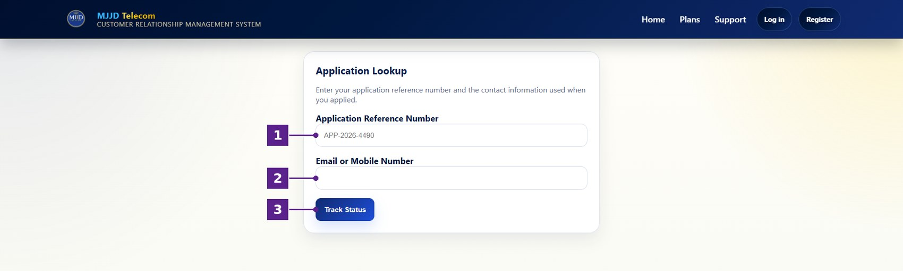
Figure 9
Application Lookup Page
Table 23
Application Lookup Page
No. | Icon/Button Name | Functions and Description
1 | Application Reference Number | The user can enter the reference number of their submitted application.
2 | Email or Mobile Number | The user can enter the email address or mobile number they used when they applied.
3 | Track Status Button | The user can select this button to view the current status of their application.
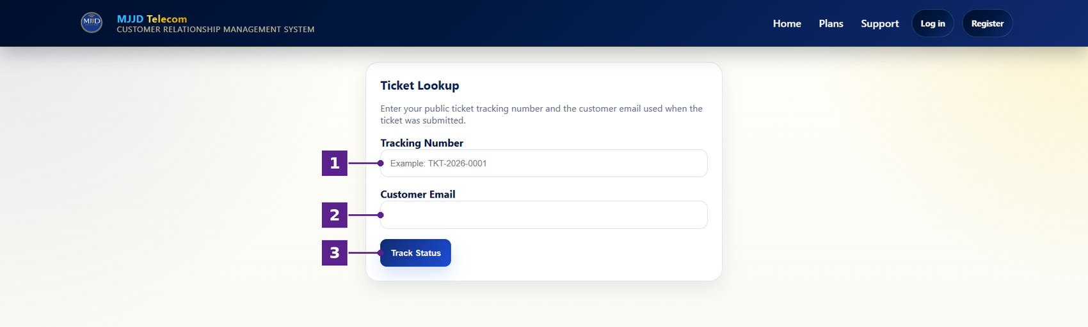
Figure 10
Ticket Lookup Page
Table 24
Ticket Lookup Page
No. | Icon/Button Name | Functions and Description
1 | Tracking Number | The user can enter the tracking number of their submitted ticket (e.g., TKT-2026-0001).
2 | Customer Email | The user can enter the email address used when the ticket was submitted.
3 | Track Status Button | The user can select this button to view the current status of their support ticket.
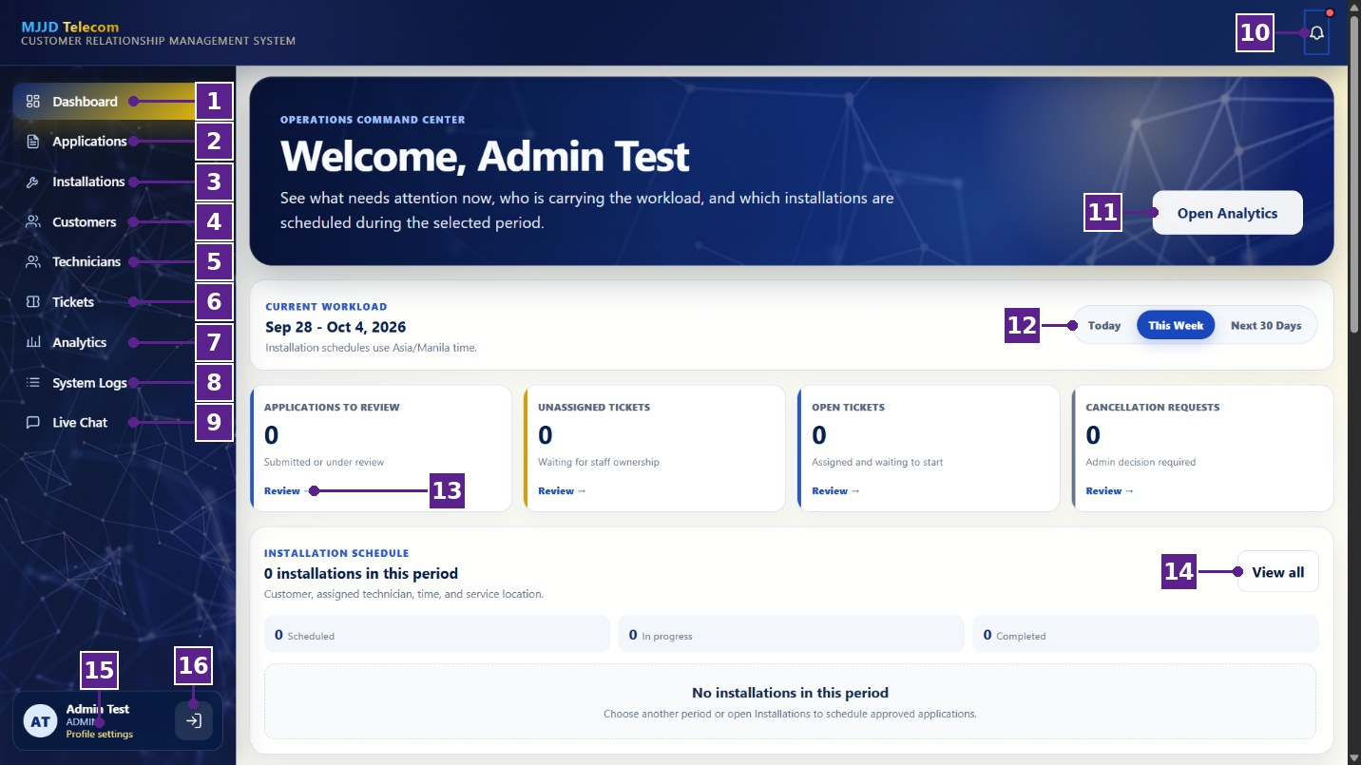
Figure 11
Admin Dashboard
Table 25
Admin Dashboard
No. | Icon/Button Name | Functions and Description
1 | Dashboard | The administrator can select this option to view the overview of current operations.
2 | Applications | The administrator can select this option to review and manage customer service applications.
3 | Installations | The administrator can select this option to monitor installation schedules and technician assignments.
4 | Customers | The administrator can select this option to view and manage customer records.
5 | Technicians | The administrator can select this option to view and manage technician records.
6 | Tickets | The administrator can select this option to manage customer support tickets.
7 | Analytics | The administrator can select this option to view analytics and generate reports.
8 | System Logs | The administrator can select this option to view the audit trail of system activities.
9 | Live Chat | The administrator can select this option to respond to customer conversations.
10 | Notification Bell | The administrator can select this icon to view system notifications.
11 | Open Analytics Button | The administrator can select this button to go directly to the Analytics page.
12 | Period Filter | The administrator can choose whether to view the workload for today, this week, or the next 30 days.
13 | Workload Cards | Show the number of applications to review, unassigned tickets, open tickets, and cancellation requests. The Review link opens the related records.
14 | View All Button | The administrator can select this button to view all installation schedules.
15 | Profile Settings | The administrator can select this option to update their profile information.
16 | Logout Button | The administrator can select this button to sign out of the system.
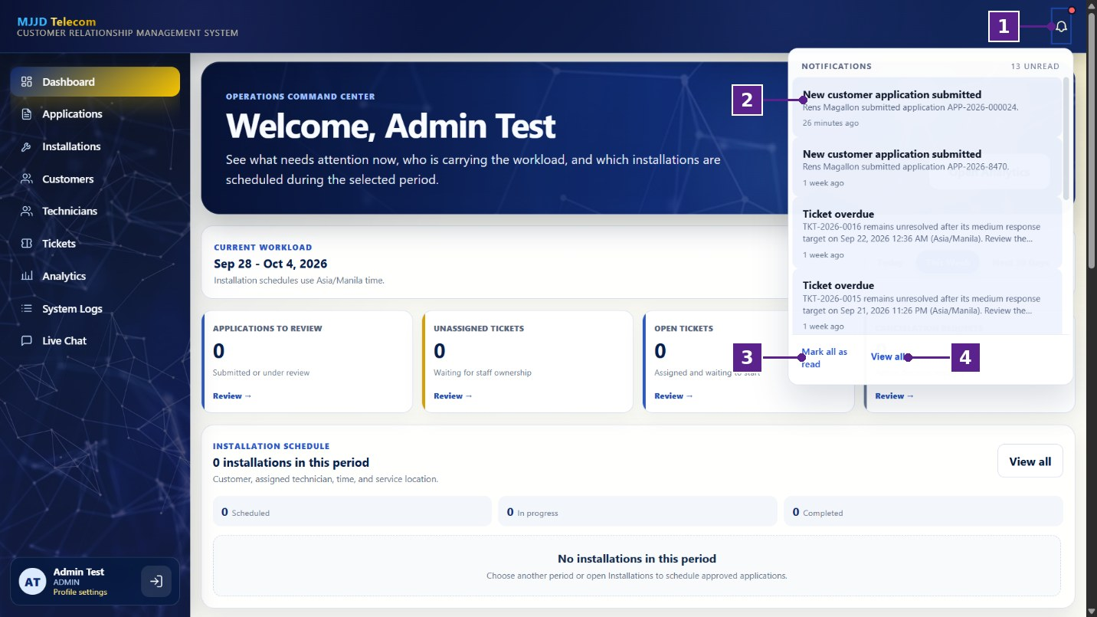
Figure 12
Notifications Panel
Table 26
Notifications Panel
No. | Icon/Button Name | Functions and Description
1 | Notification Bell | The administrator can select this icon to open or close the notification panel.
2 | Notification Item | Displays a notification, such as a new application or an overdue ticket, with the time it was received.
3 | Mark All as Read | The administrator can select this option to mark all notifications as read.
4 | View All | The administrator can select this option to view the complete list of notifications.
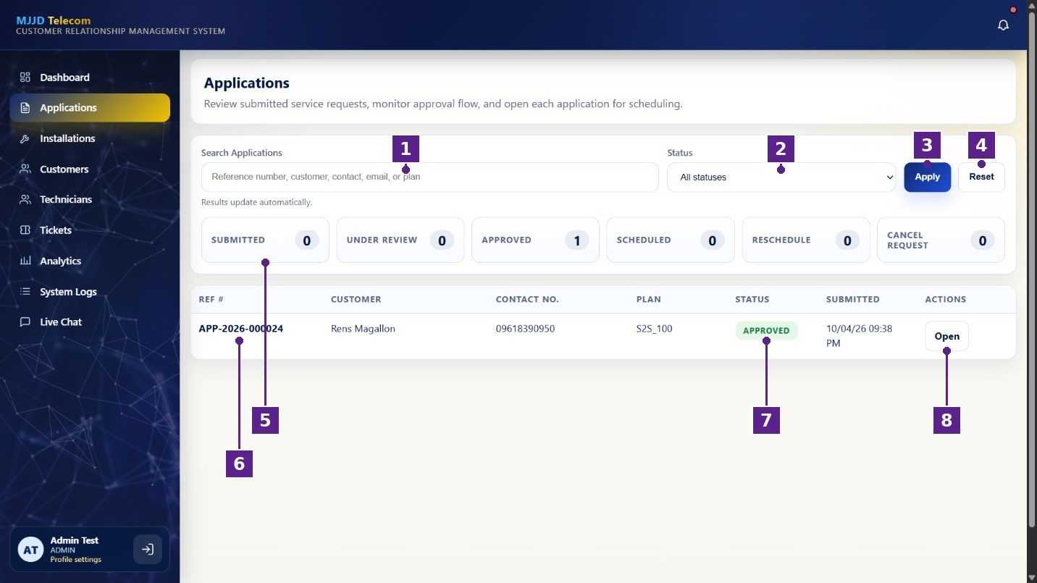
Figure 13
Applications Page
Table 27
Applications Page
No. | Icon/Button Name | Functions and Description
1 | Search Applications | The administrator can search applications by reference number, customer, contact, email, or plan.
2 | Status Filter | The administrator can filter applications by status.
3 | Apply Button | The administrator can select this button to apply the selected search and filter.
4 | Reset Button | The administrator can select this button to clear the search and filter.
5 | Status Summary | Shows the number of applications that are submitted, under review, approved, scheduled, for rescheduling, or requested for cancellation.
6 | Applications List | Displays the reference number, customer, contact number, plan, status, and submission date of each application.
7 | Status Label | Shows the current status of the application.
8 | Open Button | The administrator can select this button to open the application and review its details.
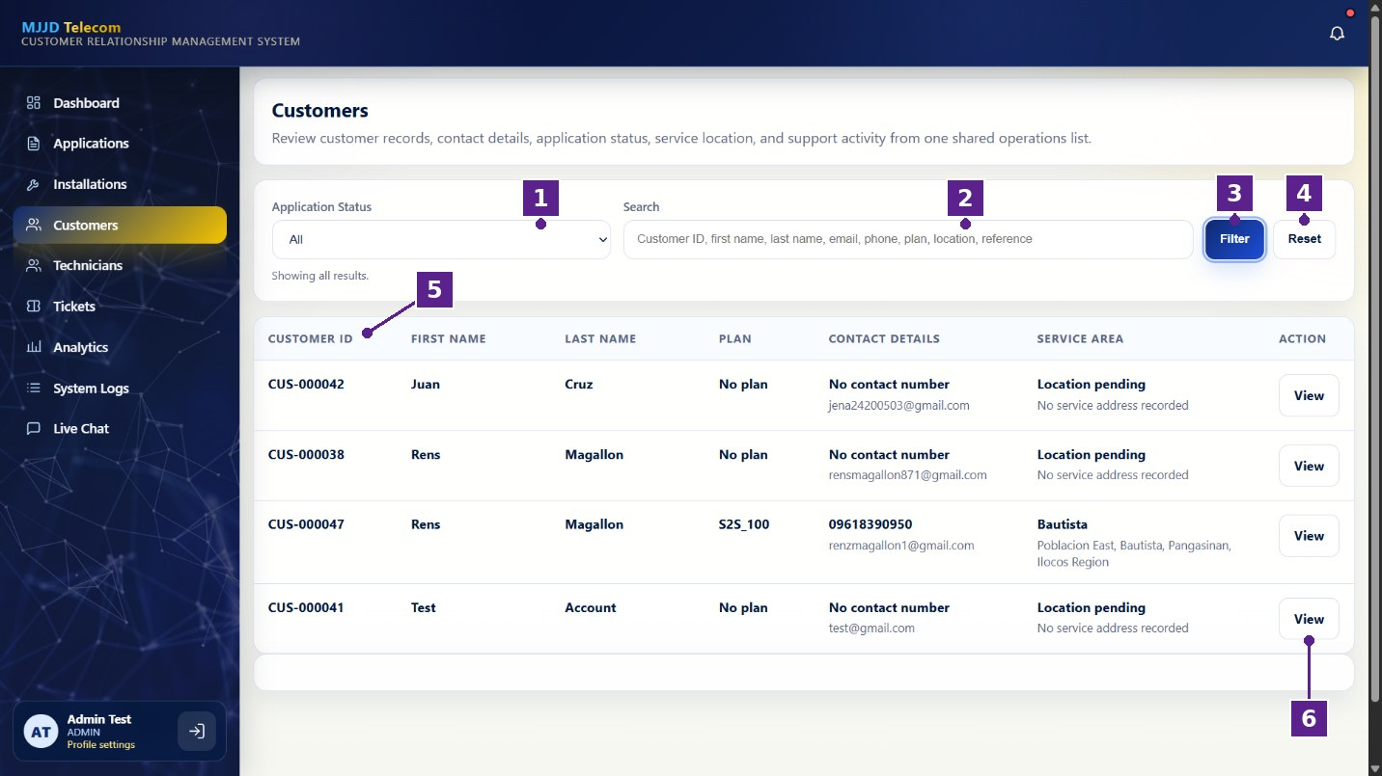
Figure 14
Customers Page
Table 28
Customers Page
No. | Icon/Button Name | Functions and Description
1 | Application Status Filter | The administrator can filter customers by their application status.
2 | Search | The administrator can search customers by ID, name, email, phone, plan, location, or reference number.
3 | Filter Button | The administrator can select this button to apply the selected search and filter.
4 | Reset Button | The administrator can select this button to clear the search and filter.
5 | Customer List | Displays the customer ID, name, plan, contact details, and service area of each customer.
6 | View Button | The administrator can select this button to open the full profile of the customer.
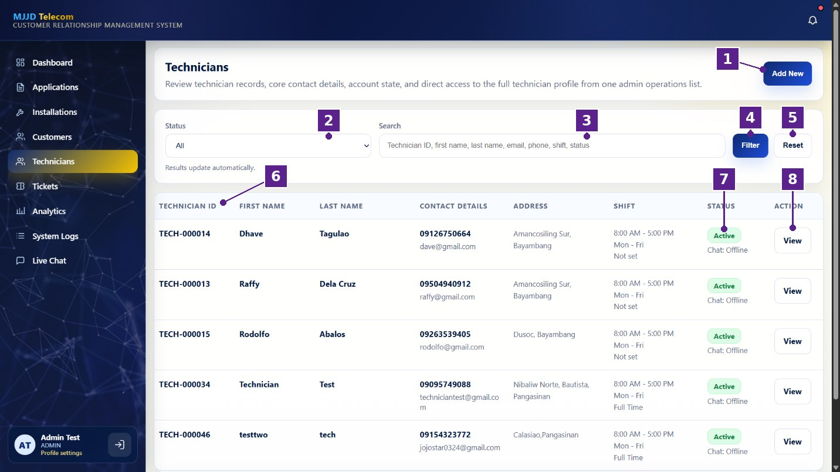
Figure 15
Technicians Page
Table 29
Technicians Page
No. | Icon/Button Name | Functions and Description
1 | Add New Button | The administrator can select this button to add a new technician account.
2 | Status Filter | The administrator can filter technicians by account status.
3 | Search | The administrator can search technicians by ID, name, email, phone, shift, or status.
4 | Filter Button | The administrator can select this button to apply the selected search and filter.
5 | Reset Button | The administrator can select this button to clear the search and filter.
6 | Technician List | Displays the technician ID, name, contact details, address, shift, and status of each technician.
7 | Status Label | Shows whether the technician account is active and whether the technician is online for chat.
8 | View Button | The administrator can select this button to open the full profile of the technician.
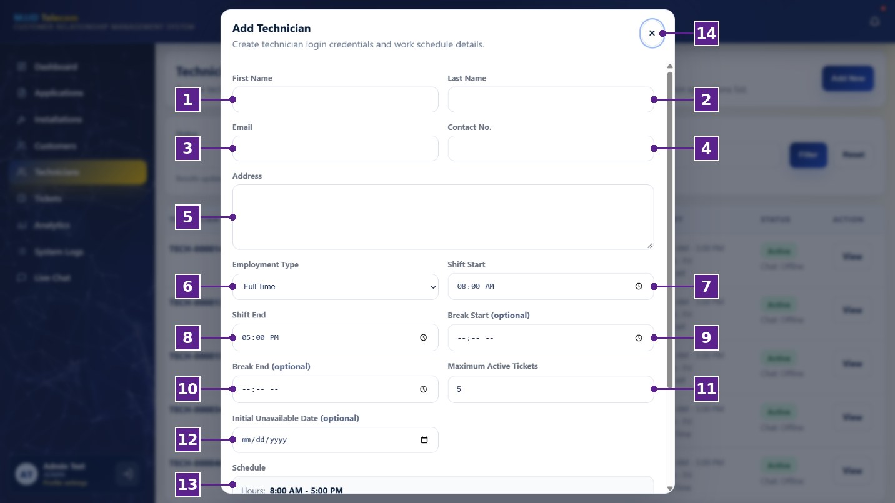
Figure 16
Add Technician Window
Table 30
Add Technician Window
No. | Icon/Button Name | Functions and Description
1 | First Name | The administrator can enter the first name of the technician.
2 | Last Name | The administrator can enter the last name of the technician.
3 | Email | The administrator can enter the email address that the technician will use to log in.
4 | Contact No. | The administrator can enter the contact number of the technician.
5 | Address | The administrator can enter the address of the technician.
6 | Employment Type | The administrator can select the employment type of the technician.
7 | Shift Start | The administrator can set the start time of the technician’s shift.
8 | Shift End | The administrator can set the end time of the technician’s shift.
9 | Break Start (optional) | The administrator can set the start of the technician’s break.
10 | Break End (optional) | The administrator can set the end of the technician’s break.
11 | Maximum Active Tickets | The administrator can set the maximum number of tickets the technician can handle at a time.
12 | Initial Unavailable Date (optional) | The administrator can set a date when the technician will not be available.
13 | Schedule | Displays a summary of the technician’s working hours.
14 | Close (×) Button | The administrator can select this button to close the window without saving.
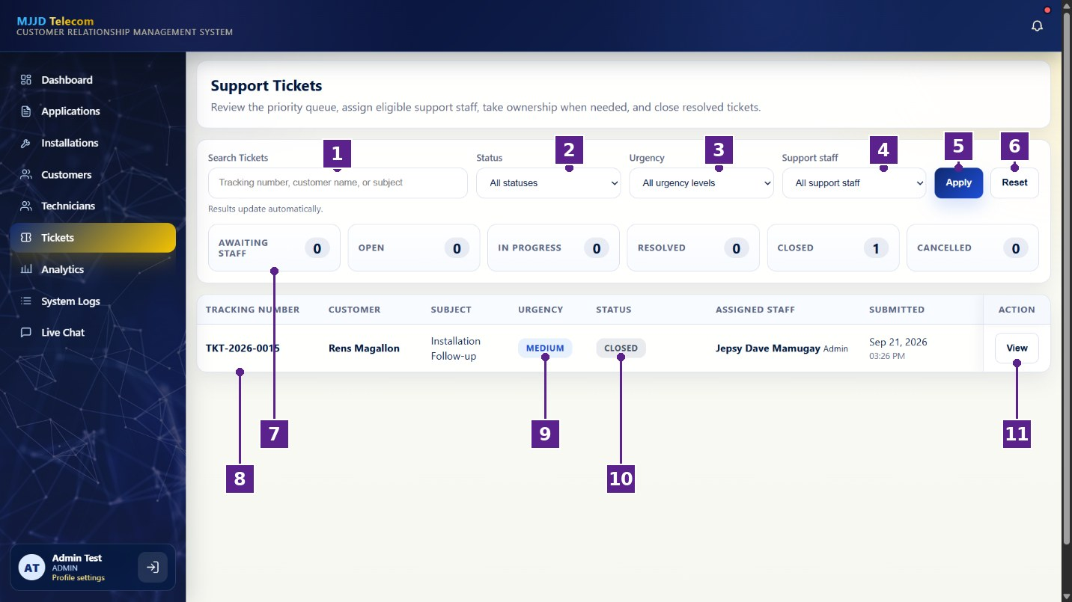
Figure 17
Support Tickets Page
Table 31
Support Tickets Page
No. | Icon/Button Name | Functions and Description
1 | Search Tickets | The administrator can search tickets by tracking number, customer name, or subject.
2 | Status Filter | The administrator can filter tickets by status.
3 | Urgency Filter | The administrator can filter tickets by urgency level.
4 | Support Staff Filter | The administrator can filter tickets by the assigned support staff.
5 | Apply Button | The administrator can select this button to apply the selected filters.
6 | Reset Button | The administrator can select this button to clear the filters.
7 | Status Summary | Shows the number of tickets that are awaiting staff, open, in progress, resolved, closed, or cancelled.
8 | Tickets List | Displays the tracking number, customer, subject, urgency, status, assigned staff, and submission date of each ticket.
9 | Urgency Label | Shows the urgency level of the ticket.
10 | Status Label | Shows the current status of the ticket.
11 | View Button | The administrator can select this button to open the ticket and manage its details.
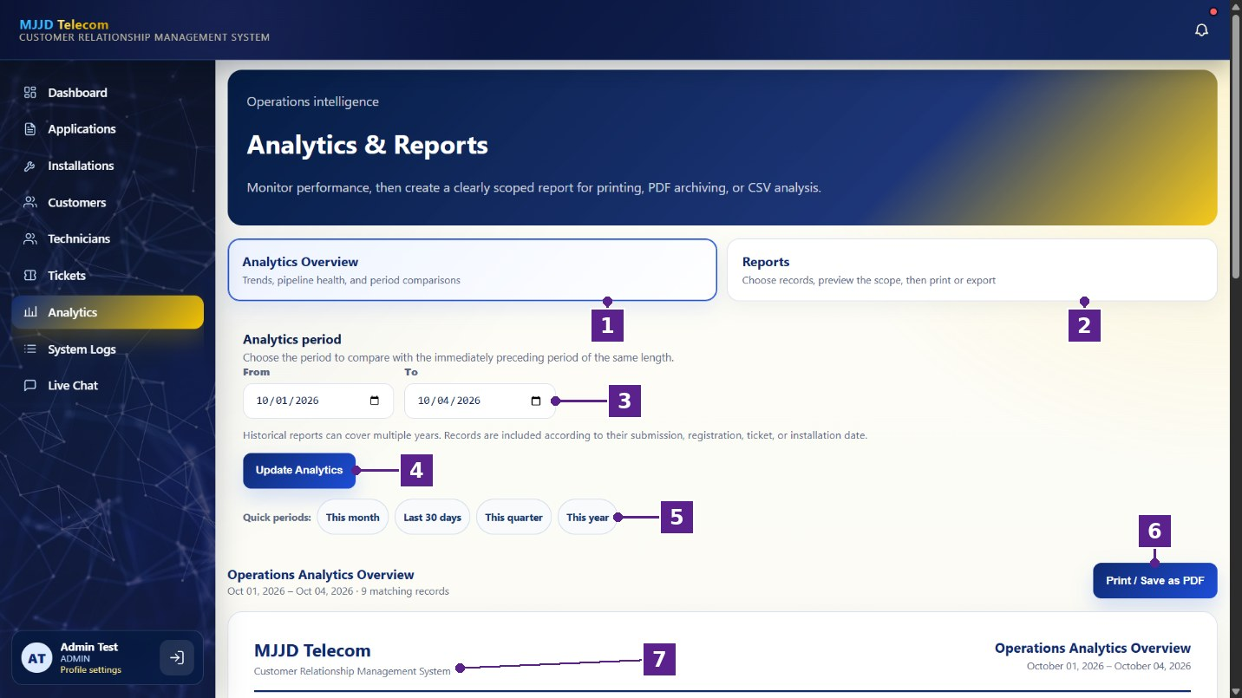
Figure 18
Analytics and Reports Page
Table 32
Analytics and Reports Page
No. | Icon/Button Name | Functions and Description
1 | Analytics Overview Tab | The administrator can select this tab to view trends, pipeline health, and period comparisons.
2 | Reports Tab | The administrator can select this tab to choose records, preview them, and print or export a report.
3 | From and To Dates | The administrator can set the date range to be analyzed.
4 | Update Analytics Button | The administrator can select this button to refresh the analytics based on the selected dates.
5 | Quick Periods | The administrator can select a preset period, such as this month, the last 30 days, this quarter, or this year.
6 | Print / Save as PDF Button | The administrator can select this button to print the overview or save it as a PDF file.
7 | Report Preview | Displays a preview of the operations analytics report.
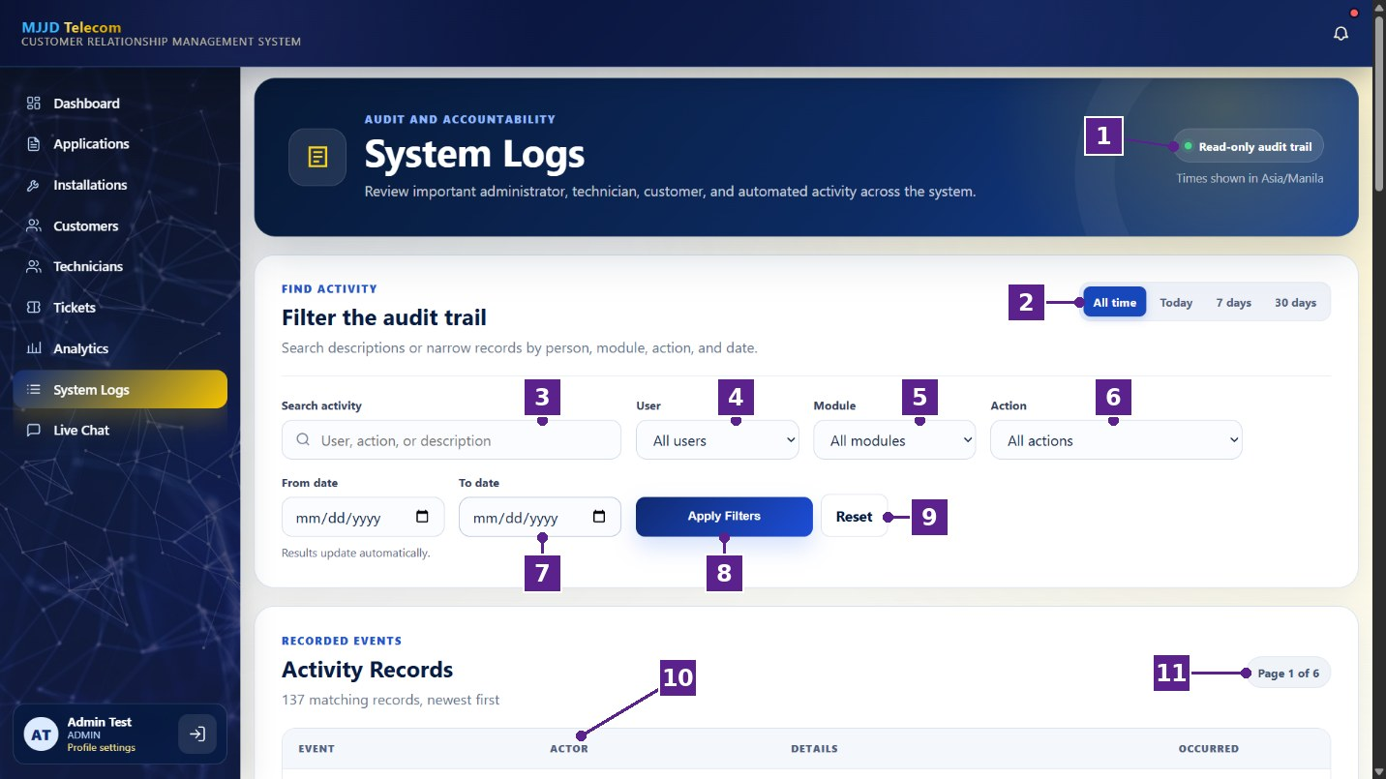
Figure 19
System Logs Page
Table 33
System Logs Page
No. | Icon/Button Name | Functions and Description
1 | Read-only Audit Trail Label | Indicates that the system logs can be viewed but not edited.
2 | Time Range Buttons | The administrator can show activities from all time, today, the last 7 days, or the last 30 days.
3 | Search Activity | The administrator can search activities by user, action, or description.
4 | User Filter | The administrator can filter activities by user.
5 | Module Filter | The administrator can filter activities by system module.
6 | Action Filter | The administrator can filter activities by type of action.
7 | From and To Date | The administrator can set a specific date range for the activities.
8 | Apply Filters Button | The administrator can select this button to apply the selected filters.
9 | Reset Button | The administrator can select this button to clear the filters.
10 | Activity Records | Displays the event, actor, details, and date of each recorded activity.
11 | Page Indicator | Shows the current page of the activity records.
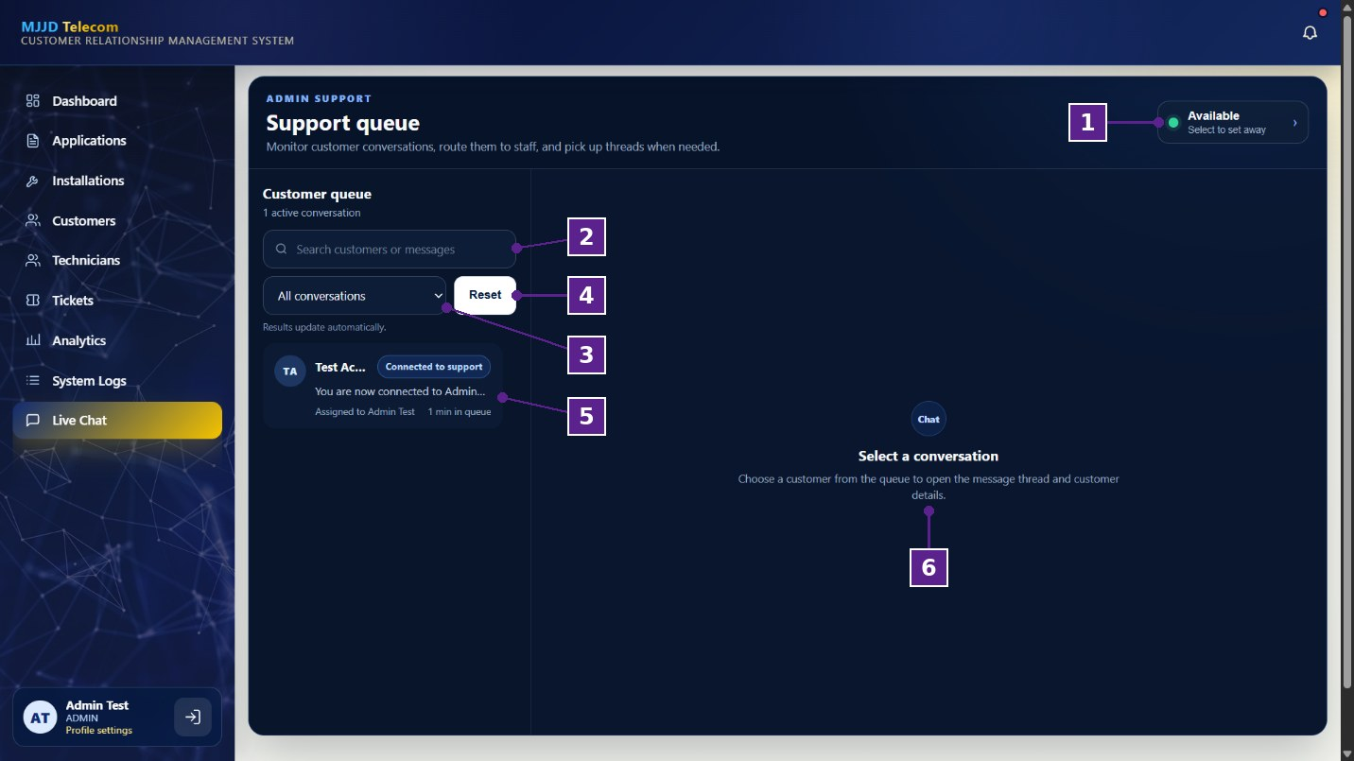
Figure 20
Admin Live Chat Page
Table 34
Admin Live Chat Page
No. | Icon/Button Name | Functions and Description
1 | Availability Status | The administrator can select this to set their status as available or away.
2 | Search Conversations | The administrator can search customers or messages.
3 | Conversation Filter | The administrator can filter the conversations in the queue.
4 | Reset Button | The administrator can select this button to clear the search and filter.
5 | Conversation Item | Displays a customer conversation with its latest message, assigned staff, and waiting time.
6 | Conversation Panel | Displays the selected conversation and the customer details.
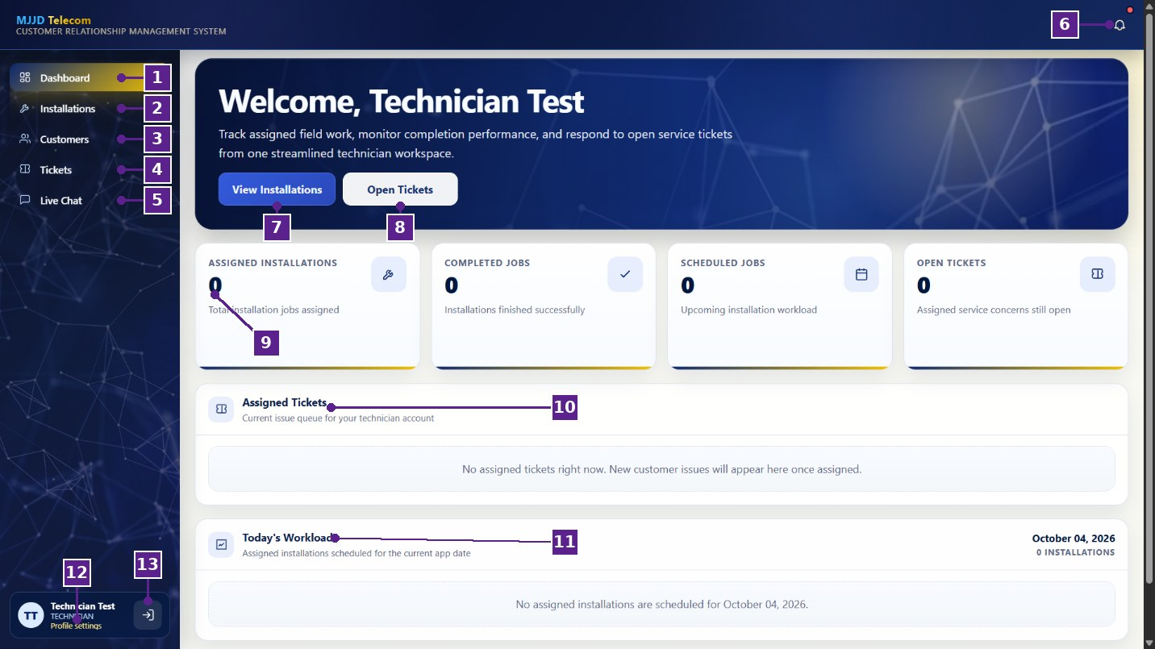
Figure 21
Technician Dashboard
Table 35
Technician Dashboard
No. | Icon/Button Name | Functions and Description
1 | Dashboard | The technician can select this option to view their work overview.
2 | Installations | The technician can select this option to view their assigned installations.
3 | Customers | The technician can select this option to view customer records.
4 | Tickets | The technician can select this option to view their assigned tickets.
5 | Live Chat | The technician can select this option to respond to assigned customer conversations.
6 | Notification Bell | The technician can select this icon to view notifications.
7 | View Installations Button | The technician can select this button to go to their assigned installations.
8 | Open Tickets Button | The technician can select this button to go to their assigned tickets.
9 | Summary Cards | Show the number of assigned installations, completed jobs, scheduled jobs, and open tickets.
10 | Assigned Tickets | Displays the tickets currently assigned to the technician.
11 | Today’s Workload | Displays the installations scheduled for the current day.
12 | Profile Settings | The technician can select this option to update their profile information.
13 | Logout Button | The technician can select this button to sign out of the system.
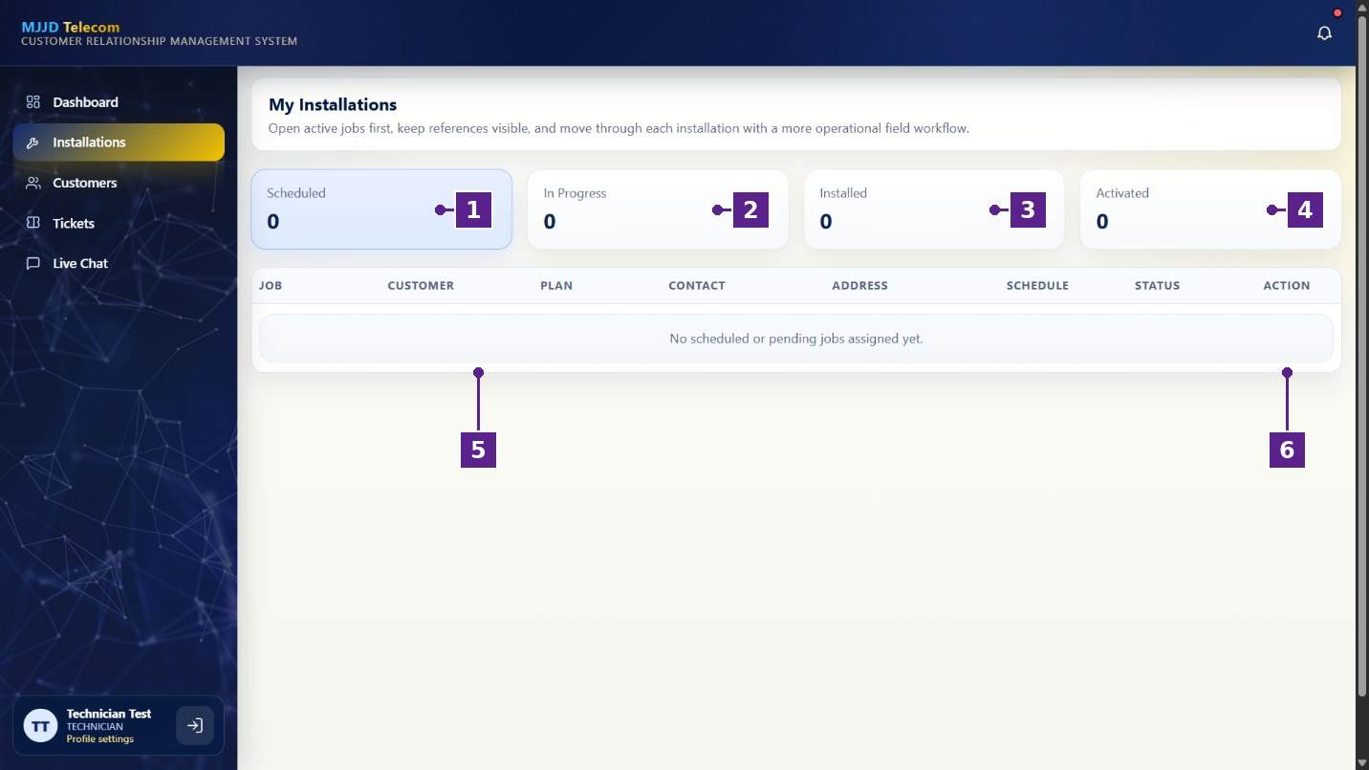
Figure 22
My Installations Page
Table 36
My Installations Page
No. | Icon/Button Name | Functions and Description
1 | Scheduled | Shows the number of scheduled installations.
2 | In Progress | Shows the number of installations currently being worked on.
3 | Installed | Shows the number of completed installations.
4 | Activated | Shows the number of installations with activated service.
5 | Installations List | Displays the job, customer, plan, contact, address, schedule, and status of each assigned installation.
6 | Action Column | The technician can use the buttons in this column to open and update an installation.
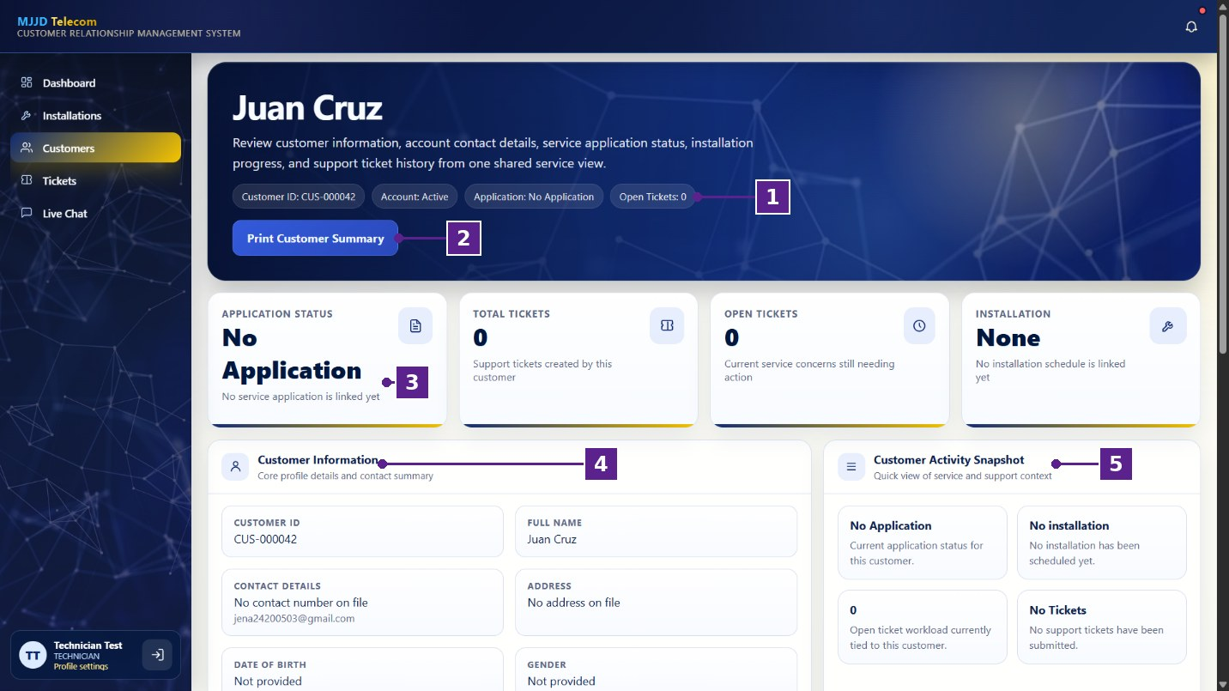
Figure 23
Customer Profile Page
Table 37
Customer Profile Page
No. | Icon/Button Name | Functions and Description
1 | Customer Details Labels | Show the customer ID, account status, application status, and number of open tickets.
2 | Print Customer Summary Button | The technician can select this button to print a summary of the customer’s record.
3 | Summary Cards | Show the customer’s application status, total tickets, open tickets, and installation status.
4 | Customer Information | Displays the customer’s ID, name, contact details, address, date of birth, and gender.
5 | Customer Activity Snapshot | Displays a quick view of the customer’s application, installation, and ticket activity.
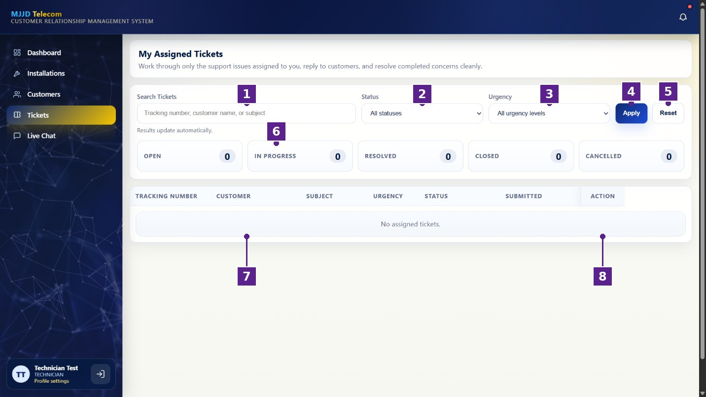
Figure 24
My Assigned Tickets Page
Table 38
My Assigned Tickets Page
No. | Icon/Button Name | Functions and Description
1 | Search Tickets | The technician can search their tickets by tracking number, customer name, or subject.
2 | Status Filter | The technician can filter their tickets by status.
3 | Urgency Filter | The technician can filter their tickets by urgency level.
4 | Apply Button | The technician can select this button to apply the selected filters.
5 | Reset Button | The technician can select this button to clear the filters.
6 | Status Summary | Shows the number of assigned tickets that are open, in progress, resolved, closed, or cancelled.
7 | Tickets List | Displays the details of each ticket assigned to the technician.
8 | Action Column | The technician can use the buttons in this column to open and respond to a ticket.
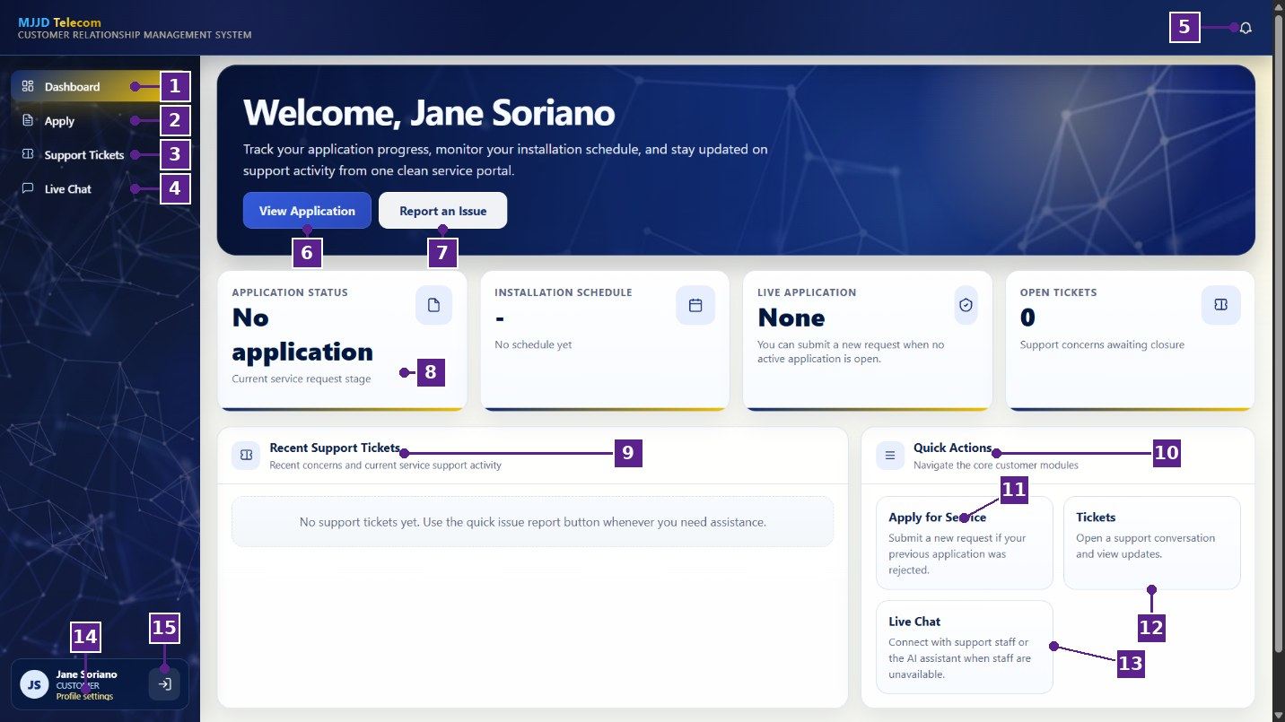
Figure 25
Customer Dashboard
Table 39
Customer Dashboard
No. | Icon/Button Name | Functions and Description
1 | Dashboard | The customer can select this option to view their account overview.
2 | Apply | The customer can select this option to apply for internet service.
3 | Support Tickets | The customer can select this option to view and create support tickets.
4 | Live Chat | The customer can select this option to chat with MJJD support or the AI assistant.
5 | Notification Bell | The customer can select this icon to view notifications.
6 | View Application Button | The customer can select this button to view their submitted application.
7 | Report an Issue Button | The customer can select this button to report a concern through a support ticket.
8 | Summary Cards | Show the customer’s application status, installation schedule, live application, and open tickets.
9 | Recent Support Tickets | Displays the customer’s recent support tickets.
10 | Quick Actions | Provide shortcuts to the main customer features.
11 | Apply for Service | The customer can select this option to submit a new service application.
12 | Tickets | The customer can select this option to open a support conversation and view updates.
13 | Live Chat | The customer can select this option to connect with support staff or the AI assistant.
14 | Profile Settings | The customer can select this option to update their profile information.
15 | Logout Button | The customer can select this button to sign out of the system.
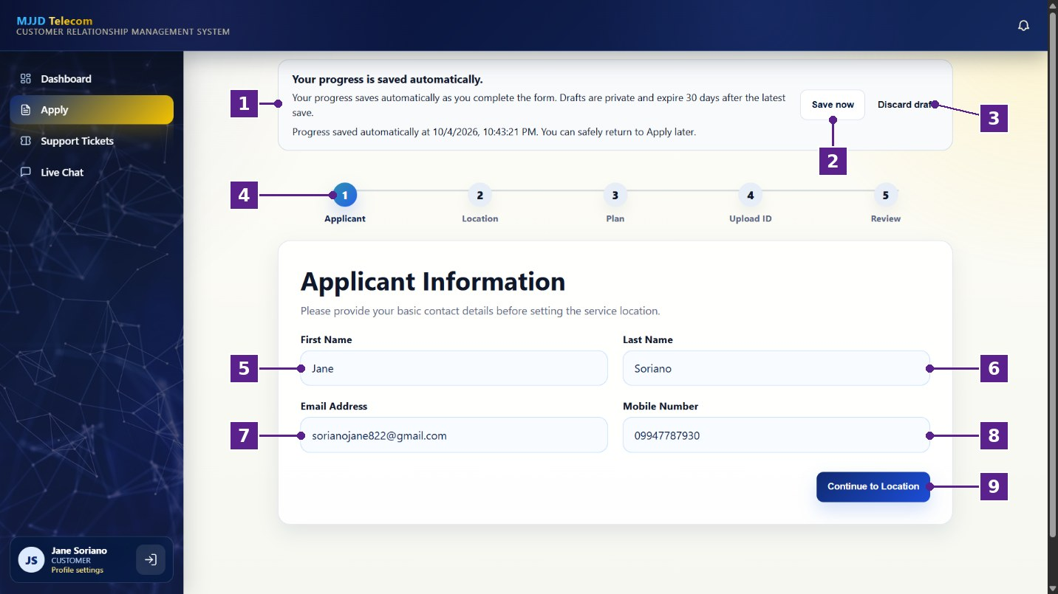
Figure 26
Applicant Information Step
Table 40
Applicant Information Step
No. | Icon/Button Name | Functions and Description
1 | Auto-save Notice | Informs the customer that their progress is saved automatically and shows the time of the last save.
2 | Save Now Button | The customer can select this button to save their progress immediately.
3 | Discard Draft | The customer can select this option to delete their saved draft.
4 | Progress Steps | Shows the five steps of the application: Applicant, Location, Plan, Upload ID, and Review.
5 | First Name | The customer can enter their first name.
6 | Last Name | The customer can enter their last name.
7 | Email Address | The customer can enter their email address.
8 | Mobile Number | The customer can enter their mobile number.
9 | Continue to Location Button | The customer can select this button to proceed to the service location step.
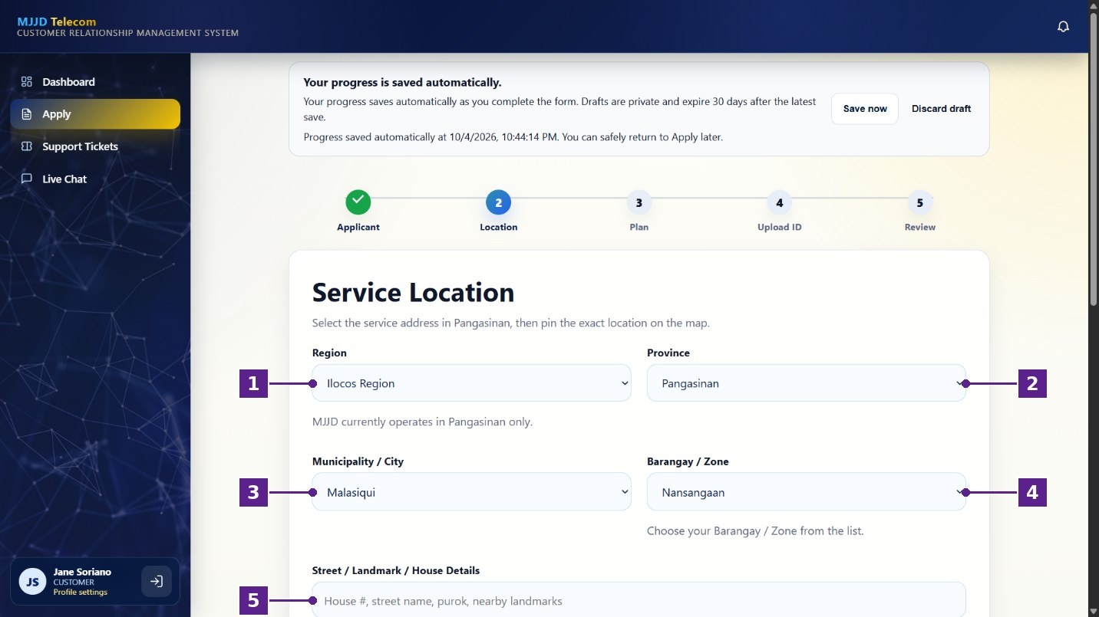
Figure 27
Service Location Step
Table 41
Service Location Step
No. | Icon/Button Name | Functions and Description
1 | Region | The customer can select the region of their service address.
2 | Province | The customer can select the province of their service address.
3 | Municipality / City | The customer can select the municipality or city of their service address.
4 | Barangay / Zone | The customer can select the barangay or zone of their service address.
5 | Street / Landmark / House Details | The customer can enter their house number, street, purok, or nearby landmarks.
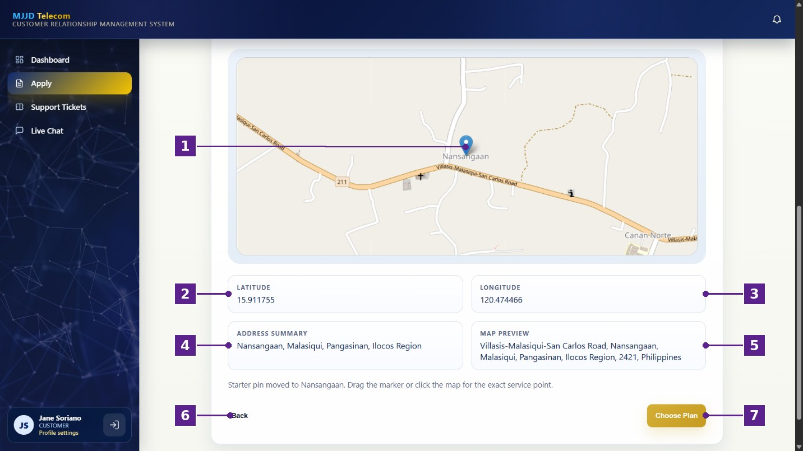
Figure 28
Location Pin Map
Table 42
Location Pin Map
No. | Icon/Button Name | Functions and Description
1 | Map Pin | The customer can drag the marker or click the map to set the exact location of the service point.
2 | Latitude | Displays the latitude of the pinned location.
3 | Longitude | Displays the longitude of the pinned location.
4 | Address Summary | Displays a summary of the selected service address.
5 | Map Preview | Displays the full address based on the pinned location.
6 | Back Button | The customer can select this button to return to the previous step.
7 | Choose Plan Button | The customer can select this button to proceed to the plan step.
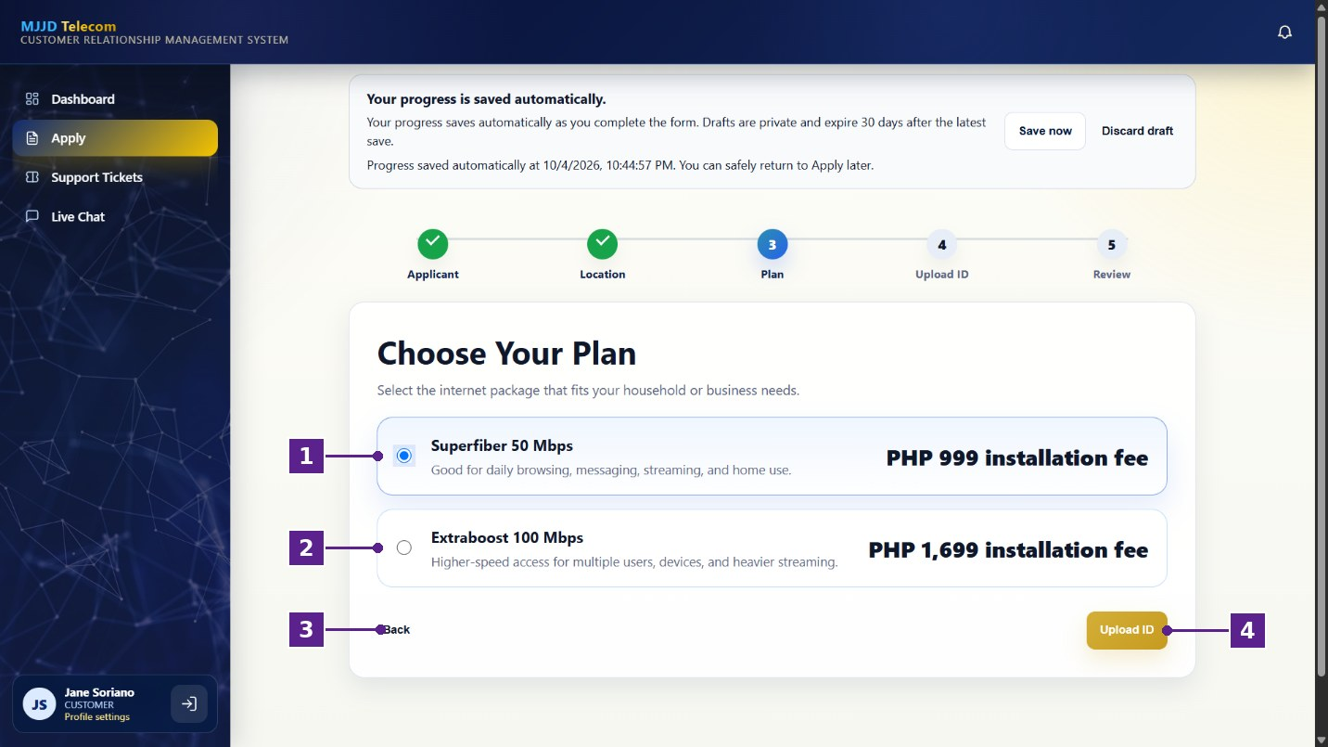
Figure 29
Choose Your Plan Step
Table 43
Choose Your Plan Step
No. | Icon/Button Name | Functions and Description
1 | Superfiber 50 Mbps | The customer can select this option to choose the Superfiber plan with a PHP 999 installation fee.
2 | Extraboost 100 Mbps | The customer can select this option to choose the Extraboost plan with a PHP 1,699 installation fee.
3 | Back Button | The customer can select this button to return to the previous step.
4 | Upload ID Button | The customer can select this button to proceed to the identity verification step.
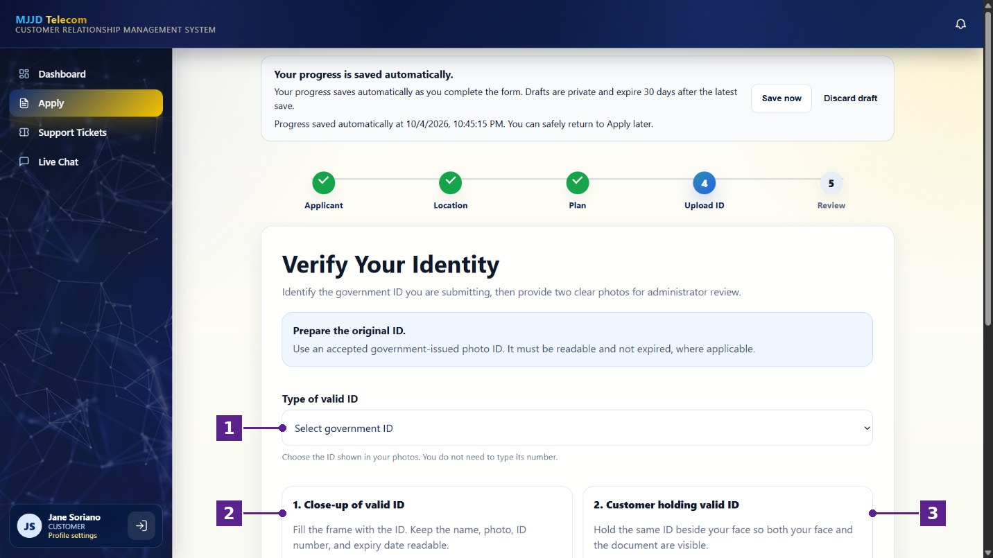
Figure 30
Verify Your Identity Step
Table 44
Verify Your Identity Step
No. | Icon/Button Name | Functions and Description
1 | Type of Valid ID | The customer can select the type of government-issued ID they will submit.
2 | Close-up of Valid ID | Shows the instructions for taking a clear close-up photo of the ID.
3 | Customer Holding Valid ID | Shows the instructions for taking a photo of the customer holding the same ID beside their face.
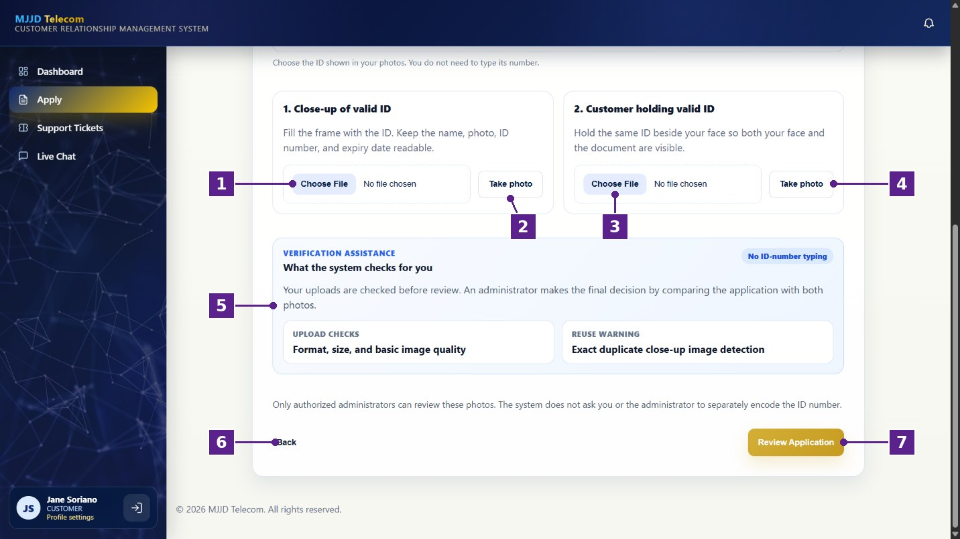
Figure 31
ID Upload Section
Table 45
ID Upload Section
No. | Icon/Button Name | Functions and Description
1 | Choose File (Close-up) | The customer can select this button to upload a close-up photo of their ID.
2 | Take Photo (Close-up) | The customer can select this button to take a close-up photo of their ID using the device camera.
3 | Choose File (Holding ID) | The customer can select this button to upload a photo of themselves holding their ID.
4 | Take Photo (Holding ID) | The customer can select this button to take a photo of themselves holding their ID using the device camera.
5 | Verification Assistance | Explains the checks done on the uploaded photos, such as format, size, image quality, and duplicate detection.
6 | Back Button | The customer can select this button to return to the previous step.
7 | Review Application Button | The customer can select this button to proceed to the review step.
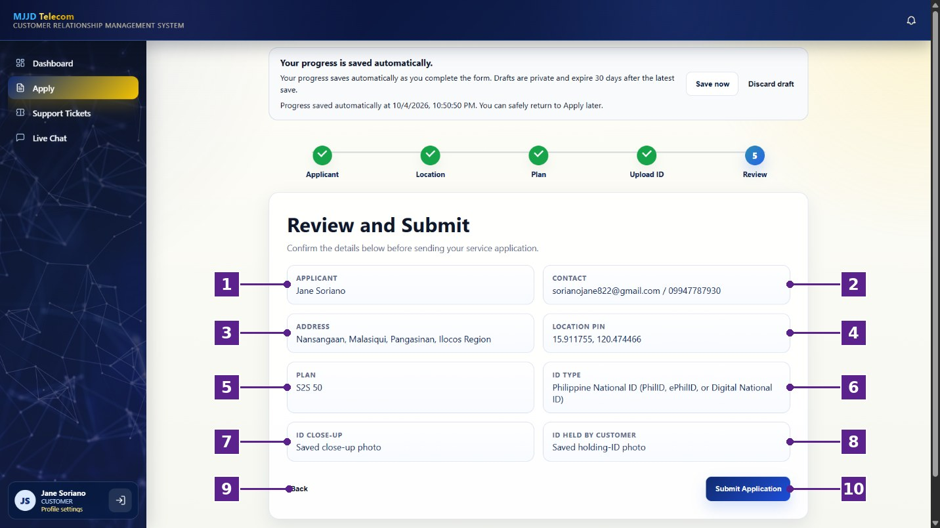
Figure 32
Review and Submit Step
Table 46
Review and Submit Step
No. | Icon/Button Name | Functions and Description
1 | Applicant | Displays the name of the applicant.
2 | Contact | Displays the email address and mobile number of the applicant.
3 | Address | Displays the service address.
4 | Location Pin | Displays the coordinates of the pinned location.
5 | Plan | Displays the selected internet plan.
6 | ID Type | Displays the type of ID submitted.
7 | ID Close-up | Shows that the close-up photo of the ID has been saved.
8 | ID Held by Customer | Shows that the photo of the customer holding the ID has been saved.
9 | Back Button | The customer can select this button to return to the previous step.
10 | Submit Application Button | The customer can select this button to submit their service application.
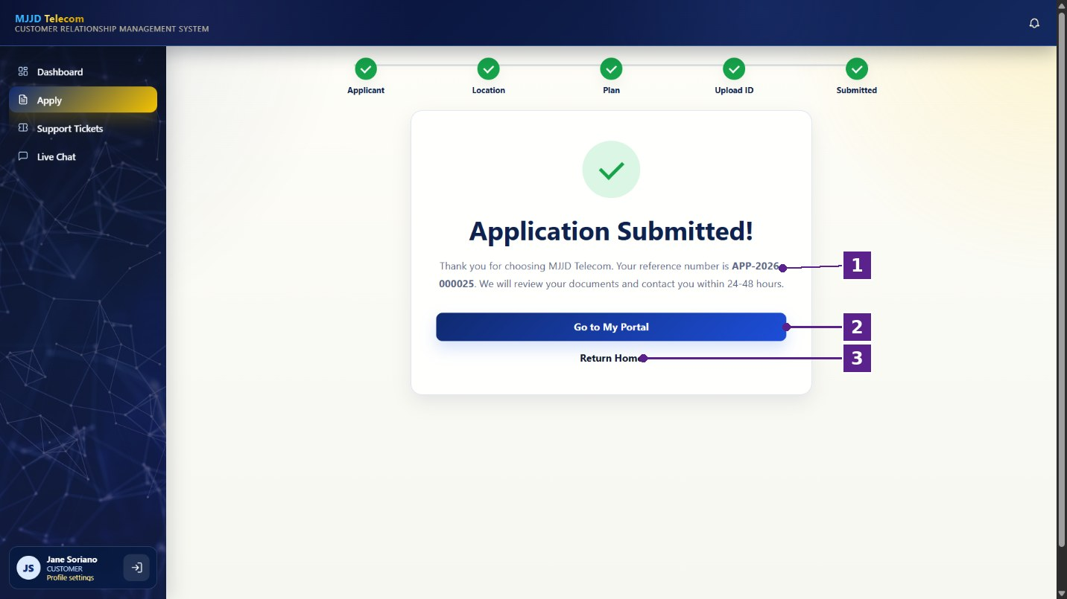
Figure 33
Application Submitted Page
Table 47
Application Submitted Page
No. | Icon/Button Name | Functions and Description
1 | Reference Number | Displays the reference number of the submitted application, which the customer can use to track it.
2 | Go to My Portal Button | The customer can select this button to go to their customer dashboard.
3 | Return Home | The customer can select this option to go back to the homepage.
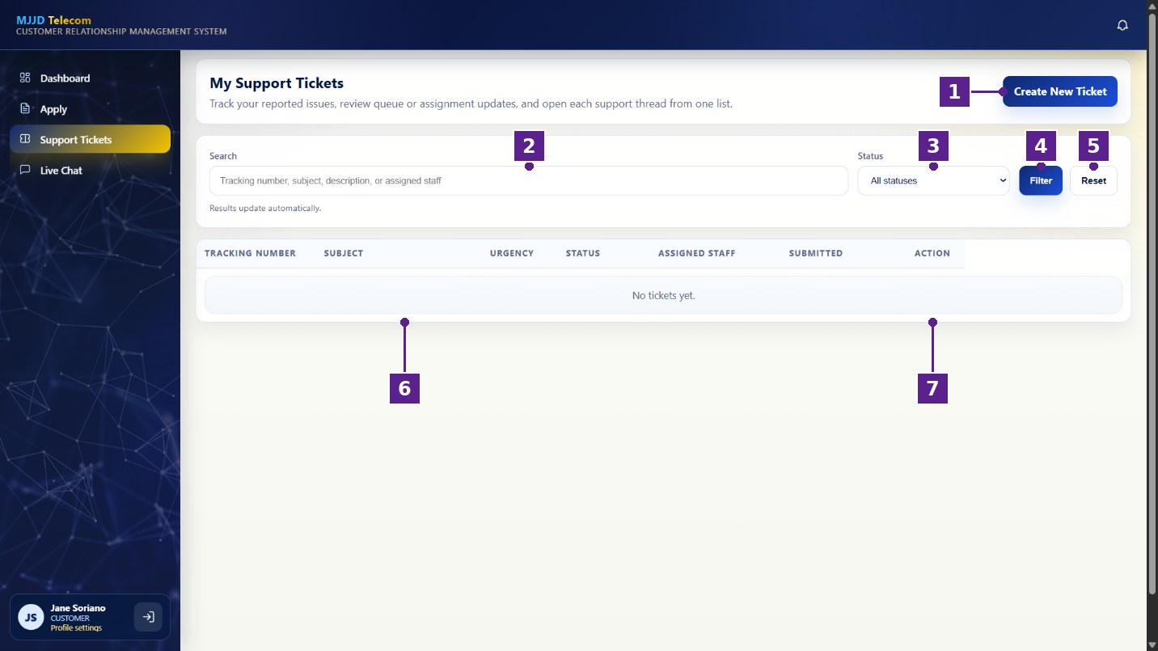
Figure 34
My Support Tickets Page
Table 48
My Support Tickets Page
No. | Icon/Button Name | Functions and Description
1 | Create New Ticket Button | The customer can select this button to report a new issue.
2 | Search | The customer can search their tickets by tracking number, subject, description, or assigned staff.
3 | Status Filter | The customer can filter their tickets by status.
4 | Filter Button | The customer can select this button to apply the selected search and filter.
5 | Reset Button | The customer can select this button to clear the search and filter.
6 | Tickets List | Displays the tracking number, subject, urgency, status, assigned staff, and submission date of each ticket.
7 | Action Column | The customer can use the buttons in this column to open a ticket and view its updates.
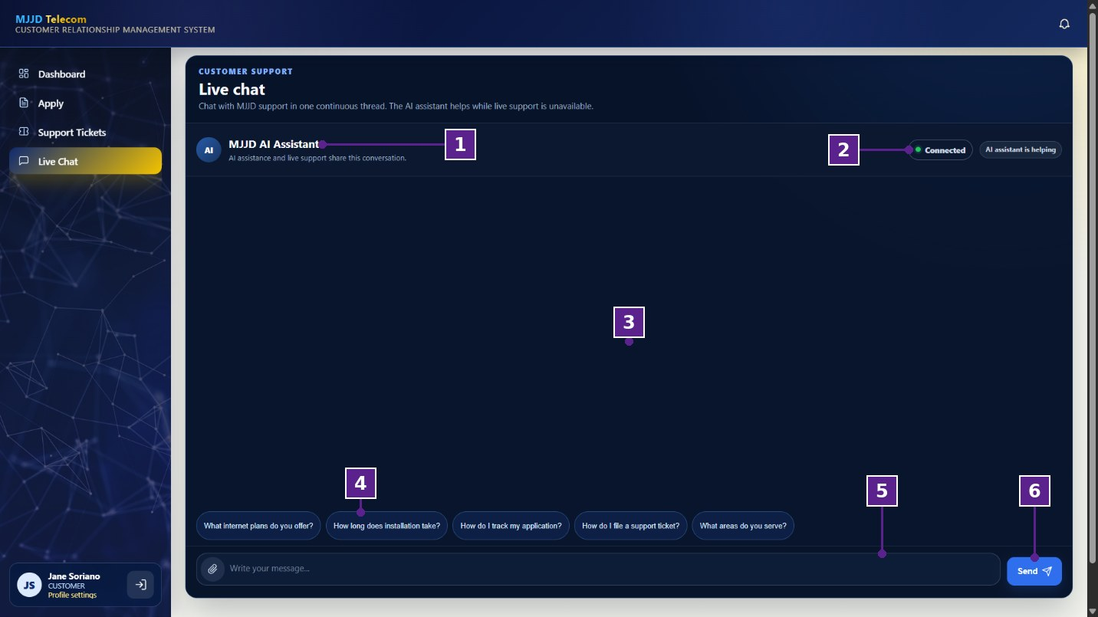
Figure 35
Customer Live Chat Page
Table 49
Customer Live Chat Page
No. | Icon/Button Name | Functions and Description
1 | MJJD AI Assistant | Shows who the customer is chatting with. The AI assistant and live support share one conversation.
2 | Connection Status | Shows that the chat is connected and whether the AI assistant is currently helping.
3 | Chat Area | Displays the messages between the customer and MJJD support.
4 | Suggested Questions | The customer can select a suggested question to ask it quickly.
5 | Message Field | The customer can type their message here. The clip icon allows them to attach a file.
6 | Send Button | The customer can select this button to send their message.
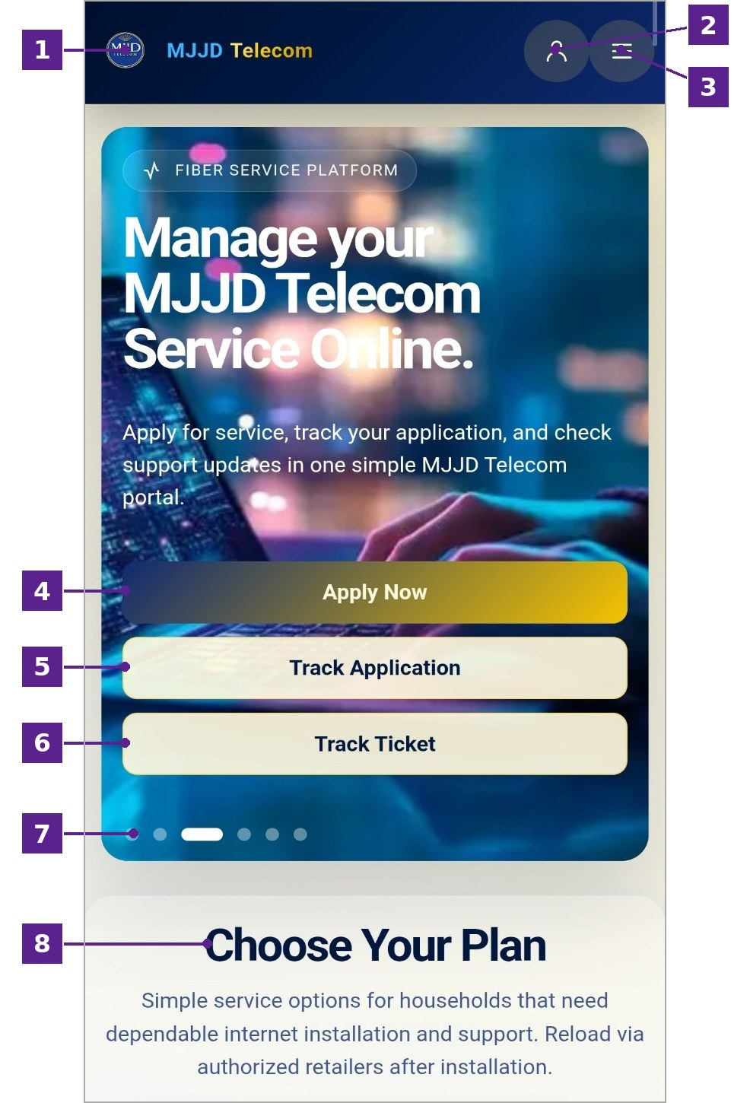
Figure 36
Homepage for Mobile
Table 50
Homepage for Mobile
No. | Icon/Button Name | Functions and Description
1 | MJJD Telecom Logo | Displays the MJJD Telecom logo and the name of the Customer Relationship Management System.
2 | Profile Icon | The user can select this icon to log in or register an account.
3 | Menu Icon | The user can select this icon to open the navigation menu.
4 | Apply Now Button | The user can select this button to start an application for internet service installation.
5 | Track Application Button | The user can select this button to check the status of a submitted service application.
6 | Track Ticket Button | The user can select this button to check the status of a submitted support ticket.
7 | Slider Indicators | The user can select these indicators to view the different featured banners on the homepage.
8 | Choose Your Plan Section | The user can scroll down to view the available internet service plans.
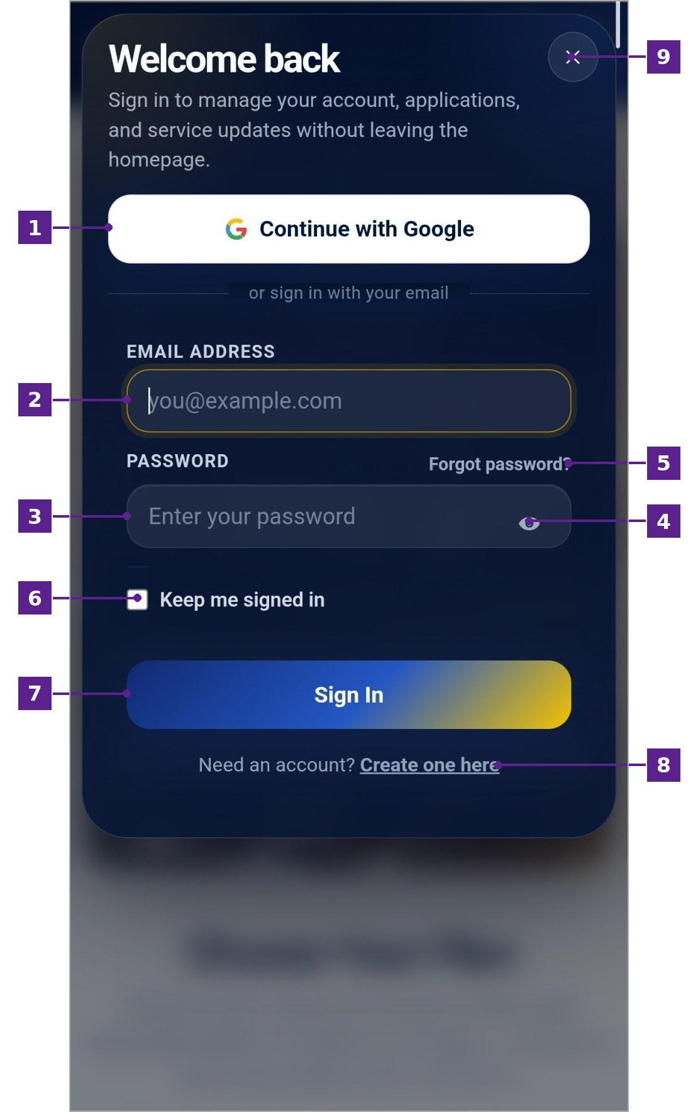
Figure 37
Login Page for Mobile
Table 51
Login Page for Mobile
No. | Icon/Button Name | Functions and Description
1 | Continue with Google | The user can select this button to sign in using their Google account.
2 | Email Address | The user can enter their registered email address.
3 | Password | The user can enter their account password.
4 | Show Password Icon | The user can select this icon to show or hide the entered password.
5 | Forgot Password? | The user can select this option to recover or reset their password.
6 | Keep Me Signed In Checkbox | The user can check this box to stay signed in on the device.
7 | Sign In Button | The user can select this button to submit their email address and password and access their account.
8 | Create One Here | The user can select this option to open the registration window if they do not have an account.
9 | Close (×) Button | The user can select this button to close the login window.
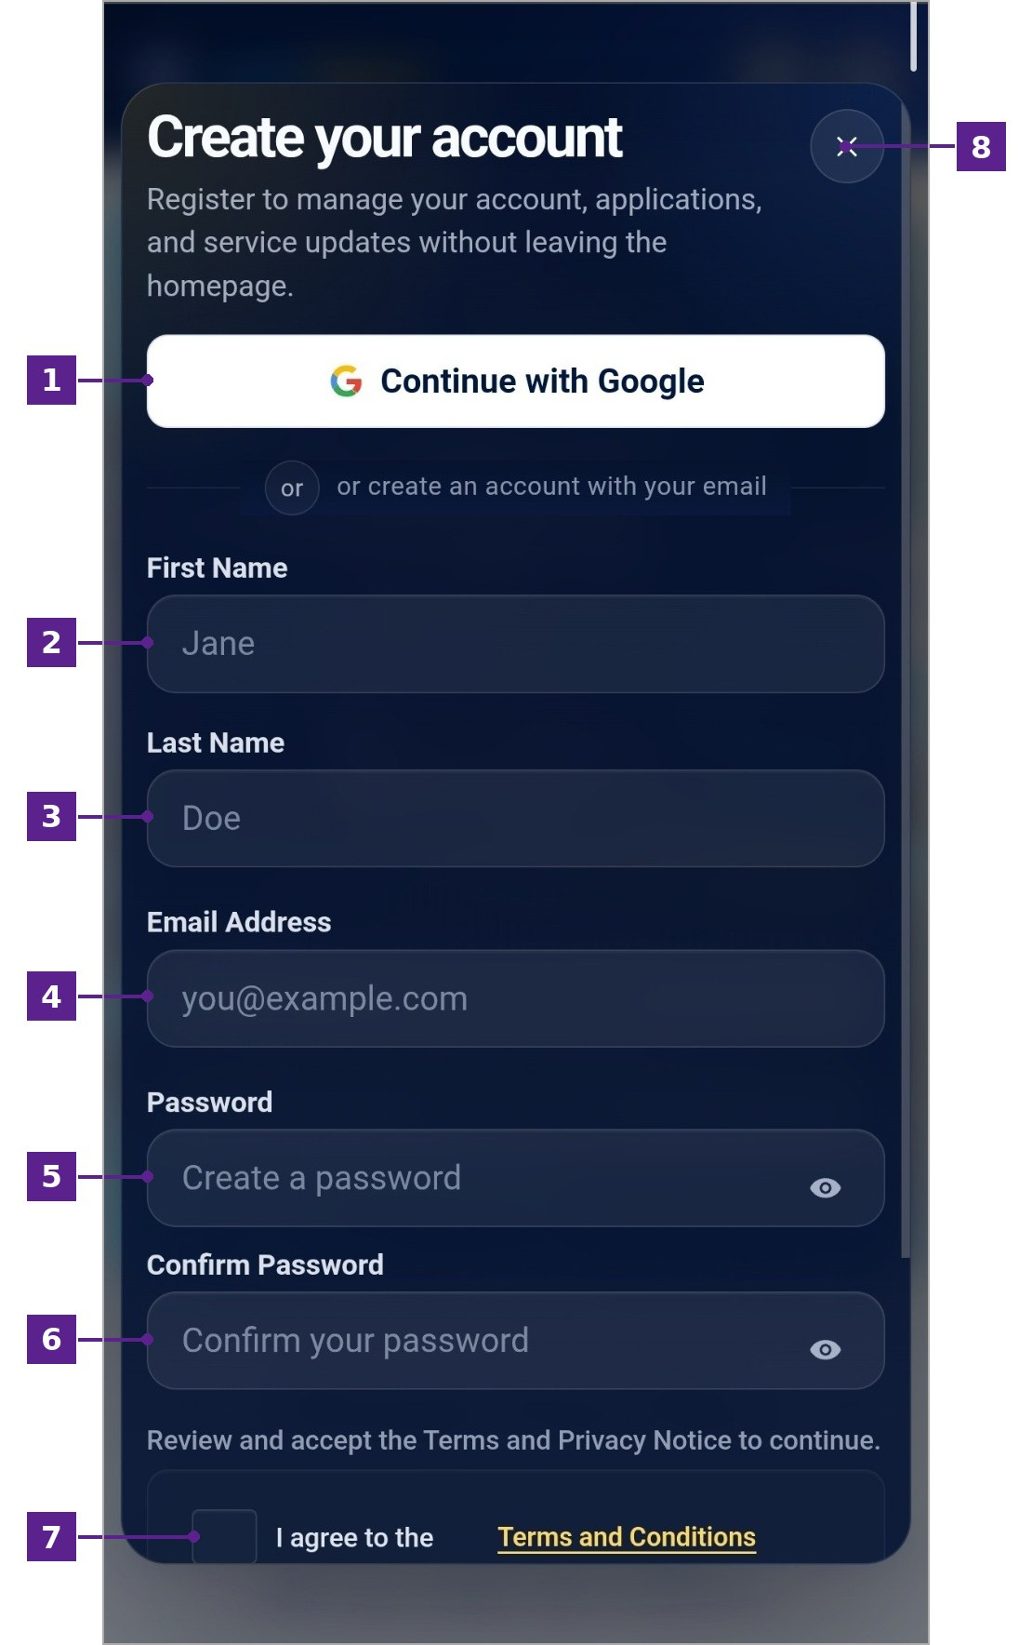
Figure 38
Register Page for Mobile
Table 52
Register Page for Mobile
No. | Icon/Button Name | Functions and Description
1 | Continue with Google | The user can select this button to create an account using their Google account.
2 | First Name | The user can enter their first name.
3 | Last Name | The user can enter their last name.
4 | Email Address | The user can enter the email address to be used for their account.
5 | Password | The user can create a password. The eye icon shows or hides the password.
6 | Confirm Password | The user can re-enter the password to confirm that both entries match.
7 | Terms and Conditions Checkbox | The user can check this box to agree to the Terms and Conditions.
8 | Close (×) Button | The user can select this button to close the registration window.
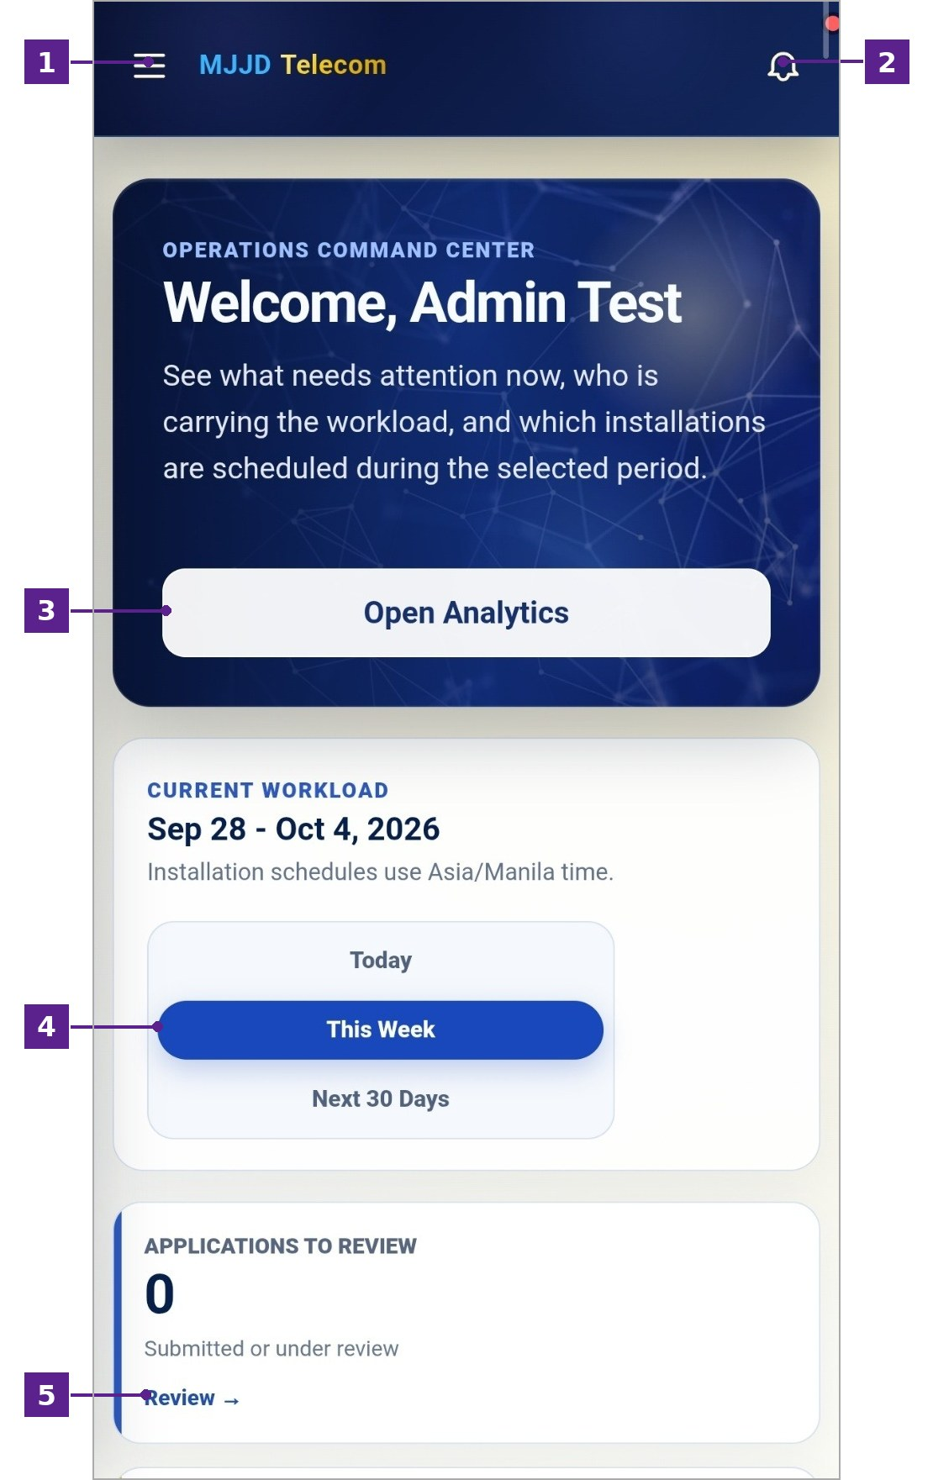
Figure 39
Admin Dashboard for Mobile
Table 53
Admin Dashboard for Mobile
No. | Icon/Button Name | Functions and Description
1 | Menu Icon | The administrator can select this icon to open the navigation menu.
2 | Notification Bell | The administrator can select this icon to view system notifications.
3 | Open Analytics Button | The administrator can select this button to go directly to the Analytics page.
4 | Period Filter | The administrator can choose whether to view the workload for today, this week, or the next 30 days.
5 | Workload Cards | Show the number of applications to review and other items needing attention. The Review link opens the related records.
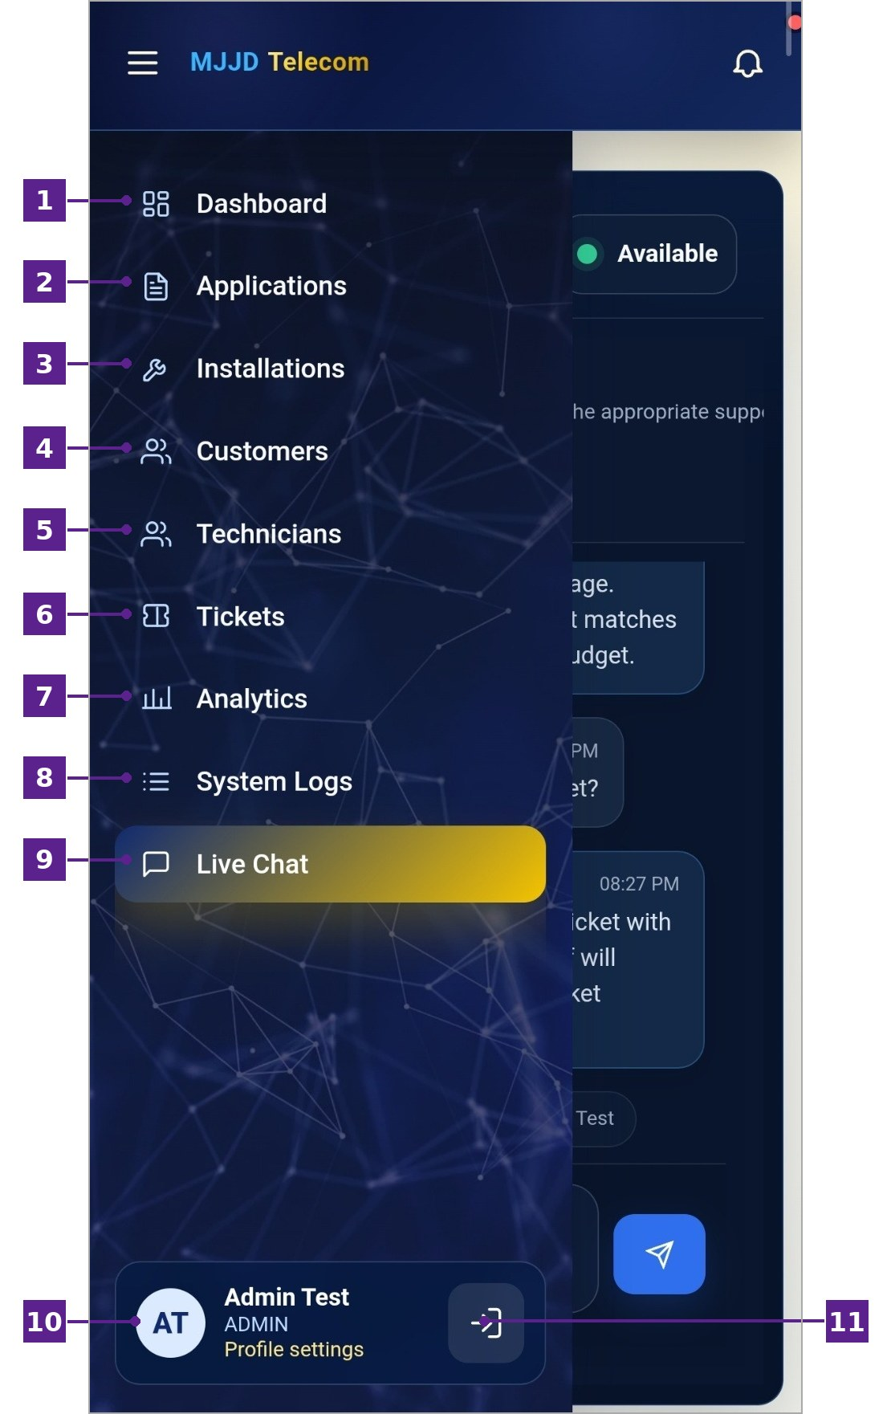
Figure 40
Admin Navigation Menu for Mobile
Table 54
Admin Navigation Menu for Mobile
No. | Icon/Button Name | Functions and Description
1 | Dashboard | The administrator can select this option to view the overview of current operations.
2 | Applications | The administrator can select this option to review and manage customer service applications.
3 | Installations | The administrator can select this option to monitor installation schedules and technician assignments.
4 | Customers | The administrator can select this option to view and manage customer records.
5 | Technicians | The administrator can select this option to view and manage technician records.
6 | Tickets | The administrator can select this option to manage customer support tickets.
7 | Analytics | The administrator can select this option to view analytics and generate reports.
8 | System Logs | The administrator can select this option to view the audit trail of system activities.
9 | Live Chat | The administrator can select this option to respond to customer conversations.
10 | Profile Settings | The administrator can select this option to update their profile information.
11 | Logout Button | The administrator can select this button to sign out of the system.
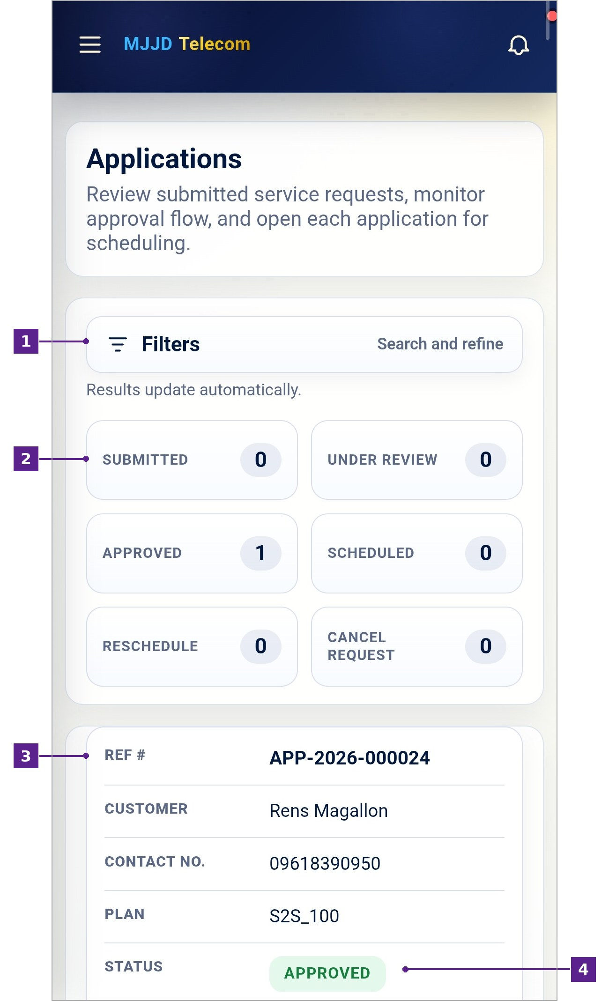
Figure 41
Applications Page for Mobile
Table 55
Applications Page for Mobile
No. | Icon/Button Name | Functions and Description
1 | Filters | The administrator can select this to show the search and filter options.
2 | Status Summary | Shows the number of applications under each status.
3 | Application Record | Displays the reference number, customer, contact number, plan, and status of each application.
4 | Status Label | Shows the current status of the application.
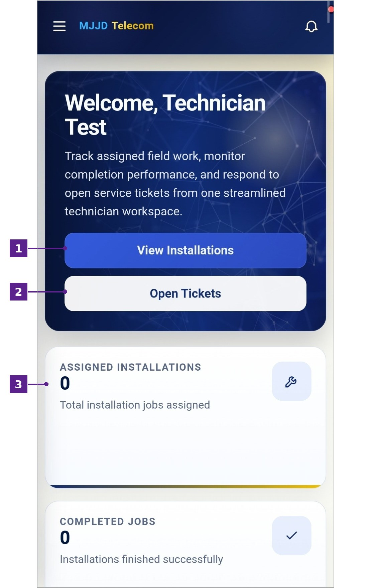
Figure 42
Technician Dashboard for Mobile
Table 56
Technician Dashboard for Mobile
No. | Icon/Button Name | Functions and Description
1 | View Installations Button | The technician can select this button to go to their assigned installations.
2 | Open Tickets Button | The technician can select this button to go to their assigned tickets.
3 | Summary Cards | Show the number of assigned installations, completed jobs, scheduled jobs, and open tickets.
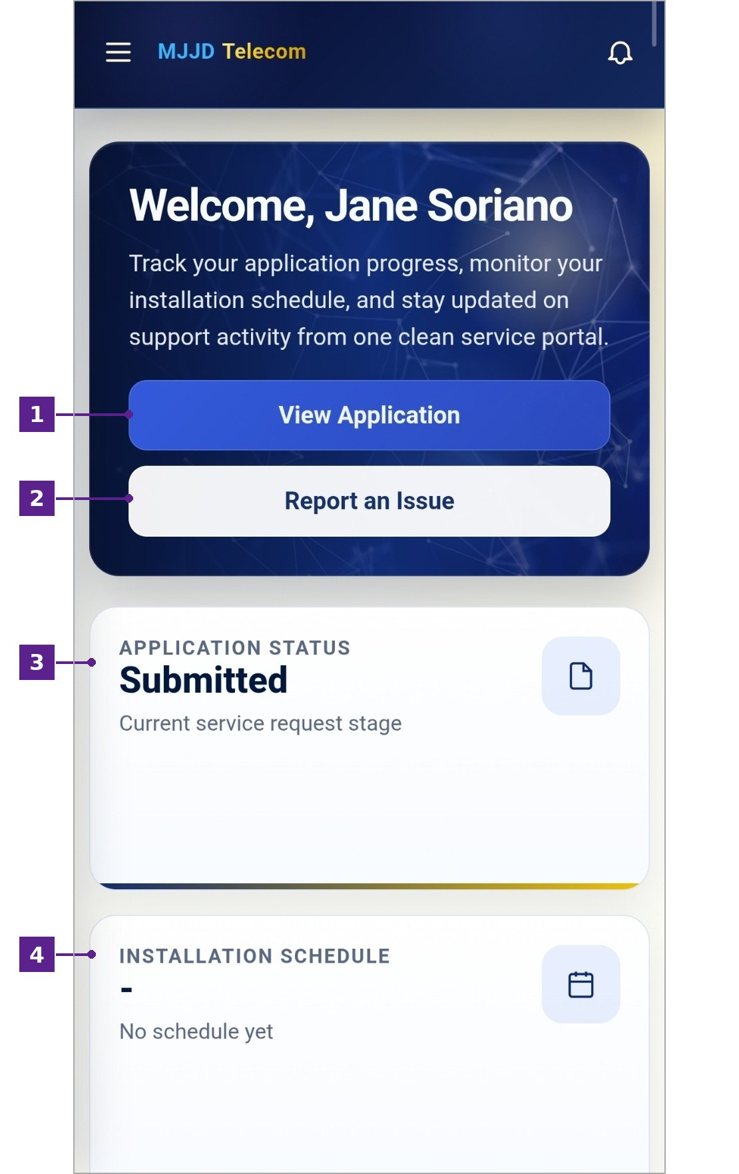
Figure 43
Customer Dashboard for Mobile
Table 57
Customer Dashboard for Mobile
No. | Icon/Button Name | Functions and Description
1 | View Application Button | The customer can select this button to view their submitted application.
2 | Report an Issue Button | The customer can select this button to report a concern through a support ticket.
3 | Application Status | Shows the current stage of the customer’s service application.
4 | Installation Schedule | Shows the scheduled installation date once it is set.
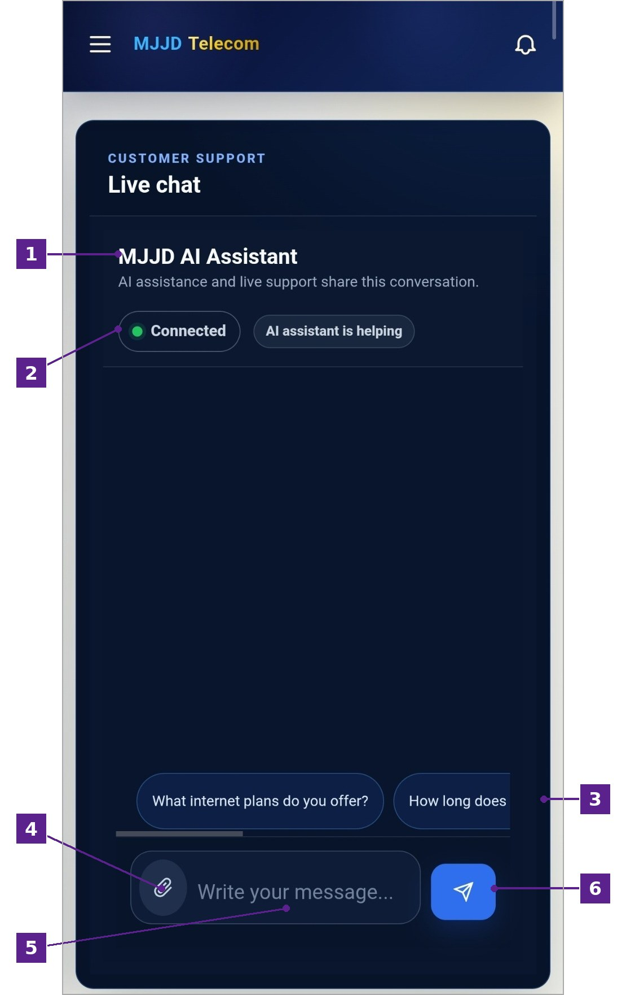
Figure 44
Customer Live Chat Page for Mobile
Table 58
Customer Live Chat Page for Mobile
No. | Icon/Button Name | Functions and Description
1 | MJJD AI Assistant | Shows who the customer is chatting with. The AI assistant and live support share one conversation.
2 | Connection Status | Shows that the chat is connected and whether the AI assistant is currently helping.
3 | Suggested Questions | The customer can select a suggested question to ask it quickly.
4 | Attach Icon | The customer can select this icon to attach a file.
5 | Message Field | The customer can type their message here.
6 | Send Button | The customer can select this button to send their message.

CURRICULUM VITAE


MAGALLON, RENS V.
Poblacion East, Bautista, Pangasinan
Contact No. 0961-839-0950
Email: renzmagallon1@gmail.com

PERSONAL DATA

Age : 21
Date of Birth : June 28, 2004
Place of Birth : Manzon, San Carlos Pangasinan
Sex : Male
Citizenship : Filipino
Religion : Roman Catholic
Dialects : Tagalog, English
Status : Single
Height : 5’8
Weight : 75kg
Name of Father : Renato N. Magallon
Occupation :
Name of Mother : Susan Hope J. Villanueva
Occupation : Agent

EDUCATIONAL BACKGROUND

College Bachelor of Science in Information Technology
Philippine College of Science and Technology
Old Nalsian, Calasiao, Pangasinan

Senior High School Bautista National High School SHS
Accountancy, Business, and Management
Poblacion East, Bautista, Pangasinan
2021-2023

Junior High School Merry Mount Preparatory School
Ilang-ilang, Payatas A, Quezon City
2017-2021

Elementary Saint Nazaire School of Quezon City
Ilang-ilang, Payatas A, Quezon City
2010-2017

MAMUGAY, JYXZL IZZY P.
Nansangaan, Malasiqui, Pangasinan
Contact No. 0994-778-7930
Email: jyxzlmamugay@gmail.com

PERSONAL DATA

Age : 21
Date of Birth : March 24, 2005
Place of Birth : Nalsian Sur, Bayambang, Pangasinan
Sex : Female
Citizenship : Filipino
Religion : Roman Catholic
Dialects : Tagalog, English
Status : Single
Height : 5’2
Weight : 50kg
Name of Father : Joel C. Mamugay
Occupation : Carpenter
Name of Mother : Imelda P. Mamugay
Occupation : Housewife

EDUCATIONAL BACKGROUND

College Bachelor of Science in Information Technology
Philippine College of Science and Technology
Old Nalsian, Calasiao, Pangasinan

Senior High School Bayambang National High School SHS
Accountancy, Business, and Management
Magsaysay St. Bayambang, Pangasinan
2021-2023

Junior High School Bayambang National High School
Magsaysay St. Bayambang, Pangasinan
2017-2021

Elementary Bayambang Central School
Magsaysay St. Bayambang, Pangasinan
2011-2017

SORIANO, EFRYEL JANE S.
Nansangaan, Malasiqui, Pangasinan
Contact No. 0994-778-7930
Email: sorianojane822@gmail.com
PERSONAL DATA

Age : 21
Date of Birth : March 25, 2005
Place of Birth : Nansangaan, Malasiqui Pangasinan
Sex : Female
Citizenship : Filipino
Religion : Born Again
Dialects : Tagalog, Pangasinan, English
Status : Single
Height : 4’11
Weight : 44kg
Name of Father : Ernesto F. Soriano
Occupation : Housekeeper
Name of Mother : Tita S. Soriano
Occupation : Housekeeper

EDUCATIONAL BACKGROUND

College Bachelor of Science in Information Technology
Philippine College of Science and Technology
Old Nalsian, Calasiao, Pangasinan

Senior High School Talospatang National High School SHS
Humanities and Social Sciences
Talospatang, Malasiqui, Pangasinan
2021-2023

Junior High School Talospatang National High School
Talospatang, Malasiqui, Pangasinan
2017-2021

Elementary Talospatang Elementary School
Talospatang, Malasiqui, Pangasinan
2010-2017


TUMANAN, ARJAY P.
Lokeb Norte, Malasiqui, Pangasinan
Contact No. 0951-864-8595
Email: arjaytumanan08@gmail.com

PERSONAL DATA

Age : 21
Date of Birth : August 27, 2004
Place of Birth : Lokeb Norte, Malasiqui Pangasinan
Sex : Male
Citizenship : Filipino
Religion : Roman Catholic
Dialects : Tagalog, Pangasinan,
Status : Single
Height : 5’5
Weight : 72kg
Name of Father : Sanny U. Tumanan
Occupation : Farmers
Name of Mother : Mercy P. Tumanan
Occupation : Housekeeper

EDUCATIONAL BACKGROUND

College Bachelor of Science in Information Technology
Philippine College of Science and Technology
Old Nalsian, Calasiao, Pangasinan

Senior High School Marian Educational Center of Malasiqui
Tambac, Malasiqui, Pangasinan
2021-2023

Junior High School Lokeb Norte National High School
Lokeb Norte, Malasiqui, Pangasinan
2017-2021

Elementary Lokeb Norte Elementary School
Lokeb Norte, Malasiqui, Pangasinan
2011-

